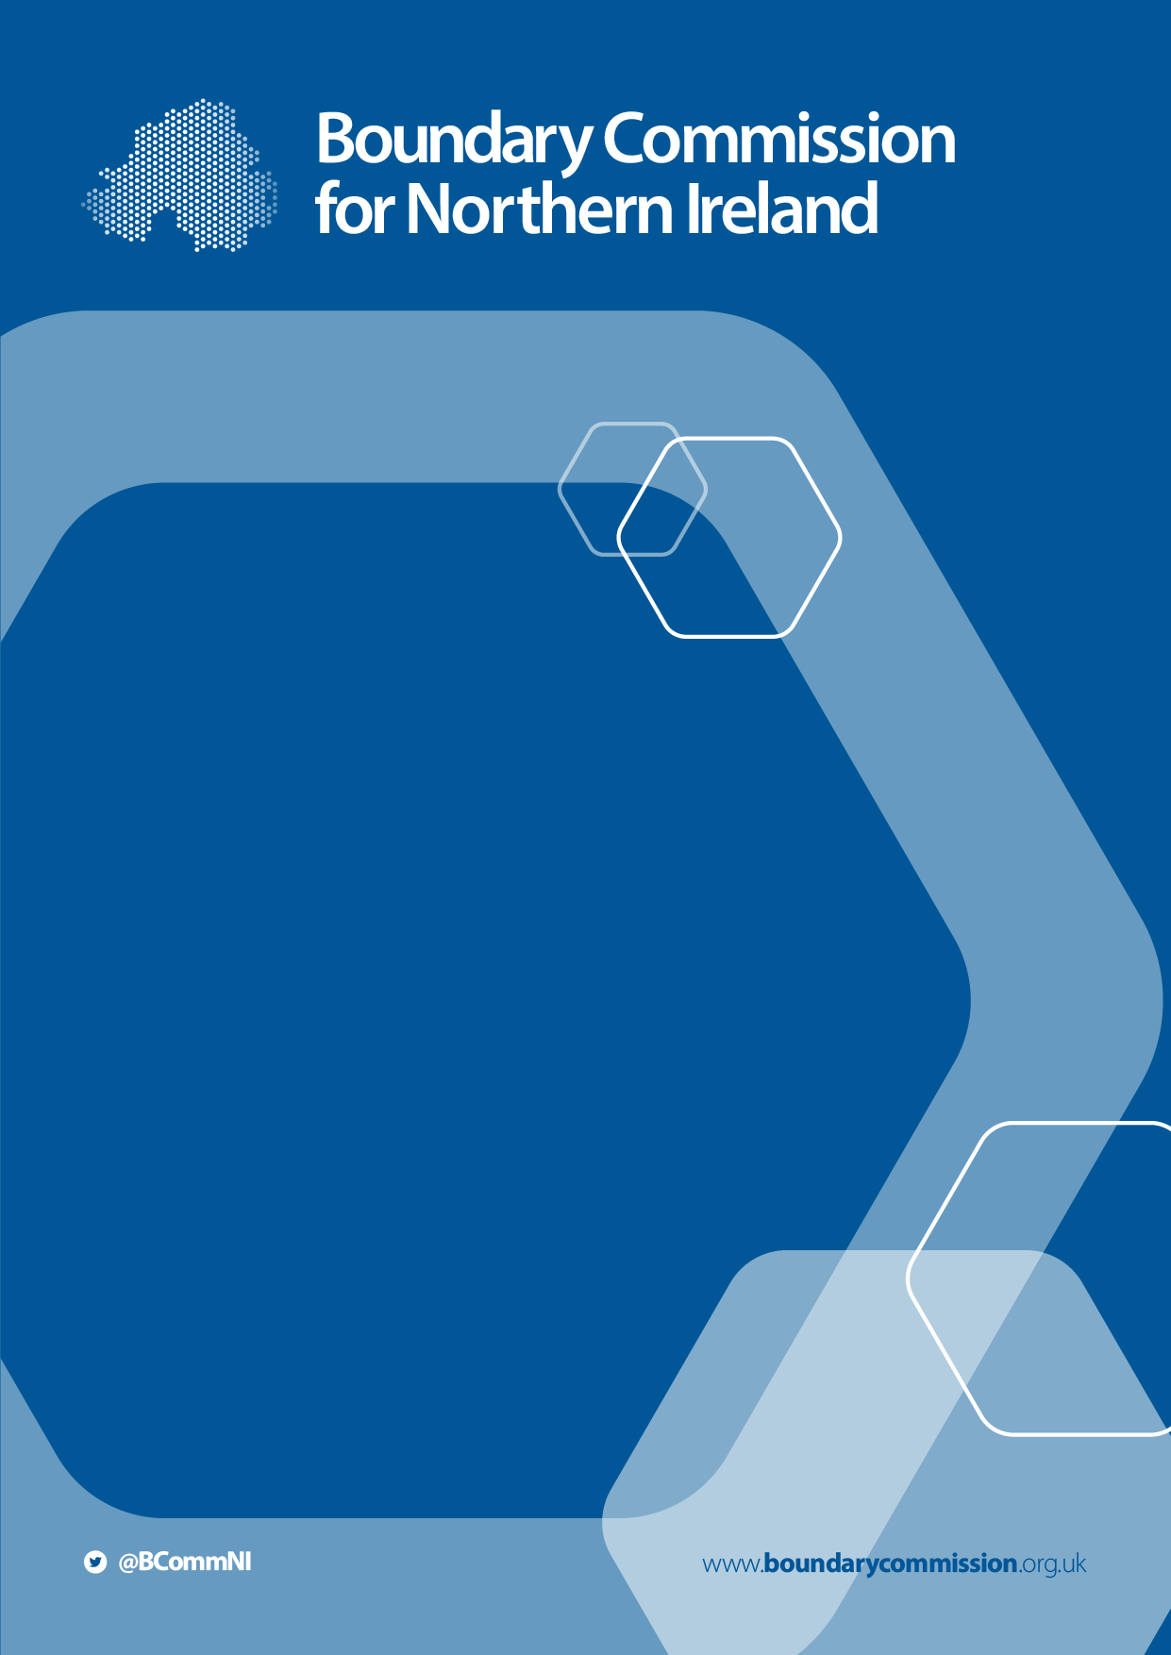
2023 Parliamentary
Constituency
Boundary Review

Guide to the Secondary Consultation Period, including Public Hearings

January 2022

2023 Review of Parliamentary Constituencies

The Secondary Consultation Period,

including Public Hearings

Introduction

Thank you for your interest in the Boundary Commission for Northern Ireland (BCNI) 2023 Review of Parliamentary Constituencies. BCNI is an independent and impartial public body which is responsible for reviewing Parliamentary constituency boundaries in Northern Ireland on the basis of rules set out in the Parliamentary Constituencies Act 1986, as amended (the Act). In accordance with the Act, BCNI is required to review Parliamentary constituency boundaries and submit its final report with recommendations before 1st July 2023.
The Act requires the Commission to hold three periods of public consultation during the course of the 2023 Review. The initial consultation was launched on 20th October 2021 and closed on 15th December 2021. This Guide provides information about the secondary consultation period, including the public hearings. The secondary consultation period begins on 9th February 2022, and lasts for six weeks.

Statutory Process

The initial consultation period has now been completed and the representations received have been published on the Commission’s website. These representations have been published ahead of the commencement of the secondary consultation period to facilitate timely access and engagement – however, further written representations with regards to them should not be submitted until the secondary consultation begins on 9th February 2022.

Secondary Consultation – Written Representations

The secondary consultation period provides an opportunity to submit ‘further written representations with respect to the representations published’ (i.e. those received during the initial consultation period). Therefore written representations made during the secondary consultation period can support or challenge the representations made by others during the initial consultation.

The written representations from the initial consultation period have been published at https://www.boundarycommission.org.uk/2023-review/representations-received/stage/initial. A response template for further representations with respect to those initial representations will be made available on our website when the consultation opens. These further representations should be received by the Commission between 9th February and 23rd March 2022, using the email address review@boundarycommission.org.uk. If you require copies of the initial representations in an alternative format, or you wish to submit a hard copy of your written representation, please get in touch with us by phone on 028 90 527821 or by email to contact@boundarycommission.org.uk.

Secondary Consultation – Public Hearings

The Commission is also required to hold public hearings during the secondary consultation period. The Act states at Schedule 2A that ‘the public hearings in Northern Ireland shall be concerned with proposals for Northern Ireland, and shall between them cover the whole of Northern Ireland.’ The complete text of Schedule 2A can be found at Appendix 1.

Public hearings are therefore intended to provide an opportunity to make oral representations about any of the Commission’s initial proposals, and to present or comment on any counterproposals.

The Commission has appointed an independent Chair for each of the public hearings. It is for the Chair to determine the procedure that is to govern the hearing and ensure its effective operation, in line with the legislation. The Chair is not required to submit a report or recommendations relating to the hearing to the Commission.

In line with the legislation, the Chair will allow representations to be made by qualifying political parties and other individuals or organisations that the Chair considers have an interest in the proposals. The Chair may restrict the amount of time available for representations, and may determine the order in which representations are made.

After the Secondary Consultation

After the end of the secondary consultation period, the Commission will publish the records of the public hearings on our website. We will also publish the written representations received during the secondary consultation period. For information about our Data Protection and Privacy Policy please visit https://www.boundarycommission.org.uk/publications/data-protection-and-privacy-policy.

Detailed information about the third consultation period will be announced at the appropriate time. For further detailed information about the statutory process, please see the Guide to the 2023 Review, which is available at www.boundarycommission.org.uk/publications/guide-2023-review.

Public Hearings

The secondary consultation period, during which the public hearings occur, will begin on 9th February 2022 and end on 23rd March 2022. The Commission will hold three public hearings during this period – details of the dates, times and venues for these hearings will be published on 9th February. Representations about any or all proposed constituencies can be made at any of the public hearings – you may therefore attend any of the public hearings and make oral representations about any constituency.

The Commission will follow any relevant public health guidance applicable at the time of the public hearings. Should COVID-19 restrictions impact plans for the public hearings, we will communicate this via our website and social media (and directly to those who have registered) as soon as possible.

Attendance at the hearings

The public hearings for the 2023 Review will allow for representations to be made both in-person, and via video link (subject to any public health restrictions at the time of the hearings). To ensure the hearings run smoothly, as well as to ensure the accuracy of the statutory record, those interested parties wishing to attend any of the public hearings whether in person or online, are asked to register their attendance in advance.

Once the dates and venues for the hearings have been announced on 9th February, you can contact us to register by calling 028 90527821 or by emailing review@boundarycommission.org.uk. We would be grateful for registrations no less than one week before the date of your preferred hearing in order to ensure its smooth running.

When you contact us to register, we request that you provide the following information:

- Your name
- The organisation you represent (if any)
- Preferred contact details
- The hearing you would like to attend, and whether you plan to attend in-person or virtually
- Whether you wish to book a slot to make an oral representation, and whether you wish to use any supporting materials
- Whether you require a translator or interpreter.

We will acknowledge receipt of your details, your preferred hearing and whether you wish to attend in-person or virtually. The Commission will then contact you around one week before your preferred hearing to confirm your registration, and other arrangements. Those who wish to attend in-person will receive details of any relevant public health advice relating to the venue. Those attending virtually will receive details of the video-conferencing arrangements.

Those who have requested a slot to make an oral representation (whether in-person or virtually) will be provided with an approximate speaking time. In order to facilitate full participation by all who wish to speak, each speaker should aim to ensure that their representation can be heard in no more than 15 minutes, subject to the discretion of the Chair.

The interactive map displaying the Commission’s Initial Proposals will be available on a large screen during each hearing. Speakers may also wish to use their own supporting materials (such as alternative maps or slides) alongside their oral representation – please let us know when you register if this is the case. If you wish to have electronic versions of these materials displayed during your speaking slot, please provide a copy of these to the Commission in advance of the hearing date to ensure the smooth running of the event.

Procedure

At the beginning of each hearing, the Chair will outline the procedures to be followed. The Chair may then adjourn the proceedings to facilitate any final timetabling of speakers. In line with the legislation, there will then be an explanation of the proposals with which the hearing is concerned, and how written representations may also be made during the secondary consultation period.

The Chair will then call on speakers in turn to make their representation, asking them first to provide their name and what organisation they represent (if any). The Chair will manage the time that each participant has to speak, and (if necessary due to time constraints) who is permitted to speak. The Chair may also put questions, or allow questions to be put to those present at the hearing, and manage the process of any questioning that occurs.

During the hearing, all devices should be turned off or placed in silent mode unless using them to facilitate online representations. Recording of the hearing will not be permitted (although background photography may be permitted at the Chair’s discretion, upon request). The Chair will reserve the right to ask attendees to refrain from any activity they consider disruptive to proceedings.

Recording and Publication

After the end of the secondary consultation period, the Act requires the Commission to publish the record of each public hearing. Therefore, all contributions to the hearing (both in-person and virtual) will be recorded, and to ensure accuracy, participants may be asked to repeat what they have said. The transcript will include the name of the speaker and organisation represented (if any). Personal information such as address and contact information will not be published.

Media

Representatives of the media are welcome to register to attend a public hearing, but any recording of the hearing will not be permitted (although background photography may be permitted at the Chair’s discretion, upon request). As above, a transcript of each hearing will be published on the Commission’s website after the secondary consultation period has ended. Media enquiries should be directed to Kieran Donnelly, Morrow Communications, on 07769702275 or k.donnelly@morrowcommunications.com.

Get in touch

The Commission is keen to encourage participation in the secondary consultation process, including the public hearings. If you have any questions about the process, or would like to discuss how you can take part, please get in touch with us by calling 028 90527821 or by emailing contact@boundarycommission.org.uk.

Appendix 1 – Schedule 2A of the Parliamentary Constituencies Act, as amended
SCHEDULE 2A

PUBLIC HEARINGS ABOUT BOUNDARY COMMISSION PROPOSALS

Purpose of hearings

1 The purpose of a public hearing is to enable representations to be made about any of the proposals with which the hearing is concerned.

Number of hearings

2 (1) In relation to any particular report under section 3(1)(a) of this Act –
the Boundary Commission for England shall cause at least two and no more than five public hearings to be held in each English region;
the Boundary Commission for Scotland shall cause at least two and no more than five public hearings to be held in Scotland
the Boundary Commission for Wales shall cause at least two and no more than five public hearings to be held in Wales
the Boundary Commission for Northern Ireland shall cause at least two and no more than five public hearings to be held in Northern Ireland.

(2) The public hearings in an English region shall be concerned with proposals for that region, and shall between them cover the whole region.

(3) The public hearings in Scotland shall be concerned with proposals for Scotland, and shall between them cover the whole of Scotland.

(4) The public hearings in Wales shall be concerned with proposals for Wales, and shall between them cover the whole of Wales.

(5) The public hearings in Northern Ireland shall be concerned with proposals for Northern Ireland, and shall between them cover the whole of Northern Ireland.

Chair of hearing

3 For each public hearing the Boundary Commission concerned shall appoint a person to chair the hearing.

Length of hearings

4A public hearing shall be completed within two days.

Procedure at hearings
5 It is for the chair of each public hearing to determine the procedure that is to govern that hearing.

6 The chair shall make arrangements for a public hearing to begin with an explanation of –
the proposals with which the hearing is concerned;
how written representations about the proposals may be made (as mentioned in section 5(1)(a), (4)(b), (4B)(b), or (5)(c) of this Act).

7 (1) The chair of a public hearing must allow representations to be made –
by each qualifying party;
by any other persons (whether individuals or organisations) considered by the chair to have an interest in any of the proposals with which the hearing is concerned.
Paragraph (b) above has effect subject to sub-paragraph (3)(b) below.

(2) The chair may restrict the amount of time allowed for representations –
by qualifying parties, and
by other persons,
and need not allow the same amount to each.

(3) The chair may determine –
the order in which representations are made, and
if necessary because of shortage of time, which of those wishing to make representations are not allowed to do so,
in whatever way the chair decides.

8 (1) The chair may put questions, or allow questions to be put, to a person present at the hearing.

(2) If questions are allowed to be put, the chair may regulate the manner of questioning or restrict the number of questions a person may ask.

Interpretation

9 In this Schedule –
“the chair” means the person appointed under paragraph 3 above;
“English region” means an electoral region specified in Schedule 1 to the European Parliamentary Elections Act 2002 (ignoring paragraph 2(2) of that Schedule and references to Gibraltar) as it has effect on the day referred to in rule 5(2) of Schedule 2 to this Act;
“public hearing” means a hearing under section 5(4)(c) of this Act;
“qualifying party” means a party that is registered under Part 2 of the Political Parties, Elections, and Referendums Act 2000 and either –
Has at least one Member of the House of Commons representing a constituency in the region, or (as the case may be) the part of the United Kingdom, in which the hearing is held, or
Received at least 10% of the votes cast in that region or part in the most recent parliamentary general election.

Qualifying party” means a party that is registered under Part 2 of the Political Parties, Elections, and Referendums Act 2000 and either – - Has at least one Member of the House of Commons representing a constituency in the region, or (as the case may be) the part of the United Kingdom, in which the hearing is held, or - Received at least 10% of the votes cast in that region or part in the most recent parliamentary general election.

