Final Recommendations Report of the 2023 Review of Parliamentary Constituencies

Initial proposals for the
2023 Parliamentary
Constituency
Boundary Review

Published 20 October 2021

Boundary Commission for Northern Ireland

2023 Review of Parliamentary Constituencies

FINAL RECOMMENDATIONS REPORT

Presented to Parliament pursuant to Section 3 of the Parliamentary Constituencies Act 1986,
as amended.

© Crown copyright 2023
This publication is licensed under the terms of the Open Government Licence v3.0 except where otherwise stated. To view this licence, visit
http://www.nationalarchives.gov.uk/doc/open-government-licence/version/3

Where we have identified any third-party copyright information you will need to obtain permission from the copyright holders concerned.

This publication is available at www.boundarycommission.org.uk.

Any enquiries regarding this publication should be sent to us at:

Boundary Commission for Northern Ireland
Level 7
Erskine House
20-32 Chichester Street
Belfast
BT1 4GF
Email: contact@boundarycommission.org.uk

ISBN 978-1-5286-4069-5
E02901006 06/23

Printed in the UK on behalf of the Controller of His Majesty’s Stationery Office.

Contents

Foreword 7
Chapter 1 9
Process and Procedures 9
Commencement 9
The Consultation Process 9
The Final Recommendations 10
Next Steps 10
Future Reviews 11
Chapter 2 12
Rules, Factors and Approach 12
Rules and Factors 12
Approach adopted to developing Initial Proposals 14
Consideration of representations received at initial and secondary stages 17
Approach adopted to developing Revised Proposals 18
Consideration of representations received at the third consultation stage 20
Approach adopted to developing Final Recommendations 21
Chapter 3 23
The Delineation of Constituencies 23
Overview 23
Detail of Recommended Constituencies (in alphabetical order) 25
Chapter 4 85
Summary of Final Recommendations 85
Delineation 85
Naming and Designation 86
Appendix A 88
Boundary Commission for Northern Ireland: Membership and Constitution 88
Appendix B 89
Schedule 2 of the Parliamentary Constituencies Act 1986 (as amended) 89
Appendix C 94
Wards split by current (2008) Parliamentary constituency boundaries 94
Appendix D 97
Composition of the Recommended Constituencies 97
Appendix E 115
Representations Received 115
Appendix F 118
Constituency Map of Northern Ireland 118
Appendix G 120
Individual Constituency Maps 120

Foreword

The Boundary Commission for Northern Ireland is an independent and impartial public body. It is responsible for reviewing Parliamentary constituency boundaries in Northern Ireland on the basis of rules laid down by Parliament. The constitution of the Commission is set out in Appendix A.

There are separate Parliamentary Boundary Commissions for England, Scotland, Wales and Northern Ireland. Each of these Commissions must follow a process set out in the Parliamentary Constituencies Act 1986, as amended by the Boundary Commissions Act 1992, the Parliamentary Voting System and Constituencies Act 2011, the Electoral Registration and Administration Act 2013, and the Parliamentary Constituencies Act 2020.

The Parliamentary Constituencies Act 2020 brought the 2018 Boundary Review to a close without implementation. The 2020 Act also introduced some changes to the statutory boundary review process. The key changes are as follows:

- 650 seats across the UK, compared to 600 in the 2018 Review;
- Three periods of public consultation, rather than two;
- Public hearings now take place during the secondary consultation period rather than the first;
- The interval between reviews will be eight years once the 2023 Review is completed, meaning the next review is currently anticipated to finish in 2031;
- Reintroduction of the ‘inconvenience’ Rule 5 factor and a change to the Parliamentary process after submission.

The 2020 Act also requires each Commission to submit a report to the Speaker of the House of Commons before 1st July 2023, following a detailed statutory consultation process. The Boundary Commission for Northern Ireland is grateful to all those individuals and organisations who made representations to us during that process. The report of the Boundary Commission for Northern Ireland must show the constituencies into which it recommends that Northern Ireland should be divided and recommend the names by which they should be known. The Commission therefore submits the following report to the Speaker in line with its statutory duties.

Finally, the Commission records its gratitude to its statutory assessors who provided advice and assistance during the 2023 Review of Parliamentary Constituencies, and to the District Judges who chaired the public hearings. Furthermore, the Commission acknowledges the invaluable professional assistance provided by staff from Land & Property Services. We would also like to thank our Secretariat team, which comprises Heather McKinley, Andrea Richardson and Lyn McBride, for their diligent work and support throughout the 2023 Review.

Mr Justice Michael Humphreys
(Deputy Chairman)
Ms Sarah Havlin
(Commissioner)
Ms Vilma Patterson MBE
(Commissioner)

June 2023

Chapter 1

Process and Procedures

Commencement
- The Boundary Commission for Northern Ireland announced the start of its 2023 Review of Parliamentary Constituencies on 5th January 2021, following the publication of the United Kingdom electoral registers for 2nd March 2020. The Act specifies these electorate statistics as the data that the Commission is required to use for the 2023 Review.

The Consultation Process
- The Act requires the Commission to undertake three periods of consultation during the 2023 Review. Following publication of its Initial Proposals, the initial consultation period started on 20th October 2021 and finished on 15th December 2021. In line with the legislation, the Commission then published the representations received during the initial consultation on its website. The secondary consultation period, which included three public hearings, started on 9th February 2022 and finished on 23rd March 2022. In accordance with the Act, the Commission published the records of the public hearings on its website. It also published the written representations received during the secondary consultation period.

- Having considered the written representations received during the initial and secondary consultation periods, and the records of the hearings, the Commission revised its proposals. The third statutory consultation period took place between 17th November 2022 and 15th December 2022. The Commission subsequently published the written representations it received during the third consultation period.

The Final Recommendations
- Taking into account the representations received throughout the consultation process, and in line with its statutory duties, the Commission has determined what final recommendations to make for Parliamentary constituencies in Northern Ireland. Once these have been submitted in a report to the Speaker of the House of Commons, the Act states that the Speaker must then lay the report before Parliament. As soon as reasonably practicable after the report has been laid, the Commission must then publish it.

Next Steps
- Once reports from all four Boundary Commissions have been laid before Parliament, the Government must submit a draft of an Order in Council giving effect to the recommendations in the reports, no later than four months from the first date on which all four reports have been laid.

- If, before the Order in Council is submitted, the Boundary Commission identifies an error in its submitted report, it may submit a statement of modifications. The statement should specify the modifications which the Commission considers should be made to the recommendations in the report in order to correct any error in those recommendations, and its reasons for those modifications. If a Commission submits a statement of modifications, the Speaker must lay this before Parliament, and the Commission must also publish it. Where a statement of modifications has been submitted, the draft of the Order in Council must give effect to the recommendations in the report with the modifications specified in the statement.

- The Act specifies that the Order in Council will not affect any Parliamentary election until the dissolution of the Parliament then in being. Any by-elections held in the meantime must therefore be held on the basis of the old (existing) Parliamentary constituencies. With regards to Northern Ireland Assembly elections, Section 33 of the Northern Ireland Act 1998 provides that Assembly members shall be returned for the Parliamentary constituencies in Northern Ireland.

Future Reviews
- The Parliamentary Constituencies Act 2020 provides that the next review report is to be submitted to the Speaker of the House of Commons before 1st October 2031, and before 1st October of every eighth year after that.

Chapter 2

Rules, Factors and Approach

Rules and Factors
(as set out in the Initial and Revised Proposals Reports)

- The Act specifies that there shall be 650 constituencies in the United Kingdom. With the exception of five protected constituencies in Scotland, Wales and England, this total is to be distributed across the four parts of the United Kingdom in accordance with a mathematical formula specified in Schedule 2 of the Act (Appendix B).

- In accordance with that specified formula, and based on the total electorate for the United Kingdom, the number of constituencies allocated to Northern Ireland for the 2023 Review is 18, which is unchanged from the current number of constituencies.

- The Act specifies which electorate figures are to be used by the Commission when carrying out a review. For the 2023 Review, the Commission is required to use the total number of persons whose names appeared on the Parliamentary electoral register as at 2nd March 2020.

- Rule 2 in Schedule 2 of the Act stipulates that the electorate of any constituency shall be no less than 95% and no more than 105% of the United Kingdom electoral quota. This quota is the total electorate of the United Kingdom (excluding the five protected constituencies) divided by 645 (650 less the protected constituencies).

- The electoral quota for the 2023 Review is 73,393 (to the nearest whole number). Applying Rule 2, each constituency must have an electorate of no less than 69,724 and no more than 77,062.

- The Act does not require the Commission to seek to create constituencies with electorates that are as close as possible to the electoral quota – rather, the Commission should adhere to the statutory electorate range.

- Rule 5 specifies other factors which the Commission may take into account, ‘if and to such extent as they think fit’. These are:

      - special geographical considerations, including in particular the size, shape and accessibility of a constituency;
      - local government boundaries which exist, or are prospective, on the review date;
      - boundaries of existing constituencies;
      - any local ties that would be broken by changes in constituencies; and
      - the inconveniences attendant on such changes.

- The Act defines local government boundaries in Northern Ireland as the boundaries of wards that existed or were prospective on 1st December 2020.

- The Commission may at its discretion decide to take some or all or none of these factors into account. Rule 5 does not require the Commission to take these factors into account, nor does it restrict the Commission to only taking these factors into account, if it considers other factors to be relevant to the exercise of its powers.

- Rule 7 only applies to Northern Ireland. Where the Commission feels that having to apply Rule 2 would unreasonably impair its ability to take into account the factors set out in Rule 5, or to submit a report on time, Rule 7 can be applied and one or more constituencies recommended which fall slightly outside the Rule 2 range, in accordance with a prescribed formula. For the 2023 Review this means that the Commission could propose one or more constituencies of between 68,314 and 77,062 electors.

- The Act does not define what ‘unreasonably impairs’ means. The Commission will consider that it is unreasonably impaired when it is prevented contrary to good sense from giving weight to any or all of the Rule 5 factors by the restrictions on electoral size required by Rule 2.

Approach adopted to developing Initial Proposals
(as set out in the Initial and Revised Proposals Reports)

- In formulating its Initial Proposals, the Commission noted that 11 of the 18 extant constituencies’ electorates fell outside the Rule 2 statutory range (69,724 - 77,062). Changes to the existing constituencies were therefore required. The electorates of the existing (2008) constituencies are shown below:

Constituency (2008) | Electorate
Belfast East | 66,273
Belfast North | 72,332
Belfast South | 70,134
Belfast West | 65,761
East Antrim | 64,907
East Londonderry | 69,359
Fermanagh and South Tyrone | 72,945
Foyle | 74,431
Lagan Valley | 75,884
Mid Ulster | 70,501
Newry and Armagh | 81,329
North Antrim | 77,156
North Down | 67,109
South Antrim | 71,915
South Down | 79,295
Strangford | 66,990
Upper Bann | 83,028
West Tyrone | 66,339

- It was also noted that the existing Parliamentary constituencies are those established in 2008, but that the existing local government boundaries (i.e. wards) are more recent, dating from 2012. It is therefore the case that the boundaries of the current wards do not completely align with the boundaries of the existing constituencies. There are 56 wards which currently straddle two or more existing constituencies. These wards are listed at Appendix C.

- In developing its Initial Proposals, the Commission considered that the boundaries of existing constituencies and wards, being clear and certain, provided an appropriate starting point for its work. Wards are well-defined and well-understood units, offering clear and certain administrative boundary lines. The Commission therefore considered whole wards to be the default building block for constituencies. It was also mindful of undue disruption to existing constituency boundaries in its delineation.

- This was, however, only the identification of a starting point; it does not mean that an existing constituency should be considered to be protected from change simply because its electorate falls within the statutory electorate range, as the Commission must ensure that all constituencies in Northern Ireland are in line with the requirements of the Act. Nor does this starting point mean that some existing wards may not be split across constituencies, given a balancing of factors and the statutory requirements within which the Commission must work.

- In considering existing ward boundaries to be the default building block for constituencies, the Commission sought to address the misalignment of the 56 wards that are currently split by the 2008 Parliamentary constituencies by moving each of them wholly into a single constituency, where the Commission was satisfied that it was appropriate to do so.

- The Commission noted that each of the 56 split wards already has overlapping extents with at least two constituencies. In developing the Initial Proposals, and being mindful of undue disruption to existing constituency boundaries, the Commission was satisfied that it was appropriate for 54 of these split wards to be aligned wholly into one of the constituencies in which it was already partially located.

- In addition to existing constituency and ward boundaries, the Commission considered it appropriate to take account of ‘special geographical considerations’, as referred to at Schedule 2 to the Act, which continues ‘… including in particular the size, shape and accessibility of a constituency’. The Commission considered that these were likely to be matters that were clear and certain, and so of particular assistance at this stage of the Commission’s work.

- The Commission’s understanding is that special geographical considerations will include physical features such as mountains, lakes, coastlines, major roads, major rivers and built-up areas, and it will be mindful of dividing constituencies across those features. The Commission also understands that consideration of ‘the size, shape and accessibility of a constituency’ will include consideration of matters such as the geographical compactness of a proposed constituency (i.e. consisting of parts that are positioned together neatly); the extent to which a proposed constituency is made up of wards that are adjacent to each other, or contains detached parts; and the availability of direct transport access from a ward to the rest of its proposed constituency.

- In developing the Initial Proposals, the Commission anticipated that where the remaining factors identified in Rule 5 (namely local ties and inconvenience) were relevant, this was likely to be most readily identified in the course of the consultation process, with the benefit of public input. The Act does not define ‘any local ties which would be broken by changes in constituencies’. The Commission understands this phrase to relate primarily to patterns of commuting, shopping, school attendance, the organisation of health and other public services, and transport routes, but that this understanding, like that of ‘the inconveniences attendant on such changes’ was likely to be more fully informed by the consultation process.

- It may be that some factors mentioned above may have greater prominence than others in particular localities, or that the factors under consideration may conflict with each other. Where that is the case, Commissioners will be required to make a judgement based on a balancing of factors, giving due consideration to the statutory electorate range requirement.
- Finally, the Commission is required to recommend a name and a designation (either ‘county’ or ‘borough’) for each of the recommended constituencies. The Commission’s approach to the naming of constituencies is that, if a constituency remains largely unchanged, the existing constituency name should usually be kept. Should proposed changes mean retaining the existing name would not be appropriate, the Commission’s approach will be to apply the established convention of naming constituencies after counties qualified by compass points (for example ‘West Tyrone’) or after special geographical considerations (for example ‘Upper Bann’).
- The Commission is also required to designate each of the constituencies as either ‘county’ or ‘borough’ constituencies. This designation determines the level of candidates’ expenses allowable at elections. The Commission considers that, as a general principle, where constituencies contain more than a small rural element they should normally be designated as county constituencies. Otherwise, they should be designated as borough constituencies.

Consideration of representations received at initial and secondary stages
(as set out in the Revised Proposals Report)

- A total of 31 written representations were received during the initial consultation period. Five oral representations were made at the public hearings and a further three written representations were received during the secondary consultation period. Some representations focussed on a particular constituency, or a small number of wards within a constituency. Other representations proposed alternative schemes impacting multiple constituencies. Some representations were supportive of some or all of the Commission’s Initial Proposals, others opposed some or all of the Initial Proposals.

- The Commission must work within the legislative requirements of the Parliamentary Constituencies Act 1986 (as amended) for all 18 constituencies. Representations opposing the Initial Proposals did not always include alternative suggestions which took into account those requirements. Representations making counter-proposals did not always address the knock-on effects of those counter-proposals on other constituencies.

- Furthermore, a number of representations made during the initial and secondary consultation periods raised issues which are not within the Commission’s statutory remit. These included:

    - The use of alternative registers. The legislation requires the Commission to use the Parliamentary electorate data as at 2nd March 2020.
    - Electoral outcomes. As an independent and impartial body, it would not be appropriate for the Commission to take into account existing or future voting patterns, or possible impacts on future election results.
    - Changes to the legislation. Any amendment to the legislation, including relating to Rule 7, and relating to using data other than the electorate in calculating the distribution of seats, is a matter for Parliament.

Approach adopted to developing Revised Proposals
(as set out in the Revised Proposals Report)

- The Commission took a particular approach to the delineation of the Initial Proposals, as set out above, indicating that its decision-making would be further informed by the consultation process. Having undertaken two periods of consultation, the Commission conscientiously considered the representations made to it. That consideration was reflected in the Revised Proposals made, and the Commission was grateful to all those who made representations, whether in writing or at the public hearings.

- The Commission’s approach has been informed by the relevant legislation – namely, the Parliamentary Constituencies Act 1986 (as amended) – and has recognised the importance of giving reasons for its decision-making. The legislation is not completely prescriptive; instead its key features include the imposition of a mandatory requirement in Rule 2 (subject to the limited exceptions of Rule 7), and the identification of a number of permissible considerations in Rule 5.

- In making its decisions, the Commission must take into account all relevant considerations, and consider what weight should be attached to them. The weight to be given to a relevant consideration is a matter for the Commission to determine, subject to a requirement that it do so rationally. In making its Initial Proposals, the Commission set out its approach in order to explain the reasons for its delineation - likewise, detailed below are reasons for the revisions to the Commission’s Initial Proposals.

- While a number of respondents to the initial and secondary consultations differed from the Commission regarding the judgement to be made on the balancing of factors in certain areas, or proposed additional factors to be taken into consideration, it was noted that representations received did not primarily focus on the approach the Commission took to delineation (instead they focused on the delineation itself, rather than the methodology). Having reflected on its approach to delineation, generally and in light of the representations it received, the Commission considered that the approach set out in its Initial Proposals Report (including the approach to naming and designation), informed by the consultation process, remained appropriate for the making of its Revised Proposals.

- The Initial Proposals Report indicated that where the factors of local ties and inconvenience were of relevance, this was most likely to be identified by the consultation process. Likewise, it was indicated that the Commission’s understanding of these factors would be more fully informed by the consultation process. That being so, where representations have identified these factors as being relevant, and have more fully informed the Commission’s understanding of these factors, then those representations have been given such weight as the Commission considers appropriate.

- The Commission has sought to be responsive to the representations made. These representations have, for example, been of substantial assistance to Commissioners in the identification of initial proposals meriting reconsideration in light of a significant level and commonality of responses received.

- It remains the case that some factors may have greater prominence than others in particular localities, or that the factors under consideration may conflict with each other. Where that has been the case, Commissioners have been required to make a judgement based on a balancing of factors, giving due consideration to the mandatory Rule 2 requirement.

- Where representations invoked Rule 7, the Commission considered them in light of the statutory threshold for the use of Rule 7, namely that it is only available where Commissioners’ ability to take into account the Rule 5 factors is unreasonably impaired by having to apply Rule 2. The Act does not define what ‘unreasonably impaired’ means. The Commission will consider that it is unreasonably impaired when it is prevented contrary to good sense from giving weight to any or all of the Rule 5 factors by the restrictions on electoral size required by Rule 2.

Consideration of representations received at the third consultation stage
- Having completed two statutory consultation stages, the Commission then published its Revised Proposals, and held the third consultation stage between 17th November 2022 and 15th December 2022. At the close of the third consultation stage, 28 written representations had been received. A petition had also been received which had been collected by seven organisations. The Commission is grateful for the submissions made, which have been of substantial assistance in making these Final Recommendations. As was the case during the previous consultation stages, some representations received focussed on a particular constituency, or a small number of wards within a constituency. The petition received related to a specific ward. Other representations proposed alternative schemes impacting multiple constituencies. Some representations were supportive of proposals which the Commission had made at this stage; other representations opposed proposals which the Commission had made.

- As at all stages of the review, the Commission must work within the legislative requirements of the Parliamentary Constituencies Act 1986 (as amended) for all 18 constituencies. Representations opposing the proposals did not always include alternative suggestions which took into account those requirements. Representations making counter-proposals did not always address the knock-on effects of those counter-proposals on other constituencies.

- Issues were also raised at the third consultation stage which are not within the Commission’s statutory remit, such as the use of alternative electorate registers and the use of alternative data. The legislation requires the Commission to use the Parliamentary electorate data as at 2nd March 2020. Any amendment to the legislation, including using data other than the electorate, is a matter for Parliament.

Approach adopted to developing Final Recommendations
- The Commission took a particular approach to the delineation of the Initial and Revised Proposals, as set out above. Having now undertaken three periods of consultation, the Commission has conscientiously considered the representations made to it. That consideration is reflected in the Final Recommendations now made, and the Commission is grateful to all those who made representations.

- The Commission’s approach to date has been informed by the relevant legislation – namely, the Parliamentary Constituencies Act 1986 (as amended) – and has recognised the importance of giving reasons for its decision-making. As previously noted, the legislation is not completely prescriptive; instead its key features include the imposition of a mandatory requirement in Rule 2 (subject to the limited exceptions of Rule 7), and the identification of a number of permissible considerations in Rule 5.

- In making its decisions, the Commission must take into account all relevant considerations, and consider what weight should be attached to them. The weight to be given to a relevant consideration is a matter for the Commission to determine, subject to a requirement that it do so rationally. In making its Initial and Revised Proposals, the Commission set out its approach in order to explain the reasons for its delineation - likewise, detailed below and in Chapter 3 are reasons for any revisions to those Revised Proposals.

- As noted above, the Commission received representations to the third consultation agreeing with revised proposals which they had made, although a number of respondents differed from the Commission regarding the judgement to be made on the balancing of factors in certain areas or proposed additional factors to be taken into consideration. In doing so, some representations concurred with the approach the Commission had taken to the delineation (for example, submitting proposals in which a split ward was considered to offer the most satisfactory resolution to the totality of issues arising in a constituency). Other representations demurred from aspects of the Commission’s approach (for example, preferring an approach less mindful of undue disruption to existing constituency boundaries). Nonetheless, representations received did not primarily focus on proposing alternative approaches. Having reflected on its approach to delineation in accordance with the Act, generally and in light of the representations it received, the Commission considered that the approach set out in both its Initial and Revised Proposals Reports, informed further by the third consultation stage, remained appropriate for the making of its Final Recommendations.

- The Initial and Revised Proposals Reports indicated that where the factors of local ties and inconvenience were of relevance, this was most likely to be identified by the consultation process. Likewise, it was indicated that the Commission’s understanding of these factors would be more fully informed by the consultation process. That being so, where representations have identified these factors as being relevant, and have more fully informed the Commission’s understanding of these factors, then those representations have been given such weight as the Commission considered appropriate.

- As at the Revised Proposals stage, the Commission has sought to be responsive to the representations made. These representations have, for example, been of substantial assistance to Commissioners in the identification of proposals meriting reconsideration in light of a significant level and commonality of responses received.

- It remains the case that some factors may have greater prominence than others in particular localities, or that the factors under consideration may conflict with each other. Where that has been the case, Commissioners have been required to make a judgement based on a balancing of factors, giving due consideration to the mandatory Rule 2 requirement.

- Where representations invoked Rule 7, the Commission considered them in light of the statutory threshold for the use of Rule 7, namely that it is only available where Commissioners’ ability to take into account the Rule 5 factors is unreasonably impaired by having to apply Rule 2. The Act does not define what ‘unreasonably impaired’ means. The Commission will consider that it is unreasonably impaired when it is prevented contrary to good sense from giving weight to any or all of the Rule 5 factors by the restrictions on electoral size required by Rule 2.

Chapter 3

The Delineation of Constituencies

Overview
- The number of constituencies allocated to Northern Ireland for the 2023 Review is 18. This is unchanged from the current number of constituencies.

- The delineation of constituencies is an iterative process, rather than a linear one, with complex interdependencies and knock-on effects. It remains the case that some factors may have greater prominence over others in particular localities, or the factors under consideration may at times conflict with each other. No constituency can be addressed in isolation, and the Commission must ensure that all constituencies in Northern Ireland are in line with the requirements of the Act. That being so, the Commission explored a range of options, including those shown in the Initial and Revised Proposals Reports, in the development of these Final Recommendations.

- The Final Recommendations have been developed taking into account the Rules, Factors and Approach outlined in Chapter 2 above, as well as the representations made to the Commission during three periods of public consultation. Commissioners took into account all considerations relevant to their task, attaching such weight to each as they considered appropriate and reaching a judgement having conducted a balancing exercise in respect of relevant factors. The Final Recommendations have also been informed by the site visits which were carried out by Commissioners throughout the review. The Final Recommendations are in line with Commission’s stated approach, and are those determined by the Commission to offer the most satisfactory resolution of the totality of issues arising in each constituency.

- This chapter describes the Commission’s Final Recommendations in detail, as follows:

- the name and designation of the recommended constituency;
- the electorate of the recommended constituency;
- details of changes to the constituency which were previously proposed by the Commission (as set out in the Initial and Revised Proposals Reports) and;
- details of the composition of the recommended constituency and rationale for any changes at the Final Recommendations stage.

- A map showing the current (2008) constituencies in Northern Ireland, together with the recommended constituencies, is provided at Appendix F. Appendix G provides individual maps of each recommended constituency. An interactive map showing the recommended constituencies (together with the Initial and Revised Proposals Reports, the representations received, and other resources) can be accessed via www.boundarycommission.org.uk.

Detail of Recommended Constituencies (in alphabetical order)

Belfast East
- In the Commission’s Final Recommendations, the constituency of Belfast East has an electorate of 70,076 and is designated as a borough constituency. No change of name is recommended.

Initial Proposals
- The current constituency of Belfast East has an electorate of 66,273 which is below the Rule 2 statutory electorate range. The constituency is limited in where it can gain electorate from, given its adjacent constituencies of North Down and Strangford are also under-range, and its boundary with Belfast North is in Belfast Lough, which represents a special geographical consideration. That being so, and being mindful of undue disruption to existing constituency boundaries, the following split wards were aligned within Belfast East (in which they were already partially located) in order to meet the statutory electorate range: Cregagh, Hillfoot, Merok and Woodstock. The split ward of Garnerville was allocated to North Down, in order to address the statutory range in that constituency.

Revised Proposals
- Commissioners were grateful for the views and insights submitted in representations to the initial and secondary consultations relating to this constituency, including those which more fully informed their understanding of the factors of local ties and inconvenience. Commissioners took into account all considerations relevant to their task, attaching such weight to each as they considered appropriate and reaching a judgement having conducted a balancing exercise in respect of relevant factors.

- Having done so, Commissioners decided not to make any revision to the Initial Proposals in respect of the constituency of Belfast East. In particular, the judgement to be made in this locality must address the need to meet the statutory electorate range in all constituencies, in the context of special geographical considerations (such as Belfast Lough). In line with their stated approach, Commissioners were also mindful of undue disruption to existing constituency boundaries. Having taken into consideration representations received during the initial and secondary consultation periods, Commissioners determined that the most satisfactory resolution of the totality of issues arising in each constituency remained that found in the Initial Proposals.

Final Recommendations
- Commissioners were grateful for the views and insights submitted in representations to the third consultation relating to this constituency. As at the Revised Proposals stage, Commissioners took into account all considerations relevant to their task, attaching such weight to each as they considered appropriate, and reaching a judgement having conducted a balancing exercise in respect of relevant factors.

- Having done so, Commissioners affirmed their decision at Revised Proposals stage to make no revisions to the Initial Proposals in respect of the constituency of Belfast East. In particular, the judgement to be made in this locality must address the need to meet the statutory electorate range in all constituencies, in the context of special geographical considerations (such as Belfast Lough). In considering the representations received, Commissioners took into account constituency shape (including the geographical compactness of the proposed constituency, i.e. consisting of parts that fit together neatly) and were mindful of undue disruption to existing constituency boundaries. On the information available to them, Commissioners did not consider that any exception to the approach of aligning split wards wholly within one constituency was warranted in this constituency.

- Having taken into consideration representations received throughout the consultation process, Commissioners determined that the most satisfactory resolution of the totality of issues arising in each constituency remained that found in the Initial Proposals. The constituency of Belfast East as set out in the Initial Proposals therefore becomes the final recommendation for the constituency of Belfast East.

Belfast North
- In the Commission’s Final Recommendations, the constituency of Belfast North has an electorate of 71,372 and is designated as a borough constituency. No change of name is recommended.

Initial Proposals
- The current constituency of Belfast North has an electorate of 72,332 which is within the Rule 2 statutory electorate range. This constituency is adjacent to the under-range constituencies of East Antrim and Belfast West. Having considered the need to satisfy the statutory electorate range in each constituency, and a balancing of factors (in particular the built-up areas located around the Newtownabbey area, and being mindful of undue disruption to existing constituency boundaries), the following split wards were aligned within Belfast North (in which they were already partially located): Ballyhenry, Carnmoney Hill, Forth River and Hightown.

- The following split wards were aligned within other adjacent constituencies (in which they were also already partially located): Abbey (within East Antrim), Burnthill, Carnmoney and Fairview (within South Antrim) and Shankill and Woodvale (within Belfast West).

Revised Proposals
- Commissioners were grateful for the views and insights submitted in representations to the initial and secondary consultations relating to this constituency (where changes in the Initial Proposals were limited to the alignment of wards that were already split), including those which more fully informed their understanding of the factors of local ties and inconvenience. Commissioners took into account all considerations relevant to their task, attaching such weight to each as they considered appropriate and reaching a judgement having conducted a balancing exercise in respect of relevant factors.

- Having done so, Commissioners decided not to make any revision to the Initial Proposals in respect of the constituency of Belfast North. In particular, the judgement to be made in this locality must address the need to meet the statutory electorate range in all constituencies, in the context of special geographical considerations (such as Belfast Lough). In line with their stated approach, Commissioners were also mindful of undue disruption to existing constituency boundaries. Having taken into consideration representations received at initial and secondary consultation stages, Commissioners determined that the most satisfactory resolution of the totality of issues arising in each constituency remained that found in the Initial Proposals.

Final Recommendations
- Commissioners were grateful for the views and insights submitted in representations to the third consultation relating to this constituency, including those which more fully informed their understanding of the factor of special geographical considerations. As at the Revised Proposals stage, Commissioners took into account all considerations relevant to their task, attaching such weight to each as they considered appropriate, and reaching a judgement having conducted a balancing exercise in respect of relevant factors. As part of that exercise, Commissioners undertook a site visit to this constituency.

- In relation to the ward of Abbey (which is currently split between Belfast North and East Antrim), Commissioners determined that they had been more fully informed regarding special geographical considerations in this locality, namely an accessibility issue caused by the railway tracks. In their Initial and Revised Proposals, Commissioners had aligned Abbey within East Antrim. However, this alignment had resulted in part of the ward not having direct access from the rest of the East Antrim constituency due to the absence of track-crossing infrastructure in that locality. Commissioners also noted that the statutory electorate range in both Belfast North and East Antrim constituencies would be met if this ward was left split. Given special geographical considerations, Commissioners therefore determined that an exception to the approach of aligning split wards wholly within one constituency was warranted in this case.

- Having conducted the balancing exercise, Commissioners therefore decided to revise their Revised Proposals in respect of the constituency of Belfast North (which remained unchanged from that set out in the Initial Proposals). In considering the representations received, the judgement to be made in this locality must address the need to meet the statutory electorate range in all constituencies, in the context of special geographical considerations (such as accessibility) and being mindful of undue disruption to existing constituency boundaries.

- Having taken into consideration representations received throughout the consultation process, and in making their final recommendation for the constituency of Belfast North, Commissioners determined that the most satisfactory resolution of the totality of issues arising in each constituency is found by making the following revision to the Revised Proposals:

  - The split ward of Abbey, which was aligned within East Antrim, is left split between Belfast North and East Antrim.

Belfast South and Mid Down
- In the Commission’s Final Recommendations, the constituency of Belfast South and Mid Down has an electorate of 71,978 and is designated as a borough constituency. A change of name is recommended, from the current name ‘Belfast South’ to ‘Belfast South and Mid Down’.

Initial Proposals
- The current constituency of Belfast South has an electorate of 70,134 which is within the Rule 2 statutory electorate range. The constituency is adjacent to the under-range constituencies of Belfast East, Belfast West, and Strangford. Given the limitations on where Belfast East can gain electorate from, the following wards which were split between Belfast East and Belfast South were aligned within Belfast East: Cregagh, Hillfoot, Merok and Woodstock. The ward of Falls, which is split between Belfast South and Belfast West was aligned within Belfast West, in order to help satisfy the statutory electorate range in that constituency.

- That being so, and considering a balancing of factors (in particular built-up areas), the following split wards were aligned within Belfast South (in which they were also already partially located): Belvoir, Blackstaff, Carryduff East, Central, and Knockbracken.

- Considering the limitations on the numbers of electorate from which to build adjacent constituencies which reach the statutory electorate range, and having aligned the wards split between Belfast South and other constituencies, Belfast South can look to the within-range constituency of Lagan Valley to help satisfy its statutory range. The whole ward of Drumbo was therefore transferred from Lagan Valley to Belfast South. While the constituency of Strangford is under-range, it can in turn look to its adjacent over-range constituency of South Down for additional electorate, and so the wards of Moneyreagh and Saintfield were transferred from Strangford to Belfast South.

- The Commission considered that in this constituency, the proposed changes meant that the existing name was no longer appropriate. The Commission proposed the name Belfast South and Mid Down, to reflect the new boundary of the proposed constituency.

Revised Proposals
- Commissioners were grateful for the views and insights submitted in representations to the initial and secondary consultations relating to this constituency, including those which more fully informed their understanding of the factors of local ties and inconvenience. They noted some commonality of responses regarding the extension of the constituency around its southern boundary. Commissioners took into account all considerations relevant to their task, attaching such weight to each as they considered appropriate and reaching a judgement having conducted a balancing exercise in respect of relevant factors. As part of that balancing exercise, Commissioners also conducted a site visit to the constituency.

- In considering the concerns expressed regarding the southern boundary of the constituency, Commissioners noted that without the ward of Saintfield, the constituency of Belfast South and Mid Down would meet the electorate range for Rule 7 (but not Rule 2). However, Commissioners did not consider that their ability to take into account the Rule 5 factors was unreasonably impaired by having to apply Rule 2, and so the threshold for the use of Rule 7 had not been met.

- Having conducted the balancing exercise, Commissioners decided not to make any revision to the Initial Proposals in respect of the constituency of Belfast South and Mid Down. In particular, the judgement to be made in this locality must address the need to meet the statutory electorate range in all constituencies, in the context of special geographical considerations (such as the motorway, other major roads and accessibility). In line with their stated approach, Commissioners were also mindful of undue disruption to existing constituency boundaries. Having taken into consideration representations received at initial and secondary consultation stages, Commissioners determined that the most satisfactory resolution of the totality of issues arising in each constituency remained that found in the Initial Proposals.

Final Recommendations
- Commissioners were grateful for the views and insights submitted in representations to the third consultation relating to this constituency. As at the Revised Proposals stage, Commissioners took into account all considerations relevant to their task, attaching such weight to each as they considered appropriate, and reaching a judgement having conducted a balancing exercise in respect of relevant factors.

- Commissioners considered objections to the ward of Saintfield being located in Belfast South and Mid Down, which instead propose the ward remains in the constituency of Strangford. They noted that without the ward of Saintfield, the constituency of Belfast South and Mid Down would meet the electorate range for Rule 7 (but not Rule 2). On the information available to them, Commissioners remain of the view that their ability to take into account the Rule 5 factors was not unreasonably impaired by having to apply Rule 2, and so the threshold for the use of Rule 7 was not met.

- Having conducted the balancing exercise, Commissioners affirmed their decision at Revised Proposals stage to make no revisions to the Initial Proposals in respect of the constituency of Belfast South and Mid Down. In particular, the judgement to be made in this locality must address the need to meet the statutory electorate range in all constituencies, in the context of special geographical considerations. Commissioners took into account physical features (such as the M1 motorway and the built-up area of Lisburn) and were mindful of dividing constituencies across those features. In considering the representations received, Commissioners took into account constituency shape (including the geographical compactness of the proposed constituency, i.e. consisting of parts that fit together neatly) and were mindful of undue disruption to existing constituency boundaries. On the information available to them, Commissioners did not consider that any exception to the approach of aligning split wards wholly within one constituency was warranted in this constituency.

- Having taken into consideration representations received throughout the consultation process, Commissioners determined that the most satisfactory resolution of the totality of issues arising in each constituency remained that found in the Initial Proposals. The constituency of Belfast South and Mid Down as set out in the Initial Proposals therefore becomes the final recommendation for the constituency of Belfast South and Mid Down.

Belfast West
- In the Commission’s Final Recommendations, the constituency of Belfast West has an electorate of 71,921 and is designated as a borough constituency. No change of name is recommended.

Initial Proposals
- The current constituency of Belfast West has an electorate of 65,761 which is below the Rule 2 statutory electorate range. That being so, and being mindful of constituency shape, built-up areas and undue disruption to existing constituency boundaries, the following split wards were aligned within Belfast West (in which they were already partially located): Derryaghy, Dunmurry, Falls, Shankill and Woodvale.

- Given that, and having considered the need to satisfy the statutory electorate range in each constituency, the following split wards were aligned within other adjacent constituencies (in which they were also already partially located): Blackstaff, Central (within Belfast South), Forth River (within Belfast North) and Stonyford (within South Antrim).

Revised Proposals
- Commissioners were grateful for the views and insights submitted in representations to the initial and secondary consultations relating to this constituency (where changes in the Initial Proposals were limited to the alignment of wards that were already split), including those which more fully informed their understanding of the factors of local ties and inconvenience. Commissioners took into account all considerations relevant to their task, attaching such weight to each as they considered appropriate and reaching a judgement having conducted a balancing exercise in respect of relevant factors.

- Having done so, Commissioners decided not to make any revision to the Initial Proposals in respect of the constituency of Belfast West. In particular, the judgement to be made in this locality must address the need to meet the statutory electorate range in all constituencies, in the context of special geographical considerations (such as the motorway). In line with their stated approach, Commissioners were also mindful of undue disruption to existing constituency boundaries. Having taken into consideration representations received at initial and secondary consultation stages, Commissioners determined that the most satisfactory resolution of the totality of issues arising in each constituency remained that found in the Initial Proposals.

Final Recommendations
- Commissioners were grateful for the views and insights submitted in representations to the third consultation relating to this constituency. As at the Revised Proposals stage, Commissioners took into account all considerations relevant to their task, attaching such weight to each as they considered appropriate, and reaching a judgement having conducted a balancing exercise in respect of relevant factors.

- Having done so, Commissioners affirmed their decision at Revised Proposals stage to make no revisions to the Initial Proposals in respect of the constituency of Belfast West. In particular, the judgement to be made in this locality must address the need to meet the statutory electorate range in all constituencies, in the context of special geographical considerations. Commissioners took into account physical features (such as the M1 motorway) and were mindful of dividing constituencies across those features, and of undue disruption to existing constituency boundaries.

- Having taken into consideration representations received throughout the consultation process, Commissioners determined that the most satisfactory resolution of the totality of issues arising in each constituency remained that found in the Initial Proposals. The constituency of Belfast West as set out in the Initial Proposals therefore becomes the final recommendation for the constituency of Belfast West.

East Antrim
- In the Commission’s Final Recommendations, the constituency of East Antrim has an electorate of 69,936 and is designated as a county constituency as it has more than a small rural element. No change of name is recommended.

Initial Proposals
- The current constituency of East Antrim has an electorate of 64,907 which is below the Rule 2 statutory electorate range. The following wards which are split between East Antrim and other adjacent constituencies were aligned as follows, considering the need to satisfy the statutory electorate range in each constituency, and a balancing of factors: Torr Head and Rathlin (within North Antrim, in particular considering Rathlin Island’s access to the port of Ballycastle), Ballyduff (within South Antrim) and Carnmoney Hill (within Belfast North).

- That being so, and in order to help satisfy the statutory electorate range in East Antrim, the following split wards were aligned within East Antrim (in which they are already partially located): Abbey, Glenwhirry, Jordanstown and Slemish.

- East Antrim can also look to its adjacent over-range constituency of North Antrim to help satisfy its statutory range. The whole ward of Glenravel was transferred from North Antrim to East Antrim constituency.

Revised Proposals
- Commissioners were grateful for the views and insights submitted in representations to the initial and secondary consultations relating to this constituency, including those which more fully informed their understanding of the factors of local ties and inconvenience. They noted some commonality of responses regarding the proposed boundary between East Antrim and North Antrim, around Ballymena. Commissioners took into account all considerations relevant to their task, attaching such weight to each as they considered appropriate and reaching a judgement having conducted a balancing exercise in respect of relevant factors. As part of that balancing exercise, Commissioners also conducted a site visit to the constituency.

- Having conducted that balancing exercise, Commissioners decided not to make any revision to the Initial Proposals in respect of the constituency of East Antrim. In particular, the judgement to be made in this locality must address the need to meet the statutory electorate range in all constituencies, in the context of special geographical considerations (such as built-up areas, compactness and accessibility). In line with their stated approach, Commissioners were also mindful of undue disruption to existing constituency boundaries. Having taken into consideration representations received at initial and secondary consultation stages, Commissioners determined that the most satisfactory resolution of the totality of issues arising in each constituency remained that found in the Initial Proposals.

Final Recommendations
- Commissioners were grateful for the views and insights submitted in representations to the third consultation relating to this constituency, including those which more fully informed their understanding of the factor of special geographical considerations. As at the Revised Proposals stage, Commissioners took into account all considerations relevant to their task, attaching such weight to each as they considered appropriate, and reaching a judgement having conducted a balancing exercise in respect of relevant factors. As part of that exercise, Commissioners undertook another site visit to this constituency.

- In relation to the ward of Abbey (which is currently split between Belfast North and East Antrim), Commissioners determined that they had been more fully informed regarding special geographical considerations in this locality, namely an accessibility issue caused by the railway tracks. In their Initial and Revised Proposals, Commissioners had aligned Abbey within East Antrim. However, this alignment had resulted in part of the ward not having direct access from the rest of the East Antrim constituency due to the absence of track-crossing infrastructure in that locality. Commissioners also noted that the statutory electorate range in both Belfast North and East Antrim constituencies would be met if this ward was left split. Given the special geographical consideration of accessibility, and being mindful of undue disruption to existing constituency boundaries, Commissioners therefore determined that an exception to the approach of aligning split wards wholly within one constituency was warranted in this case.

- Commissioners considered objections to the alignment of the wards of Glenwhirry and Slemish (which are currently split between East Antrim and North Antrim) in East Antrim, and the transfer of the whole ward of Glenravel to East Antrim from North Antrim. These representations instead proposed aligning the ward of Torr Head and Rathlin (currently split between East Antrim and North Antrim) within East Antrim and transferring the whole ward of Ballycastle to East Antrim. The judgement to be made in this locality must address the need to meet the statutory electorate range in all constituencies, in the context of special geographical considerations. Commissioners took into account physical features (such as the built-up area of Ballycastle) and were mindful of dividing constituencies across those features. In considering the representations received, Commissioners also took into account constituency shape (including the geographical compactness of the proposed constituency, i.e. consisting of parts that fit together neatly). Furthermore, Commissioners noted that in the representations made, the constituency of East Antrim would meet the electorate range for Rule 7 (but not Rule 2). On the information available to them, Commissioners did not consider that their ability to take into account the Rule 5 factors was unreasonably impaired by having to apply Rule 2, and so the threshold for the use of Rule 7 was not met.

- Having conducted the balancing exercise, Commissioners therefore decided to revise their Revised Proposals in respect of the constituency of East Antrim (which remained unchanged from that set out in the Initial Proposals). In considering the representations received, the judgement to be made in this locality must address the need to meet the statutory electorate range in all constituencies, in the context of special geographical considerations (such as accessibility, built-up areas and constituency shape), and being mindful of undue disruption to existing constituency boundaries.

- Having taken into consideration representations received throughout the consultation process, and in making their final recommendation for the constituency of East Antrim, Commissioners determined that the most satisfactory resolution of the totality of issues arising in each constituency is found by making the following revision to the Revised Proposals:

  - The split ward of Abbey, which was aligned within East Antrim, is left split between Belfast North and East Antrim.
East Londonderry
- In the Commission’s Final Recommendations, the constituency of East Londonderry has an electorate of 72,213 and is designated as a county constituency as it has more than a small rural element. No change of name is recommended.

Initial Proposals
- The current constituency of East Londonderry has an electorate of 69,359 which is below the Rule 2 statutory electorate range. Having considered a balancing of factors, in particular being mindful of undue disruption to existing constituency boundaries, the split ward of Claudy was aligned within East Londonderry, in which it was already partially located. In order to help satisfy the statutory electorate range in East Londonderry, and being mindful of constituency shape, and special geographical considerations such as the location of mountain ranges, the whole ward of Eglinton was transferred from Foyle (which is within-range) to East Londonderry constituency.

Revised Proposals
- Commissioners were grateful for the views and insights submitted in representations to the initial and secondary consultations relating to this constituency, including those which more fully informed their understanding of the factors of local ties and inconvenience. They noted some commonality of responses regarding the transfer of the ward of Eglinton from Foyle constituency to East Londonderry constituency. Commissioners took into account all considerations relevant to their task, attaching such weight to each as they considered appropriate and reaching a judgement having conducted a balancing exercise in respect of relevant factors. As part of that balancing exercise, Commissioners also conducted a site visit to the constituency.

- Representations made in relation to Eglinton proposed a different balancing of factors in that locality, and Commissioners determined that they had been more fully informed regarding the factors of local ties and inconvenience (such as access to public services, business and retail links). In considering whether revisions to their Initial Proposals were appropriate now that their consideration was informed by representations received, and in exploring a range of options, Commissioners also determined that the transfer of Eglinton was in line with their stated approach of being mindful of dividing constituencies across special geographical features such as built-up areas.
- The judgement to be made in this locality must address the need to meet the statutory electorate range in all constituencies. In considering the concerns expressed regarding the transfer of the ward of Eglinton from Foyle constituency to East Londonderry constituency, Commissioners noted that without the ward of Eglinton, the constituency of East Londonderry would meet the electorate range for Rule 7 (but not Rule 2). However, Commissioners did not consider that their ability to take into account the Rule 5 factors was unreasonably impaired by having to apply Rule 2, and so the threshold for the use of Rule 7 had not been met.

- Commissioners noted the complex interdependencies and knock-on effects of delineation, in which no constituency can be addressed in isolation. That being so, they determined that the transfer of the ward of Eglinton from Foyle constituency to East Londonderry presented the most satisfactory resolution of the totality of issues arising in each constituency.

- Having conducted the balancing exercise, Commissioners therefore decided not to make any revision to the Initial Proposals in respect of the constituency of East Londonderry. In particular, the judgement to be made in this locality must address the need to meet the statutory electorate range in all constituencies, in the context of special geographical considerations (such as the coastline, built-up areas and the location of mountain ranges). In line with their stated approach, Commissioners were also mindful of undue disruption to existing constituency boundaries. Having taken into consideration representations received at initial and secondary consultation stages, Commissioners determined that the most satisfactory resolution of the totality of issues arising in each constituency remained that found in the Initial Proposals.

Final Recommendations
- Commissioners were grateful for the views and insights submitted in representations to the third consultation relating to this constituency. As at the Revised Proposals stage, Commissioners took into account all considerations relevant to their task, attaching such weight to each as they considered appropriate, and reaching a judgement having conducted a balancing exercise in respect of relevant factors.

- Commissioners considered objections to the ward of Eglinton being located in East Londonderry, which instead proposed this ward remain in the constituency of Foyle. Commissioners determined that they had been more fully informed by representations made regarding local ties and inconvenience, including about patterns of commuting, shopping, transport routes, and school attendance which link the ward of Eglinton with the Foyle constituency. However in balancing the factors, and as observed on their previous site visit to the locality, Commissioners determined that the pattern of settlement between Derry-Londonderry and Eglinton was such that their proposals did not divide the constituency across a built-up area.

- In addition, Commissioners noted that without the ward of Eglinton, the constituency of East Londonderry would meet the electorate range for Rule 7 (but not Rule 2). On the information available to them, Commissioners did not consider that their ability to take into account the Rule 5 factors was unreasonably impaired by having to apply Rule 2, and so the threshold for the use of Rule 7 was not met. The ward of Swatragh was proposed in the consultation as an alternative option to transfer to East Londonderry, rather than Eglinton. However, the judgement to be made in this locality must address the need to meet the statutory electorate range in all constituencies, in the context of special geographical considerations. Commissioners took into account physical features (such as the built-up areas of Derry-Londonderry, Eglinton and Maghera) and were mindful of dividing constituencies across those features.

- Having conducted the balancing exercise, Commissioners affirmed their decision at Revised Proposals stage to make no revisions to the Initial Proposals in respect of the constituency of East Londonderry. Commissioners also noted the complex interdependencies and knock-on effects of delineation, in which no constituency can be addressed in isolation.

- Having taken into consideration representations received throughout the consultation process, Commissioners determined that the most satisfactory resolution of the totality of issues arising in each constituency remained that found in the Initial Proposals. The constituency of East Londonderry as set out in the Initial Proposals therefore becomes the final recommendation for the constituency of East Londonderry.

Fermanagh and South Tyrone
- In the Commission’s Final Recommendations, the constituency of Fermanagh and South Tyrone has an electorate of 74,643 and is designated as a county constituency as it has more than a small rural element. No change of name is recommended.

Initial Proposals
- The current constituency of Fermanagh and South Tyrone has an electorate of 72,945 which is within the Rule 2 statutory electorate range. The adjacent constituency of Newry and Armagh has an electorate of 81,329 which is above the statutory range, and is limited in where it can shed electorate to, given special geographical considerations (in particular the location of built-up areas) and the above-range electorates in the other adjacent constituencies of Upper Bann and South Down. That being so, the ward of Loughgall which is split between the existing constituencies of Fermanagh and South Tyrone, and Newry and Armagh, was aligned with Fermanagh and South Tyrone. The whole ward of Blackwatertown was also transferred from Newry and Armagh into Fermanagh and South Tyrone constituency.

- In considering a balancing of factors, in particular the shape of the constituency, the split wards of Ballygawley and Castlecaulfield were also aligned within Fermanagh and South Tyrone (in which they are already partially located).

- In considering the need to satisfy the statutory electorate range in each constituency, and a balancing of factors (in particular being mindful of dividing constituencies across built-up areas such as around Dungannon), the split wards of Killyman and Killymeal were aligned within the adjacent constituency of Mid Ulster. The following whole wards were transferred from Fermanagh and South Tyrone into Mid Ulster constituency: Ballysaggart, Moygashel and Mullaghmore. In addition, The Birches, which is currently split between Upper Bann and Fermanagh and South Tyrone, was aligned within Upper Bann.

Revised Proposals
- Commissioners were grateful for the views and insights submitted in representations to the initial and secondary consultation relating to this constituency, including those which more fully informed their understanding of the factors of local ties and inconvenience. They noted some commonality of responses regarding the transfer of the wards containing the settlement of Dungannon from Fermanagh and South Tyrone to Mid Ulster. Commissioners took into account all considerations relevant to their task, attaching such weight to each as they considered appropriate and reaching a judgement having conducted a balancing exercise in respect of relevant factors. As part of that balancing exercise, Commissioners also conducted a site visit to the constituency.

- In the Initial Proposals, the wards which comprise the settlement of Dungannon (Ballysaggart, Killymeal, Moygashel and Mullaghmore) were transferred to Mid Ulster. However, representations made in relation to the settlement of Dungannon proposed a different balancing of factors in that locality. Commissioners determined that they had been more fully informed regarding the factors of local ties and inconvenience (such as access to public services, business and retail links) in this locality, as well as special geographical considerations, such as size, shape and accessibility. In considering whether revisions of their Initial Proposals were appropriate now that their consideration was informed by representations received, Commissioners also reflected on their stated approach of avoiding undue disruption to existing constituency boundaries.

- In its stated approach, the Commission had also adopted a working principle that whole wards would be used as default building blocks for constituencies. However, the approach noted that this starting point does not mean that some wards may not be split across constituencies, given a balancing of factors, and the statutory requirements within which the Commission must work. It remains the Commissioners’ view, as was apparent in their Initial Proposals, that a split ward may offer the most satisfactory resolution of the totality of issues arising in a constituency.

- The currently-split wards of Castlecaulfield and Loughgall were aligned within Fermanagh and South Tyrone in the Initial Proposals. In considering a balancing of factors, a number of factors taken into consideration (namely local ties and inconvenience relating to the transfer of the wards making up the settlement of Dungannon, as set out in representations made) were determined to be more prominent than another factor (namely existing ward boundaries) in these particular localities. That being so, and in order to meet the statutory electorate range in each constituency, it was considered that an exception to the approach of aligning split wards wholly within one constituency was warranted in these cases. Commissioners therefore determined that the ward of Castlecaulfield should be left split between the constituency of Fermanagh and South Tyrone and the constituency of Mid Ulster, and the ward of Loughgall should be split between Mid Ulster and Upper Bann.

- Having conducted the balancing exercise, Commissioners therefore decided to revise the Initial Proposals in respect of the constituency of Fermanagh and South Tyrone. In particular, the judgement to be made in this locality must address the need to meet the statutory electorate range in all constituencies, in the context of special geographical considerations (such as constituency size and shape, and the location of built-up areas). In line with their stated approach, Commissioners were also mindful of undue disruption to existing constituency boundaries. Having taken into consideration representations received at initial and secondary consultation stages, Commissioners determined that the most satisfactory resolution of the totality of issues arising in each constituency is found by making the following revisions to the Initial Proposals:

  - The wards of Ballysaggart, Killymeal, Moygashel and Mullaghmore are transferred from Mid Ulster to Fermanagh and South Tyrone;
  - The split ward of Castlecaulfield, which was aligned within Fermanagh and South Tyrone, is left split between Mid Ulster and Fermanagh and South Tyrone;
  - The split ward of Loughgall, which was aligned within Fermanagh and South Tyrone, is split between Mid Ulster and Upper Bann.

Final Recommendations
- Commissioners were grateful for the views and insights submitted in representations to the third consultation relating to this constituency. As at the Revised Proposals stage, Commissioners took into account all considerations relevant to their task, attaching such weight to each as they considered appropriate, and reaching a judgement having conducted a balancing exercise in respect of relevant factors.

- Having done so, Commissioners determined that they would make no change to the proposals which they had made in respect of the constituency of Fermanagh and South Tyrone at Revised Proposals stage. The judgement to be made in this locality must address the need to meet the statutory electorate range in all constituencies, in the context of special geographical considerations (in particular the size and shape of a constituency) while also being mindful of undue disruption to existing constituency boundaries. Commissioners took into account physical features (such as the built-up area of Armagh) and were mindful of dividing constituencies across those features. On the information available to them, Commissioners did not consider that any further exception to the approach of aligning split wards wholly within one constituency was warranted in this constituency.

- Having taken into consideration representations received throughout the consultation process, Commissioners determined that the most satisfactory resolution of the totality of issues arising in each constituency remained that found in the Revised Proposals. The constituency of Fermanagh and South Tyrone as set out in the Revised Proposals therefore becomes the final recommendation for the constituency of Fermanagh and South Tyrone.

Foyle
- In the Commission’s Final Recommendations, the constituency of Foyle has an electorate of 69,890 and is designated as a county constituency as it has more than a small rural element. No change of name is recommended.

Initial Proposals
- The current constituency of Foyle has an electorate of 74,431 which is within the Rule 2 statutory electorate range. In order to satisfy the statutory electorate range in each constituency, and having considered a balancing of factors (in particular being mindful of undue disruption to existing constituency boundaries), the ward of Claudy which is currently split between Foyle and East Londonderry was aligned within under-range East Londonderry.

- In order to help satisfy the statutory electorate range in East Londonderry, and taking into account constituency shape, and special geographical considerations such as the location of mountain ranges, the whole ward of Eglinton was transferred from Foyle to East Londonderry constituency. The ward of Slievekirk which is currently split between Foyle and West Tyrone was aligned within Foyle.

Revised Proposals
- Commissioners were grateful for the views and insights submitted in representations to the initial and secondary consultations relating to this constituency, including those which more fully informed their understanding of the factors of local ties and inconvenience. They noted some commonality of responses regarding the transfer of the ward of Eglinton from Foyle constituency to East Londonderry constituency. Commissioners took into account all considerations relevant to their task, attaching such weight to each as they considered appropriate and reaching a judgement having conducted a balancing exercise in respect of relevant factors. As part of that exercise, Commissioners undertook a site visit to the constituency.

- Representations made in relation to Eglinton proposed a different balancing of factors in that locality, and Commissioners determined that they had been more fully informed regarding the factors of local ties and inconvenience (such as access to public services, business and retail links). In considering whether revisions to their Initial Proposals were appropriate now that their consideration was informed by representations received, and in exploring a range of options, Commissioners also determined that the transfer of Eglinton was in line with their stated approach of being mindful of dividing constituencies across special geographical features such as built-up areas.

- The judgement to be made in this locality must address the need to meet the statutory electorate range in all constituencies. In considering the concerns expressed regarding the transfer of the ward of Eglinton from Foyle constituency to East Londonderry constituency, Commissioners noted that without the ward of Eglinton, the constituency of East Londonderry would meet the electorate range for Rule 7 (but not Rule 2). However, Commissioners did not consider that their ability to take into account the Rule 5 factors was unreasonably impaired by having to apply Rule 2, and so the threshold for the use of Rule 7 had not been met.

- Commissioners noted the complex interdependencies and knock-on effects of delineation, in which no constituency can be addressed in isolation. That being so, they determined that the transfer of the ward of Eglinton from Foyle to East Londonderry constituency presented the most satisfactory resolution of the totality of issues arising in each constituency.

- Having conducted the balancing exercise, Commissioners did decide to make a revision to the Initial Proposals in respect of the constituency of Foyle. In particular, the judgement to be made in this locality must address the need to meet the statutory electorate range in all constituencies, in the context of special geographical considerations (such as built-up areas, and the location of mountain ranges). In line with their stated approach, Commissioners were also mindful of undue disruption to existing constituency boundaries. Having taken into consideration representations received at initial and secondary consultation stages relating to each constituency, Commissioners determined that the most satisfactory resolution of the totality of issues arising in each constituency is found by making the following revision to the Initial Proposals:

    - The split ward of Slievekirk is aligned within West Tyrone, rather than within Foyle.

Final Recommendations
- Commissioners were grateful for the views and insights submitted in representations to the third consultation relating to this constituency. As at the Revised Proposals stage, Commissioners took into account all considerations relevant to their task, attaching such weight to each as they considered appropriate, and reaching a judgement having conducted a balancing exercise in respect of relevant factors.

- Commissioners considered objections to the ward of Eglinton being located in East Londonderry, which instead propose this ward remains in the constituency of Foyle. Commissioners determined that they had been more fully informed by representations made regarding local ties and inconvenience, including about patterns of commuting, shopping, transport routes, and school attendance which link the ward of Eglinton with the Foyle constituency. However in balancing the factors, and as observed on their previous site visit to the locality, Commissioners determined that the pattern of settlement between Derry-Londonderry and Eglinton was such that their proposals did not divide the constituency across a built-up area.

- In addition, they noted that without the ward of Eglinton, the constituency of East Londonderry would meet the electorate range for Rule 7 (but not Rule 2). On the information available to them, Commissioners did not consider that their ability to take into account the Rule 5 factors was unreasonably impaired by having to apply Rule 2, and so the threshold for the use of Rule 7 was not met. The ward of Swatragh was proposed in the consultation as an alternative option to transfer to East Londonderry, rather than Eglinton. However, the judgement to be made in this locality must address the need to meet the statutory electorate range in all constituencies, in the context of special geographical considerations. Commissioners took into account physical features (such as the built-up areas of Derry-Londonderry, Eglinton and Maghera) and were mindful of dividing constituencies across those features.

- Having conducted the balancing exercise, Commissioners determined that they would make no change to the proposals which they had made in respect of the constituency of Foyle at Revised Proposals stage. In considering the representations received, Commissioners were mindful of undue disruption to existing constituency boundaries and noted the complex interdependencies and knock-on effects of delineation, in which no constituency can be addressed in isolation. On the information available to them, Commissioners did not consider that any exception to the approach of aligning split wards wholly within one constituency was warranted in this constituency.

- Having taken into consideration representations received throughout the consultation process, Commissioners determined that the most satisfactory resolution of the totality of issues arising in each constituency remained that found in the Revised Proposals. The constituency of Foyle as set out in the Revised Proposals therefore becomes the final recommendation for the constituency of Foyle.

Lagan Valley
- In the Commission’s Final Recommendations, the constituency of Lagan Valley has an electorate of 76,332 and is designated as a county constituency as it has more than a small rural element. No change of name is recommended.

Initial Proposals
- The current constituency of Lagan Valley has an electorate of 75,884 which is within the Rule 2 statutory electorate range. Its adjacent constituency of Belfast South has an electorate which is just within range, and which decreases further once four split wards are aligned within the under-range Belfast East. The adjacent constituency of Belfast West is also under-range.

- That being so, and considering a balancing of factors, the following split wards were aligned within other adjacent constituencies (within which they are already partially located): Belvoir (within Belfast South), Dunmurry, Derryaghy (within Belfast West), Stonyford (within South Antrim), Ballyward, Gransha (within South Down) and Donaghcloney (within Upper Bann). In order to help satisfy the statutory electorate range, the whole ward of Drumbo was transferred from Lagan Valley into Belfast South constituency.

- Having considered a balancing of factors (in particular, being mindful of undue disruption to existing constituency boundaries), the split wards of Ballinderry and Dromara were aligned within Lagan Valley (in which they are already partially located). In order to satisfy the statutory electorate range in each constituency, and also considering the shape of constituencies, the whole wards of Aghagallon and Magheralin were transferred from Upper Bann into Lagan Valley constituency.

Revised Proposals
- Commissioners were grateful for the views and insights submitted in representations to the initial and secondary consultations relating to this constituency, including those which more fully informed their understanding of the factors of local ties and inconvenience. Commissioners took into account all considerations relevant to their task, attaching such weight to each as they considered appropriate and reaching a judgement having conducted a balancing exercise in respect of relevant factors.
- In its stated approach, the Commission adopted a working principle that whole wards would be used as default building blocks for constituencies. However, the approach noted that this starting point does not mean that some wards may not be split across constituencies, given a balancing of factors, and the statutory requirements within which the Commission must work. It remains the Commissioners’ view, as was apparent in their Initial Proposals, that a split ward may offer the most satisfactory resolution of the totality of issues arising in a constituency.

- The currently-split ward of Donaghcloney was aligned within Upper Bann in the Initial Proposals. In considering a balancing of factors, a number of factors taken into consideration (namely local ties and inconvenience relating to the transfer of the wards making up the settlement of Dungannon, as set out in representations made) were determined to be more prominent than another factor (namely existing ward boundaries) in these particular localities. That being so, and in order to meet the statutory electorate range in each constituency, it was considered that an exception to the approach of aligning split wards wholly within one constituency was warranted in this case. Commissioners therefore determined that the ward of Donaghcloney should be left split between Lagan Valley and Upper Bann.

- Having conducted the balancing exercise, Commissioners therefore decided to revise the Initial Proposals in respect of the constituency of Lagan Valley. In particular, the judgement to be made in this locality must address the need to meet the statutory electorate range in all constituencies, in the context of special geographical considerations (such as constituency shape, and built-up areas). In line with their stated approach, Commissioners were also mindful of undue disruption to existing constituency boundaries. Having taken into consideration representations received at initial and secondary consultation stages relating to each constituency, Commissioners determined that the most satisfactory resolution of the totality of issues arising in each constituency is found by making the following revision to the Initial Proposals:

  - The split ward of Donaghcloney, which was aligned within Upper Bann, is left split between Lagan Valley and Upper Bann.

Final Recommendations
- Commissioners were grateful for the views and insights submitted in representations to the third consultation relating to this constituency, including those which more fully informed their understanding of the factors of local ties and inconvenience. As at the Revised Proposals stage, Commissioners took into account all considerations relevant to their task, attaching such weight to each as they considered appropriate, and reaching a judgement having conducted a balancing exercise in respect of relevant factors. As part of that exercise, Commissioners undertook a site visit to this constituency.

- Commissioners considered representations made in relation to the ward of Gransha (which is currently split between Lagan Valley and South Down) which Commissioners had aligned within the constituency of South Down in their proposals. While some representations supported this alignment, others (including a petition which had been collected by seven organisations) instead proposed leaving the ward split. There were also representations which proposed aligning it within Lagan Valley constituency.

- In balancing the factors, Commissioners determined that they had been more fully informed by representations made regarding local ties and inconvenience, including about patterns of transport routes, school attendance and the organisation of public services which link the northern part of the Gransha ward to the Lagan Valley constituency. They also noted that their site visit to the locality had more fully informed them regarding these local ties. As the judgement to be made in this locality must address the need to meet the statutory electorate range in all constituencies, Commissioners noted that the statutory electorate range in both Lagan Valley and South Down constituencies would be met if this ward was left split. Commissioners were mindful of undue disruption to existing constituency boundaries and considered that an exception to the approach of aligning split wards wholly within one constituency was warranted in this case.

- In considering other representations received, Commissioners also took into account physical features (such as the M1 motorway and the built-up area of Lisburn) and were mindful of dividing constituencies across those features. They considered constituency shape (including the geographical compactness of the proposed constituency, i.e. consisting of parts that fit together neatly) and were mindful of undue disruption to existing constituency boundaries.

- Having conducted the balancing exercise, the judgement to be made in this locality must address the need to meet the statutory electorate range in all constituencies, in the context of special geographical considerations, local ties and inconvenience. Commissioners also noted the complex interdependencies and knock-on effects of delineation, in which no constituency can be addressed in isolation.

- Having taken into consideration representations received throughout the consultation process, and in making their final recommendation for the constituency of Lagan Valley, Commissioners determined that the most satisfactory resolution of the totality of issues arising in each constituency is found by making the following revision to the Revised Proposals:

  - The split ward of Gransha, which was aligned within South Down, is left split between Lagan Valley and South Down.

Mid Ulster
- In the Commission’s Final Recommendations, the constituency of Mid Ulster has an electorate of 70,094 and is designated as a county constituency as it has more than a small rural element. No change of name is recommended.

Initial Proposals
- The current constituency of Mid Ulster has an electorate of 70,501 which is within the Rule 2 statutory electorate range. In considering the need to satisfy the statutory electorate range in each constituency, and a balancing of factors (in particular, built-up areas such as around Dungannon), the wards of Killyman and Killymeal, which are currently split between the constituency of Mid Ulster and the constituency of Fermanagh and South Tyrone, were aligned within Mid Ulster, together with the following whole wards which were transferred from Fermanagh and South Tyrone to Mid Ulster: Ballysaggart, Moygashel and Mullaghmore.

- The adjacent constituency of West Tyrone has an electorate of 66,339 which is below the statutory range. In order to satisfy the statutory electorate range in West Tyrone constituency, and considering special geographical considerations (such as mountain ranges) and the shape of constituencies, the whole wards of Donaghmore and Pomeroy were transferred from Mid Ulster to West Tyrone constituency.

- In considering a balancing of factors, in particular the shape of the constituency, the wards of Ballygawley and Castlecaulfield, which are split between the constituency of Mid Ulster and the constituency of Fermanagh and South Tyrone, were aligned within Fermanagh and South Tyrone.

Revised Proposals
- Commissioners were grateful for the views and insights submitted in representations to the initial and secondary consultations relating to this constituency, including those which more fully informed their understanding of the factors of local ties and inconvenience. They noted some commonality of responses regarding the transfer of the wards containing the settlement of Dungannon from Fermanagh and South Tyrone to Mid Ulster. Commissioners took into account all considerations relevant to their task, attaching such weight to each as they considered appropriate and reaching a judgement having conducted a balancing exercise in respect of relevant factors. As part of that exercise, the Commissioners undertook a site visit to the constituency.

- In the Initial Proposals, the wards which comprise the settlement of Dungannon (Ballysaggart, Killymeal, Moygashel and Mullaghmore) were transferred to Mid Ulster. However, representations made in relation to the settlement of Dungannon proposed a different balancing of factors in that locality. Commissioners determined that they had been more fully informed regarding the factors of local ties and inconvenience (such as access to public services, business and retail links) in this locality, as well as special geographical considerations, such as size, shape and accessibility. In considering whether revisions of their Initial Proposals were appropriate now that their consideration was informed by representations received, Commissioners also reflected on their stated approach of avoiding undue disruption to existing constituency boundaries.

- In its stated approach, the Commission adopted a working principle that whole wards would be used as default building blocks for constituencies. However, the approach noted that this starting point does not mean that some wards may not be split across constituencies, given a balancing of factors, and the statutory requirements within which the Commission must work. It remains the Commissioners’ view, as was apparent in their Initial Proposals, that a split ward may offer the most satisfactory resolution of the totality of issues arising in a constituency.

- The currently-split wards of Castlecaulfield and Loughgall were aligned within Fermanagh and South Tyrone in the Initial Proposals, and the currently-split ward of The Birches was aligned within Upper Bann. In considering a balancing of factors, a number of factors taken into consideration (namely local ties and inconvenience relating to the transfer of the wards making up the settlement of Dungannon, as set out in representations made) were determined to be more prominent than another factor (namely existing ward boundaries) in these particular localities. That being so, and in order to meet the statutory electorate range in each constituency, it was considered that an exception to the approach of aligning split wards wholly within one constituency was warranted in these cases. Commissioners therefore determined that the ward of Castlecaulfield should be left split between the constituency of Fermanagh and South Tyrone and the constituency of Mid Ulster, and the wards of Loughgall and The Birches should be split between Mid Ulster and Upper Bann.

- Having conducted the balancing exercise, Commissioners therefore decided to revise the Initial Proposals in respect of the constituency of Mid Ulster. In particular, the judgement to be made in this locality must address the need to meet the statutory electorate range in all constituencies, in the context of special geographical considerations (such as constituency shape, and the location of built-up areas). In line with their stated approach, Commissioners were also mindful of undue disruption to existing constituency boundaries. Having taken into consideration representations received at the initial and secondary consultation stages, Commissioners determined that the most satisfactory resolution of the totality of issues arising in each constituency is found by making the following revisions to the Initial Proposals:

  - The ward of Donaghmore is transferred to Mid Ulster from West Tyrone;
  - The wards of Ballysaggart, Killymeal, Moygashel and Mullaghmore are transferred from Mid Ulster to Fermanagh and South Tyrone;
  - The split ward of Castlecaulfield, which was aligned within Fermanagh and South Tyrone, is left split between Mid Ulster and Fermanagh and South Tyrone;
  - The split ward of Loughgall, which was aligned within Fermanagh and South Tyrone, is split between Mid Ulster and Upper Bann;
  - The split ward of The Birches, which was aligned within Upper Bann, is split between Mid Ulster and Upper Bann.

Final Recommendations
- Commissioners were grateful for the views and insights submitted in representations to the third consultation relating to this constituency. As at the Revised Proposals stage, Commissioners took into account all considerations relevant to their task, attaching such weight to each as they considered appropriate, and reaching a judgement having conducted a balancing exercise in respect of relevant factors.

- Commissioners considered representations received, including those which objected to the ward of Pomeroy being located in the constituency of West Tyrone, instead proposing it be in the constituency of Mid Ulster. However, the judgement to be made in this locality must address the need to meet the statutory electorate range in all constituencies, in the context of special geographical considerations (such as constituency shape and the accessibility provided by the B4 road). Commissioners took into account physical features (such as the Sperrin mountains) and were mindful of dividing constituencies across those features.

- Having conducted the balancing exercise, Commissioners determined that they would make no change to the proposals which they had made in respect of the constituency of Mid Ulster at Revised Proposals stage. Commissioners also noted the complex interdependencies and knock-on effects of delineation, in which no constituency can be addressed in isolation.

- Having taken into consideration representations received throughout the consultation process, the Commissioners determined that the most satisfactory resolution of the totality of issues arising in each constituency remained that found in the Revised Proposals. The constituency of Mid Ulster as set out in the Revised Proposals therefore becomes the final recommendation for the constituency of Mid Ulster.

Newry and Armagh
- In the Commission’s Final Recommendations, the constituency of Newry and Armagh has an electorate of 74,585 and is designated as a county constituency as it has more than a small rural element. No change of name is recommended.

Initial Proposals
- The current constituency of Newry and Armagh has an electorate of 81,329 which is above the Rule 2 statutory electorate range. It is limited in where it can shed electorate to, given special geographical considerations (in particular the location of built-up areas) and the above-range electorates in the other adjacent constituencies of Upper Bann and South Down.

- That being so, and considering a balancing of factors (in particular being mindful of the location of built-up areas and undue disruption to existing constituency boundaries), the following split wards were aligned within Newry and Armagh (within which they were already partially located): Abbey, Damolly, and St. Patrick’s.

- Given that, and in order to satisfy the statutory electorate range in each constituency, the ward of Loughgall (which is split between Fermanagh and South Tyrone, and Newry and Armagh) was aligned with Fermanagh and South Tyrone. The whole ward of Blackwatertown was transferred from Newry and Armagh into Fermanagh and South Tyrone constituency.

- While the adjacent constituency of South Down is also over-range, it can in turn look to its adjacent under-range constituency of Strangford to reallocate surplus electorate. That being so, the following split wards were aligned within South Down: Derryleckagh, Loughbrickland, Mayobridge. Considering in particular the location of built-up areas around Portadown, the ward of Mahon (which is currently split between Newry and Armagh, and Upper Bann) was aligned within Upper Bann.

Revised Proposals
- Commissioners were grateful for the views and insights submitted in representations to the initial and secondary consultations relating to this constituency, including those which more fully informed their understanding of the factors of local ties and inconvenience. Commissioners took into account all considerations relevant to their task, attaching such weight to each as they considered appropriate and reaching a judgement having conducted a balancing exercise in respect of relevant factors.

- In so doing, Commissioners decided not to make any revision to the Initial Proposals in respect of the constituency of Newry and Armagh. In particular, the judgement to be made in this locality must address the need to meet the statutory electorate range in all constituencies, in the context of special geographical considerations (such as built-up areas). In line with their stated approach, Commissioners were also mindful of undue disruption to existing constituency boundaries. Having taken into consideration representations received at initial and secondary consultation stages, Commissioners determined that the most satisfactory resolution of the totality of issues arising in each constituency remained that found in the Initial Proposals.

Final Recommendations
- Commissioners were grateful for the views and insights submitted in representations to the third consultation relating to this constituency. As at the Revised Proposals stage, Commissioners took into account all considerations relevant to their task, attaching such weight to each as they considered appropriate, and reaching a judgement having conducted a balancing exercise in respect of relevant factors.

- Commissioners considered proposals to leave wards which form part of the settlement of Newry split, as well as to split the whole ward of Blackwatertown. In considering the representations made, the judgement to be made in this locality must address the need to meet the statutory electorate range in all constituencies, in the context of special geographical considerations. Commissioners took into account physical features (such as the built-up areas of Armagh and Newry) and were mindful of dividing constituencies across those features. On the information available to them, Commissioners did not consider that any exception to the approach of aligning split wards wholly within one constituency was warranted in this constituency.

- Having taken into consideration representations received throughout the consultation process, Commissioners determined that the most satisfactory resolution of the totality of issues arising in each constituency remained that found in the Initial Proposals. The constituency of Newry and Armagh as set out in the Initial Proposals therefore becomes the final recommendation for the constituency of Newry and Armagh.

North Antrim
- In the Commission’s Final Recommendations, the constituency of North Antrim has an electorate of 71,165 and is designated as a county constituency as it has more than a small rural element. No change of name is recommended.

Initial Proposals
- The current constituency of North Antrim has an electorate of 77,156 which is above the Rule 2 statutory electorate range. Having considered the need to satisfy the statutory electorate range in each constituency, and a balancing of factors (in particular considering Rathlin Island’s access to the port of Ballycastle), the split ward of Torr Head and Rathlin was aligned within North Antrim (in which it is already partially located).

- The wards of Glenwhirry and Slemish which are split between North Antrim and East Antrim were aligned within under-range East Antrim. In addition, to help satisfy the statutory electorate range, the whole ward of Glenravel was transferred from North Antrim to East Antrim constituency.

Revised Proposals
- Commissioners were grateful for the views and insights submitted in representations to the initial and secondary consultations relating to this constituency, including those which more fully informed their understanding of the factors of local ties and inconvenience. They noted some commonality of responses regarding the proposed boundary between North Antrim and East Antrim, around Ballymena. Commissioners took into account all considerations relevant to their task, attaching such weight to each as they considered appropriate and reaching a judgement having conducted a balancing exercise in respect of relevant factors. As part of that balancing exercise, Commissioners also undertook a site visit to the constituency.

- Having conducted the balancing exercise, Commissioners decided not to make any revision to the Initial Proposals in respect of the constituency of North Antrim. In particular, the judgement to be made in this locality must address the need to meet the statutory electorate range in all constituencies, in the context of special geographical considerations (such as built-up areas, compactness and accessibility). In line with their stated approach, Commissioners were also mindful of undue disruption to existing constituency boundaries. Having taken into consideration representations received at initial and secondary consultation stages, Commissioners determined that the most satisfactory resolution of the totality of issues arising in each constituency remained that found in the Initial Proposals.

Final Recommendations
- Commissioners were grateful for the views and insights submitted in representations to the third consultation relating to this constituency. As at the Revised Proposals stage, Commissioners took into account all considerations relevant to their task, attaching such weight to each as they considered appropriate, and reaching a judgement having conducted a balancing exercise in respect of relevant factors.

- Commissioners considered objections to the alignment of the wards of Glenwhirry and Slemish (which are currently split between East Antrim and North Antrim) in East Antrim, and the transfer of the whole ward of Glenravel to East Antrim from North Antrim. These representations instead proposed aligning the ward of Torr Head and Rathlin (currently split between East Antrim and North Antrim) within East Antrim and transferring the ward of Ballycastle to East Antrim.

- The judgement to be made in this locality must address the need to meet the statutory electorate range in all constituencies, in the context of special geographical considerations. Commissioners took into account physical features (such as the built-up area of Ballycastle) and were mindful of dividing constituencies across those features. In considering the representations received, Commissioners also took into account constituency shape (including the geographical compactness of the proposed constituency, i.e. consisting of parts that fit together neatly). Furthermore, Commissioners noted that in the representations made, the constituency of East Antrim would meet the electorate range for Rule 7 (but not Rule 2). On the information available to them, Commissioners did not consider that their ability to take into account the Rule 5 factors was unreasonably impaired by having to apply Rule 2, and so the threshold for the use of Rule 7 was not met.

- Having taken into consideration representations received throughout the consultation process, Commissioners determined that the most satisfactory resolution of the totality of issues arising in each constituency remained that found in the Initial Proposals. The constituency of North Antrim as set out in the Initial Proposals therefore becomes the final recommendation for the constituency of North Antrim.

North Down
- In the Commission’s Final Recommendations, the constituency of North Down has an electorate of 70,412 and is designated as a county constituency as it has more than a small rural element. No change of name is recommended.

Initial Proposals
- The current constituency of North Down has an electorate of 67,109 which is below the Rule 2 statutory electorate range. The adjacent constituencies of Strangford and Belfast East are also below the statutory range. North Down is further limited in where it can gain electorate from, given special geographical considerations such as the Ards Peninsula, the location of built-up areas and its lengthy boundary with Belfast Lough.

- Having considered a balancing of factors (in particular the location of built-up areas around Bangor and Newtownards) and the need to satisfy the statutory electorate range in each constituency, the split wards of Ballygrainey and Garnerville were aligned within North Down (in which they were already partially located), and the split ward of Glen was aligned within the adjacent constituency of Strangford (in which it was already partially located).

- The wards of Carrowdore and Loughries, which are currently split between North Down and Strangford constituencies, were left split along the existing constituency boundary. These wards occupy a unique position in that they are split wards which span the entire width of the Ards Peninsula. In considering a balancing of factors, a number of factors taken into consideration (namely existing constituency boundaries and special geographical considerations, in particular that of access) were more prominent than another (namely existing ward boundaries) in this particular locality. It was considered that this exception to the approach of aligning split wards wholly within one constituency was warranted in this case.

Revised Proposals
- Commissioners were grateful for the views and insights submitted in representations to the initial and secondary consultations relating to this constituency, including those which more fully informed their understanding of the factors of local ties and inconvenience. Commissioners took into account all considerations relevant to their task, attaching such weight to each as they considered appropriate and reaching a judgement having conducted a balancing exercise in respect of relevant factors.

- In so doing, Commissioners decided not to make any revision to the Initial Proposals in respect of the constituency of North Down. In particular, the judgement to be made in this locality must address the need to meet the statutory electorate range in all constituencies, in the context of special geographical considerations (such as the coastline, the Peninsula, and built-up areas). In line with their stated approach, Commissioners were also mindful of undue disruption to existing constituency boundaries. Having taken into consideration representations received at initial and secondary consultation stages, Commissioners determined that the most satisfactory resolution of the totality of issues arising in each constituency remained that found in the Initial Proposals.

Final Recommendations
- Commissioners were grateful for the views and insights submitted in representations to the third consultation relating to this constituency. As at the Revised Proposals stage, Commissioners took into account all considerations relevant to their task, attaching such weight to each as they considered appropriate, and reaching a judgement having conducted a balancing exercise in respect of relevant factors.

- Commissioners considered representations which proposed that the ward of Garnerville (which had been aligned within North Down in the Commission’s proposals) be left split, and that the wards of Loughries and Carrowdore (which are left split between North Down and Strangford constituencies in the Commission’s proposals) be differently split. However, the judgement to be made in this locality must address the need to meet the statutory electorate range in all constituencies, in the context of special geographical considerations (such as the coastline, the Peninsula, and built-up areas such as Millisle) and Commissioners were mindful of dividing constituencies across those features. Commissioners were also mindful of undue disruption to existing constituency boundaries. On the information available to them, they did not consider that any further exception to the approach of aligning split wards wholly within one constituency was warranted in this constituency.

- Having taken into consideration representations received throughout the consultation process, Commissioners determined that the most satisfactory resolution of the totality of issues arising in each constituency remained that found in the Initial Proposals. The constituency of North Down as set out in the Initial Proposals therefore becomes the final recommendation for the constituency of North Down.
South Antrim
- In the Commission’s Final Recommendations, the constituency of South Antrim has an electorate of 71,646 and is designated as a county constituency. No change of name is recommended.

Initial Proposals
- The current constituency of South Antrim has an electorate of 71,915 which is within the Rule 2 statutory electorate range. Having considered a balancing of factors (in particular, being mindful of undue disruption to existing constituency boundaries), and the need to satisfy the statutory electorate range in each constituency, the following split wards were aligned within South Antrim (in which they are already partially located): Ballyduff, Burnthill, Carnmoney, Fairview and Stonyford. In addition, the following split wards were aligned within other adjacent constituencies (in which they are already partially located): Jordanstown (within East Antrim), Ballyhenry, Carnmoney Hill and Hightown (within Belfast North).

Revised Proposals
- Commissioners were grateful for the views and insights submitted in representations to the initial and secondary consultations relating to this constituency (where changes in the Initial Proposals were limited to the alignment of wards that were already split), including those which more fully informed their understanding of the factors of local ties and inconvenience. Commissioners took into account all considerations relevant to their task, attaching such weight to each as they considered appropriate and reaching a judgement having conducted a balancing exercise in respect of relevant factors.

- In so doing, Commissioners decided not to make any revision to the Initial Proposals in respect of the constituency of South Antrim. In particular, the judgement to be made in this locality must address the need to meet the statutory electorate range in all constituencies, in the context of special geographical considerations (such as Lough Neagh, and built-up areas). In line with their stated approach, Commissioners were also mindful of undue disruption to existing constituency boundaries. Having taken into consideration representations received at initial and secondary consultation stages, Commissioners determined that the most satisfactory resolution of the totality of issues arising in each constituency remained that found in the Initial Proposals.
Final Recommendations
- Commissioners were grateful for the views and insights submitted in representations to the third consultation relating to this constituency. As at the Revised Proposals stage, Commissioners took into account all considerations relevant to their task, attaching such weight to each as they considered appropriate, and reaching a judgement having conducted a balancing exercise in respect of relevant factors.

- Having done so, Commissioners affirmed their decision at Revised Proposals stage to make no revisions to the Initial Proposals in respect of the constituency of South Antrim. In particular, the judgement to be made in this locality must address the need to meet the statutory electorate range in all constituencies, in the context of special geographical considerations. Commissioners also noted the complex interdependencies and knock-on effects of delineation, in which no constituency can be addressed in isolation.

- Having taken into consideration representations received throughout the consultation process, Commissioners determined that the most satisfactory resolution of the totality of issues arising in each constituency remained that found in the Initial Proposals. The constituency of South Antrim as set out in the Initial Proposals therefore becomes the final recommendation for the constituency of South Antrim.

South Down
- In the Commission’s Final Recommendations, the constituency of South Down has an electorate of 71,772 and is designated as a county constituency as it has more than a small rural element. No change of name is recommended.

Initial Proposals
- The current constituency of South Down has an electorate of 79,295 which is above the Rule 2 statutory electorate range. It is limited in where it can shed electorate to, given special geographical considerations (in particular the location of built-up areas) and the above-range electorates in the other adjacent constituencies of Upper Bann, and Newry and Armagh.

- That being so, and considering a balancing of factors (in particular the location of built-up areas and access within each constituency), and the need to satisfy the statutory electorate range in each constituency, the following split wards were aligned within other adjacent constituencies (in which they are already partially located): Abbey, Damolly, St. Patrick’s (within Newry and Armagh), Dromara (within Lagan Valley), Crossgar and Killyleagh, and Derryboy (within Strangford) and Banbridge East (within Upper Bann). In addition, the following whole wards which make up Downpatrick and its hinterland were transferred from South Down to under-range Strangford constituency: Cathedral, Knocknashinna, Lecale, Strangford, and Quoile.

- That being so, and being mindful of undue disruption to existing constituency boundaries, the following split wards were aligned within South Down (in which they are already partially located): Ballyward, Derryleckagh, Gransha, Loughbrickland and Mayobridge. In addition, the whole wards of Ballynahinch and Kilmore were transferred from Strangford to South Down constituency.

Revised Proposals
- Commissioners were grateful for the views and insights submitted in representations to the initial and secondary consultations relating to this constituency including those which more fully informed their understanding of the factors of local ties and inconvenience. They noted some commonality of response regarding the initial proposal to transfer the wards containing the settlement of Downpatrick from South Down to Strangford and Quoile. Commissioners took into account all considerations relevant to their task, attaching such weight to each as they considered appropriate and reaching a judgement having conducted a balancing exercise in respect of relevant factors. As part of that exercise, Commissioners conducted a site visit to the constituency.

- In the Initial Proposals, the wards which comprise the settlement of Downpatrick and its hinterland (Cathedral, Knocknashinna, Lecale, Quoile, and Strangford) were transferred to Strangford and Quoile constituency. However, representations made in relation to the settlement of Downpatrick proposed a different balancing of factors in that locality. Commissioners determined that they had been more fully informed regarding the factors of local ties and inconvenience (such as access to public services, business and leisure/retail links) in this locality, as well as special geographical considerations, such as built-up areas and accessibility. In considering whether revisions to their Initial Proposals were appropriate now that their consideration was informed by representations received, Commissioners also reflected on their stated approach, including avoiding undue disruption to existing constituency boundaries, whether a constituency contains detached parts, the availability of direct transport access and aligning split wards within a single constituency, where appropriate.

- In its stated approach, the Commission adopted a working principle that whole wards would be used as default building blocks for constituencies. However, the approach noted that this starting point does not mean that some wards may not be split across constituencies, given a balancing of factors, and the statutory requirements within which the Commission must work. It remains the Commissioners’ view, as was apparent in their Initial Proposals, that a split ward may offer the most satisfactory resolution of the totality of issues arising in a constituency.

- The currently-split ward of Banbridge East was aligned within Upper Bann in the Initial Proposals. In considering a balancing of factors, a number of factors taken into consideration (namely local ties and inconvenience relating to the transfer of the wards making up the settlement of Dungannnon, as set out in representations made) were determined to be more prominent than another factor (namely existing ward boundaries) in these particular localities. That being so, and in order to meet the statutory electorate range in each constituency, it was considered that an exception to the approach of aligning split wards wholly within one constituency was warranted in this case. Commissioners therefore determined that the ward of Banbridge East should be left split between Upper Bann and South Down.

- The ward of Ballyward is currently split between Lagan Valley, South Down, and Strangford, and it was aligned within South Down in the Initial Proposals. In considering a balancing of factors, a number of factors taken into consideration (namely local ties and inconvenience relating to the transfer of the wards making up the settlement of Downpatrick, as set out in representations made, and special geographical considerations, such as shape and dividing constituencies across built-up areas) were determined to be more prominent than other factors (namely existing ward boundaries and existing constituency boundaries) in these particular localities. That being so, and in order to meet the statutory electorate range in each constituency, it was considered that an exception to the approach of aligning split wards wholly within one constituency was warranted in this case. Commissioners therefore determined that the ward of Ballyward should be split along the Dromara Road, between the revised constituencies of South Down and Strangford.

- The ward of Quoile is not currently split and was located within Strangford and Quoile in the Initial Proposals. In considering a balancing of factors, a number of factors taken into consideration (namely local ties and inconvenience relating to the transfer of the wards making up the settlement of Downpatrick, as set out in representations made, and special geographical considerations, such as detached parts, direct transport access and dividing constituencies across built-up areas) were determined to be more prominent than other factors (namely existing ward boundaries) in these particular localities. That being so, and in order to meet the statutory electorate range in each constituency, it was considered that an exception to the approach of using whole wards as building blocks was warranted in this case. Commissioners therefore determined that the ward of Quoile should be split between the revised constituencies of South Down and Strangford, along the River Quoile until the bridge towards the Quoile Road and thereafter along the Quoile Road/Strangford Road.

- Having conducted the balancing exercise, and noting the complex interdependencies and knock-on effects of delineation in which no constituency can be addressed in isolation, Commissioners decided to revise the Initial Proposals in respect of the constituency of South Down. In particular, the judgement to be made in this locality must address the need to meet the statutory electorate range in all constituencies, in the context of special geographical considerations (such as size, shape and accessibility, detached parts and the location of built-up areas). In line with their stated approach, Commissioners were also mindful of undue disruption to existing constituency boundaries. Having taken into consideration representations received at initial and secondary consultation stages, Commissioners determined that the most satisfactory resolution of the totality of issues arising in each constituency is found by making the following revisions to the Initial Proposals:

  - The wards of Cathedral, Knocknashinna and Lecale are transferred from Strangford and Quoile to South Down;
  - The whole ward of Quoile is split between Strangford and Quoile, and South Down;
  - The wards of Ballynahinch, Drumaness, and Kilmore are transferred from South Down to Strangford and Quoile;
  - The split ward of Ballyward, which was aligned within South Down, is split between South Down, and Strangford and Quoile;.
  - The split ward of Banbridge East, which was aligned within Upper Bann, is left split between South Down and Upper Bann.

Final Recommendations
- Commissioners were grateful for the views and insights submitted in representations to the third consultation relating to this constituency, including those which more fully informed their understanding of the factors of local ties, inconvenience, and special geographical considerations. As at the Revised Proposals stage, Commissioners took into account all considerations relevant to their task, attaching such weight to each as they considered appropriate, and reaching a judgement having conducted a balancing exercise in respect of relevant factors. As part of that exercise, Commissioners undertook another site visit to this constituency.

- In relation to the ward of Strangford, Commissioners determined that they had been more fully informed by representations made regarding special geographical considerations in this locality, namely the extension of a housing development across the ward boundary between the wards of Strangford and Quoile. In their Initial Proposals, Commissioners had located these wards within the Strangford and Quoile constituency. In their Revised Proposals, the ward of Strangford remained in the constituency of Strangford but the ward of Quoile was split between the constituencies of Strangford and South Down. However, this had resulted in a small number of houses at the edge of this built-up area being located in a different constituency to the rest of the housing development. Commissioners also noted that the statutory electorate range in both Strangford and South Down constituencies would be met if the ward of Strangford was split in a way which addressed this special geographical consideration, namely continuing eastwards along the field boundary to the north of the Saul Acres development for approximately 290m, then following the perpendicular field boundary to meet Saul Road. Being mindful of dividing constituencies across built-up areas, it was considered that an exception to the approach of using whole wards as building blocks was warranted in this case.

- In relation to proposals received that the whole ward of Strangford should be moved from the constituency of Strangford to the constituency of South Down, Commissioners noted that in these proposals, the constituency of Strangford would meet the electorate range for Rule 7 (but not Rule 2). On the information available to them, Commissioners did not consider that their ability to take into account the Rule 5 factors was unreasonably impaired by having to apply Rule 2, and so the threshold for the use of Rule 7 was not met. Commissioners also considered linked proposals that the wards of Loughries and Carrowdore (which are left split between North Down and Strangford constituencies in the Commission’s proposals) be differently split. Commissioners were mindful of undue disruption to existing constituency boundaries, and on the information available to them, they did not consider that any further exception to the approach of aligning split wards wholly within one constituency was warranted in this constituency.

- Commissioners considered representations made in relation to the ward of Gransha (which is currently split between Lagan Valley and South Down) which Commissioners had aligned within the constituency of South Down in their proposals. While some representations supported this alignment, others (including a petition which had been collected by seven organisations) instead proposed leaving the ward split. There were also representations which proposed aligning it within Lagan Valley constituency.

- In balancing the factors, Commissioners determined that they had been more fully informed by representations made regarding local ties and inconvenience, including about patterns of transport routes, school attendance and the organisation of public services which link the northern part of the Gransha ward to the Lagan Valley constituency. They also noted that their site visit to the locality had more fully informed them regarding these local ties. As the judgement to be made in this locality must address the need to meet the statutory electorate range in all constituencies, Commissioners noted that the statutory electorate range in both Lagan Valley and South Down constituencies would be met if this ward was left split. In considering the representations received, Commissioners were mindful of undue disruption to existing constituency boundaries and considered that an exception to the approach of aligning split wards wholly within one constituency was warranted in this case.

- Having conducted the balancing exercise, Commissioners therefore decided to revise their Revised Proposals in respect of the constituency of South Down. In particular, the judgement to be made in this locality must address the need to meet the statutory electorate range in all constituencies, in the context of special geographical considerations (such as built-up areas e.g. Saul Acres), local ties and inconvenience. Commissioners also noted the complex interdependencies and knock-on effects of delineation in which no constituency can be addressed in isolation,

- Having taken into consideration representations received throughout the consultation process, and in making their final recommendation for the constituency of South Down, Commissioners determined that the most satisfactory resolution of the totality of issues arising in each constituency is found by making the following revisions to the Revised Proposals:

  - The whole ward of Strangford is split between Strangford and South Down;
  - The split ward of Gransha, which was aligned within South Down, is left split between Lagan Valley and South Down.

Strangford
- In the Commission’s Final Recommendations, the constituency of Strangford has an electorate of 70,070 and is designated as a county constituency as it has more than a small rural element. No change of name is recommended.

Initial Proposals
- The current constituency of Strangford has an electorate of 66,990 which is below the Rule 2 statutory electorate range. The adjacent constituencies of North Down, Belfast East and Belfast South are also either just within range, or under-range. The existing electorate of the adjacent constituency of South Down is 79,295, which is above the statutory range.

- That being so, and being mindful of dividing constituencies across built-up areas, the following whole wards were transferred into Strangford constituency from the over-range South Down constituency: Cathedral, Knocknashinna, Lecale, Strangford, and Quoile (making up Downpatrick and its hinterland). In addition, having considered a balancing of factors (in particular built-up areas, and access within the constituency), the following split wards were aligned within Strangford: Crossgar and Killyleagh, Derryboy and Glen.

- Given that, and being mindful of the location of built-up areas and undue disruption to existing constituency boundaries, the following split wards were aligned within other adjacent constituencies: Knockbracken, Carryduff East (within Belfast South), Ballygrainey (within North Down), and Ballyward (within South Down).

- The addition to Strangford constituency of the wards making up the settlement of Downpatrick provided that constituency with sufficient electorate to allocate electorate to Belfast South. This helped to satisfy the statutory range in each constituency, and therefore the whole wards of Moneyreagh and Saintfield were transferred from Strangford to Belfast South constituency. In addition, the whole wards of Ballynahinch and Kilmore were transferred from Strangford constituency to South Down constituency.

- The wards of Carrowdore and Loughries, which are currently split between North Down and Strangford constituencies, have been left split along the existing constituency boundary. These wards occupy a unique position in that they are split wards which span the entire width of the Ards Peninsula. In considering a balancing of factors, a number of factors taken into consideration (namely existing constituency boundaries and special geographical considerations, in particular that of access) are more prominent than another (namely existing ward boundaries) in this particular locality. It is considered that this exception to the approach of aligning split wards wholly within one constituency is warranted in this case.

- The Commission considered that in this constituency, the proposed changes mean that the existing name was no longer appropriate. The Commission proposed the name Strangford and Quoile, to reflect the new boundary of the proposed constituency, and the key waterways within it.

Revised Proposals
- Commissioners were grateful for the views and insights submitted in representations to the initial and secondary consultations relating to this constituency, including those which more fully informed their understanding of the factors of local ties and inconvenience. They noted some commonality of response regarding the initial proposal to transfer the wards containing the settlement of Downpatrick from South Down to Strangford and Quoile. Commissioners took into account all considerations relevant to their task, attaching such weight to each as they considered appropriate and reaching a judgement having conducted a balancing exercise in respect of relevant factors. As part of that exercise, Commissioners undertook a site visit to this constituency.

- In the Initial Proposals, the wards which comprise the settlement of Downpatrick and its hinterland (Cathedral, Knocknashinna, Lecale, Quoile and Strangford) were transferred from South Down to Strangford and Quoile constituency. However, representations made in relation to the settlement of Downpatrick proposed a different balancing of factors in that locality. Commissioners determined that they had been more fully informed regarding the factors of local ties and inconvenience (such as access to public services, business and leisure/retail links) in this locality, as well as special geographical considerations, such as built-up areas and accessibility. In considering whether revisions of their Initial Proposals were appropriate now that their consideration was informed by representations received, Commissioners also reflected on their stated approach, including avoiding undue disruption to existing constituency boundaries, whether a constituency contains detached parts, the availability of direct transport access and aligning split wards within a single constituency, where appropriate.

- In its stated approach, the Commission adopted a working principle that whole wards would be used as default building blocks for constituencies. However, the approach noted that this starting point does not mean that some wards may not be split across constituencies, given a balancing of factors, and the statutory requirements within which the Commission must work. It remains the Commissioners’ view, as was apparent in their Initial Proposals, that a split ward may offer the most satisfactory resolution of the totality of issues arising in a constituency.

- The ward of Ballyward is currently split between Lagan Valley, South Down, and Strangford, and it was aligned within South Down in the Initial Proposals. In considering a balancing of factors, a number of factors taken into consideration (namely local ties and inconvenience relating to the transfer of the wards making up the settlement of Downpatrick, as set out in representations made, and special geographical considerations, such as shape and dividing constituencies across built-up areas) were determined to be more prominent than other factors (namely existing ward boundaries and existing constituency boundaries) in these particular localities. That being so, and in order to meet the statutory electorate range in each constituency, it was considered that an exception to the approach of aligning split wards wholly within one constituency was warranted in this case. Commissioners therefore determined that the ward of Ballyward should be split along the Dromara Road between the revised constituencies of South Down and Strangford.

- The ward of Quoile is not currently split and was located within Strangford and Quoile in the Initial Proposals. In considering a balancing of factors, a number of factors taken into consideration (namely local ties and inconvenience relating to the transfer of the wards making up the settlement of Downpatrick, as set out in representations made, and special geographical considerations, such as detached parts, direct transport access and dividing constituencies across built-up areas) were determined to be more prominent than another factor (namely existing ward boundaries) in these particular localities. That being so, and in order to meet the statutory electorate range in each constituency, it was considered that an exception to the approach of using whole wards as building blocks was warranted in this case. Commissioners therefore determined that the ward of Quoile should be split between the revised constituencies of South Down and Strangford along the River Quoile until the bridge towards the Quoile Road and thereafter along the Quoile Road/Strangford Road.

- Having conducted the balancing exercise, and noting the complex interdependencies and knock-on effects of delineation in which no constituency can be addressed in isolation, Commissioners decided to revise the Initial Proposals in respect of the constituency of Strangford and Quoile. In particular, the judgement to be made in this locality must address the need to meet the statutory electorate range in all constituencies, in the context of special geographical considerations (such as the Peninsula, size, shape and accessibility, detached parts and the location of built-up areas). In line with their stated approach, Commissioners were also mindful of undue disruption to existing constituency boundaries. Having taken into consideration representations received at initial and secondary consultation stages, Commissioners determined that the most satisfactory resolution of the totality of issues arising in each constituency is found by making the following revisions to the Initial Proposals:

  - The wards of Cathedral, Knocknashinna and Lecale are transferred from Strangford and Quoile to South Down;
  - The whole ward of Quoile is split between Strangford and Quoile, and South Down;
  - The wards of Ballynahinch, Drumaness and Kilmore are transferred from South Down to Strangford and Quoile;
  - The split ward of Ballyward, which was aligned within South Down, is split between South Down, and Strangford and Quoile.

- As outlined above, the Commission considers that the name Strangford and Quoile is no longer appropriate for this constituency, as it was proposed in order to reflect the new boundary set out in the Initial Proposals which has now been revised. That being so, the Commission considers that it is appropriate for the constituency set out in the Revised Proposals to be called Strangford.

Final Recommendations
- Commissioners were grateful for the views and insights submitted in representations to the third consultation relating to this constituency, including those which more fully informed their understanding of the factor of special geographical considerations. As at the Revised Proposals stage, Commissioners took into account all considerations relevant to their task, attaching such weight to each as they considered appropriate, and reaching a judgement having conducted a balancing exercise in respect of relevant factors. As part of that exercise, Commissioners undertook another site visit to this constituency.

- In relation to the ward of Strangford, Commissioners determined that they had been more fully informed by representations made regarding special geographical considerations in this locality, namely the extension of a housing development across the ward boundary between the wards of Strangford and Quoile. In their Initial Proposals, Commissioners had located these wards within the Strangford and Quoile constituency. In their Revised Proposals, the ward of Strangford remained in the constituency of Strangford but the ward of Quoile was split between the constituencies of Strangford and South Down. However, this had resulted in a small number of houses at the edge of this built-up area being located in a different constituency to the rest of the housing development. Commissioners also noted that the statutory electorate range in both Strangford and South Down constituencies would be met if the ward of Strangford was split in a way which addressed this special geographical consideration, namely continuing eastwards along the field boundary to the north of the Saul Acres development for approximately 290m, then following the perpendicular field boundary to meet Saul Road. Being mindful of dividing constituencies across built-up areas, it was considered that an exception to the approach of using whole wards as building blocks was warranted in this case.

- Commissioners considered proposals that the whole ward of Strangford should be moved from the constituency of Strangford to the constituency of South Down. Commissioners noted that in these proposals, the constituency of Strangford would meet the electorate range for Rule 7 (but not Rule 2). On the information available to them, they did not consider that their ability to take into account the Rule 5 factors was unreasonably impaired by having to apply Rule 2, and so the threshold for the use of Rule 7 was not met.

- Commissioners also considered proposals that the wards of Loughries and Carrowdore (which are left split between North Down and Strangford constituencies in the Commission’s proposals) be differently split. However, the judgement to be made in this locality must address the need to meet the statutory electorate range in all constituencies, in the context of special geographical considerations (including the coastline, the Peninsula, and built-up areas such as Millisle) and were mindful of dividing constituencies across these features. Commissioners were also mindful of undue disruption to existing constituency boundaries, and on the information available to them, they did not consider that any further exception to the approach of aligning split wards wholly within one constituency was warranted in this constituency.

- Commissioners considered objections to the ward of Saintfield being located in Belfast South and Mid Down, which instead propose the ward remains in the constituency of Strangford. They noted that without the ward of Saintfield, the constituency of Belfast South and Mid Down would meet the electorate range for Rule 7 (but not Rule 2). On the information available to them, Commissioners remain of the view that their ability to take into account the Rule 5 factors was not unreasonably impaired by having to apply Rule 2, and so the threshold for the use of Rule 7 was not met.

- In considering other representations received, Commissioners also took into account constituency shape (including the geographical compactness of the proposed constituency, i.e. consisting of parts that fit together neatly) and were mindful of undue disruption to existing constituency boundaries. Commissioners also noted the complex interdependencies and knock-on effects of delineation in which no constituency can be addressed in isolation.

- Having taken into consideration representations received throughout the consultation process, and in making their final recommendation for the constituency of Strangford, Commissioners determined that the most satisfactory resolution of the totality of issues arising in each constituency is found by making the following revision to the Revised Proposals:

  - The whole ward of Strangford is split between Strangford and South Down.
Upper Bann
- In the Commission’s Final Recommendations, the constituency of Upper Bann has an electorate of 76,969 and is designated as a county constituency as it has more than a small rural element. No change of name is recommended.

Initial Proposals
- The current constituency of Upper Bann has an electorate of 83,028 which is above the Rule 2 statutory electorate range. It is limited in where it can shed electorate to, given special geographical considerations (in particular, Lough Neagh at the constituency’s northern boundary, and the location of built-up areas) and the above-range electorates in the adjacent constituencies of South Down, and Newry and Armagh.

- That being so, the following split wards were aligned within other adjacent constituencies (within which they were already partially located): Ballinderry (within Lagan Valley) and Loughbrickland (within South Down, which can look to under-range Strangford to shed electorate). In addition, the whole wards of Aghagallon and Magheralin were transferred from Upper Bann into the adjacent constituency of Lagan Valley.

- Having considered the need to satisfy the statutory range in each constituency, and a balancing of factors (in particular, being mindful of undue disruption to existing constituency boundaries, the location of built-up areas, and shape of constituencies), the following split wards were aligned within Upper Bann (in which they are already partially located): Banbridge East, Donaghcloney, Mahon, and The Birches.

Revised Proposals
- Commissioners were grateful for the views and insights submitted in representations to the initial and secondary consultations relating to this constituency, including those which more fully informed their understanding of the factors of local ties and inconvenience. Commissioners took into account all considerations relevant to their task, attaching such weight to each as they considered appropriate and reaching a judgement having conducted a balancing exercise in respect of relevant factors. As part of that exercise, Commissioners undertook a site visit to the constituency.

- In its stated approach, the Commission adopted a working principle that whole wards would be used as default building blocks for constituencies. However, the approach noted that this starting point does not mean that some wards may not be split across constituencies, given a balancing of factors, and the statutory requirements within which the Commission must work. It remains the Commissioners’ view, as was apparent in their Initial Proposals, that a split ward may offer the most satisfactory resolution of the totality of issues arising in a constituency.

- The currently-split wards of Banbridge East, Donaghcloney and The Birches were aligned within Upper Bann in the Initial Proposals, and the currently-split ward of Loughgall was aligned within Fermanagh and South Tyrone. In considering a balancing of factors, a number of factors taken into consideration (namely local ties and inconvenience relating to the transfer of the wards making up the settlement of Dungannon, as set out in representations made) were determined to be more prominent than another factor (namely existing ward boundaries) in these particular localities. That being so, and in order to meet the statutory electorate range in each constituency, it was considered that an exception to the approach of aligning split wards wholly within one constituency was warranted in these cases. Commissioners therefore determined that the wards of Loughgall and The Birches should be split between Mid Ulster and Upper Bann, the ward of Banbridge East should be left split between Upper Bann and South Down, and the ward of Donaghcloney should be left split between Lagan Valley and Upper Bann.

- Having conducted the balancing exercise, Commissioners therefore decided to revise the Initial Proposals in respect of the constituency of Upper Bann. In particular, the judgement to be made in this locality must address the need to meet the statutory electorate range in all constituencies, in the context of special geographical considerations (such as constituency shape, and the location of built-up areas). In line with their stated approach, Commissioners were also mindful of undue disruption to existing constituency boundaries. Having taken into consideration representations received at initial and revised consultation stages, Commissioners determined that the most satisfactory resolution of the totality of issues arising in each constituency is found by making the following revisions to the Initial Proposals:

  - The split ward of Donaghcloney, which was aligned within Upper Bann, is left split between Upper Bann and Lagan Valley;
  - The split ward of Banbridge East, which was aligned within Upper Bann, is left split between Upper Bann and South Down;
  - The split ward of Loughgall, which was aligned within Fermanagh and South Tyrone, is split between Mid Ulster and Upper Bann;
  - The split ward of The Birches, which was aligned within Upper Bann, is split between Mid Ulster and Upper Bann.

Final Recommendations
- Commissioners were grateful for the views and insights submitted in representations to the third consultation relating to this constituency. As at the Revised Proposals stage, Commissioners took into account all considerations relevant to their task, attaching such weight to each as they considered appropriate, and reaching a judgement having conducted a balancing exercise in respect of relevant factors.

- Commissioners considered representations received, including those which proposed aligning the ward of Donaghcloney within the Lagan Valley constituency, rather than leaving the ward split between Lagan Valley and Upper Bann. However, the judgement to be made in this locality must address the need to meet the statutory electorate range in all constituencies, in the context of special geographical considerations, such as constituency shape (including the geographical compactness of the proposed constituency, i.e. consisting of parts that fit together neatly) and being mindful of undue disruption to existing constituency boundaries. Having done so, Commissioners determined that they would make no change to the proposals which they had made in respect of the constituency of Upper Bann at Revised Proposals stage. Commissioners also noted the complex interdependencies and knock-on effects of delineation, in which no constituency can be addressed in isolation.

- Having taken into consideration representations received throughout the consultation process, Commissioners determined that the most satisfactory resolution of the totality of issues arising in each constituency remained that found in the Revised Proposals. The constituency of Upper Bann as set out in the Revised Proposals therefore becomes the final recommendation for the constituency of Upper Bann.
West Tyrone
- In the Commission’s Final Recommendations, the constituency of West Tyrone has an electorate of 70,614 and is designated as a county constituency as it has more than a small rural element. No change of name is recommended.

Initial Proposals
- The current constituency of West Tyrone has an electorate of 66,339 which is below the Rule 2 statutory electorate range. In order to satisfy the statutory electorate range in each constituency, and considering special geographical considerations (such as mountains, access within the constituency and the shape of constituencies), the whole wards of Donaghmore and Pomeroy were transferred from Mid Ulster to West Tyrone constituency, and the ward of Slievekirk which is currently split between Foyle and West Tyrone was aligned within Foyle.

Revised Proposals
- Commissioners were grateful for the views and insights submitted in representations to the initial and secondary consultations relating to this constituency, including those which more fully informed their understanding of the factors of local ties and inconvenience. Commissioners took into account all considerations relevant to their task, attaching such weight to each as they considered appropriate and reaching a judgement having conducted a balancing exercise in respect of relevant factors.

- Having conducted the balancing exercise, and noting the complex interdependencies and knock-on effects of delineation in which no constituency can be addressed in isolation, Commissioners decided to revise the Initial Proposals in respect of the constituency of West Tyrone. In particular, the judgement to be made in this locality must address the need to meet the statutory electorate range in all constituencies, in the context of special geographical considerations (such as constituency shape, built-up areas, and the location of mountain ranges). In line with their stated approach, Commissioners were also mindful of undue disruption to existing constituency boundaries. Having taken into consideration representations received at initial and secondary consultation stages relating to each constituency, Commissioners determined that the most satisfactory resolution of the totality of issues arising in each constituency is found by making the following revisions to the Initial Proposals:
  - The ward of Donaghmore is transferred to Mid Ulster, from West Tyrone;
  - The split ward of Slievekirk is aligned within West Tyrone, rather than within Foyle.

Final Recommendations
- Commissioners were grateful for the views and insights submitted in representations to the third consultation relating to this constituency. As at the Revised Proposals stage, Commissioners took into account all considerations relevant to their task, attaching such weight to each as they considered appropriate, and reaching a judgement having conducted a balancing exercise in respect of relevant factors.

- Commissioners considered representations, including those which objected to the ward of Pomeroy being located in the constituency of West Tyrone, instead proposing it be located in the constituency of Mid Ulster. However, the judgement to be made in this locality must address the need to meet the statutory electorate range in all constituencies, in the context of special geographical considerations (such as constituency shape and the accessibility provided by the B4 road). Commissioners took into account physical features (such as the Sperrin mountains) and were mindful of dividing constituencies across those features. On the information available to them, Commissioners did not consider that any exception to the approach of aligning split wards wholly within one constituency was warranted in this constituency.

- Having conducted the balancing exercise, Commissioners determined that they would make no change to the proposals which they had made in respect of the constituency of West Tyrone at Revised Proposals stage. They noted the complex interdependencies and knock-on effects of delineation, in which no constituency can be addressed in isolation.

- Having taken into consideration representations received throughout the consultation process, the Commissioners determined that the most satisfactory resolution of the totality of issues arising in each constituency remained that found in the Revised Proposals. The constituency of West Tyrone as set out in the Revised Proposals therefore becomes the final recommendation for the constituency of West Tyrone.

Chapter 4

Summary of Final Recommendations
- The Commission has recommended constituencies based on the Rules, Factors and Approach outlined above at Chapter 2, and following consideration of the representations made. There are complex interdependencies arising from the statutory Rules. The delineation of constituencies is therefore not a linear process – no single constituency can be addressed in isolation, and a judgement based on a balancing of factors must often be made.

Delineation
- In its stated approach, the Commission adopted a working principle that whole wards would be used as default building blocks for constituencies. However, the approach noted that this starting point does not mean that some wards may not be split across constituencies, given a balancing of factors, and the statutory requirements within which the Commission must work. It remains the Commissioners’ view, as was apparent in their Initial and Revised Proposals, that a split ward may offer the most satisfactory resolution of the totality of issues arising in a constituency.

- Of the 56 wards which are currently split by existing constituency boundaries, the Commission’s Initial Proposals aligned 54 of them wholly within a single constituency. The Commission’s Revised Proposals subsequently aligned 48 of them wholly within a single constituency. Given special geographical considerations in the locality, the previously whole ward of Quoile was also split, in order to make available direct land access between Strangford ward and the rest of Strangford constituency.

- In the context of the legislative framework and a balancing of factors, and having considered the representations made, the Final Recommendations align 46 of the currently-split wards wholly within a single constituency. The Commission considered that the exceptions to its approach of aligning split wards wholly within one constituency were warranted, in light of matters arising in representations received. In line with their stated approach of being mindful of dividing constituencies across special geographical features such as built-up areas, the previously whole ward of Strangford has also been split. The previously whole ward of Quoile remains split, as in the Revised Proposals.

- The Commission’s Initial Proposals moved 20 whole wards from their current constituency into a different constituency. Having considered the representations made, and a balancing of factors, and in particular being mindful of undue disruption to existing constituency boundaries, the Revised Proposals moved 11 whole wards from their current constituency into a different constituency. The Final Recommendations move ten whole wards from their current constituency into a different constituency – the previously whole ward of Strangford has now been split, so is no longer considered to be one of the whole wards moved.

- The Commission has recommended 18 constituencies within the Rule 2 statutory range. Commissioners did not consider that their ability to take into account the Rule 5 factors was unreasonably impaired in respect of any constituency, and so the threshold for the use of Rule 7 was not met.

- In the Final Recommendations, 13 constituencies remain the same as they were in the Revised Proposals. Five constituencies have been changed, namely Belfast North, East Antrim, Lagan Valley, South Down, and Strangford. The changes in those five constituencies relate to the wards of Abbey, Gransha, and Strangford. The currently-split ward of Abbey (which had been aligned within East Antrim) has been left split between Belfast North and East Antrim, and the currently-split ward of Gransha (which had been aligned within South Down) has been left split between Lagan Valley and South Down. The whole ward of Strangford has been split between the constituencies of South Down and Strangford.

Naming and Designation
- In making its Initial Proposals, the Commission considered that in two constituencies, the proposed changes meant that the existing name was no longer appropriate. The name ‘Strangford’ was changed to ‘Strangford and Quoile’, and the name ‘Belfast South’ was changed to ‘Belfast South and Mid Down’. The Commission also considered that proposed changes to 16 of the 18 constituencies were such that the current names should be retained.

- A number of representations received during the initial and secondary consultation stages referenced the naming of constituencies. The Commission considered these and determined that revisions to its Initial Proposals meant that the name of one constituency was no longer appropriate – the name ‘Strangford and Quoile’ was therefore changed to ‘Strangford’ at the Revised Proposals stage.

- The Commission also considered those proposals for names which were made to them at the third consultation stage. Following the delineation process, it was determined that the names of constituencies set out at the Revised Proposals stage remained appropriate. Therefore in the Final Recommendations, the names of 17 constituencies are unchanged from their current names, and the name of one constituency is changed from its current name – it is recommended that the name ‘Belfast South’ is changed to ‘Belfast South and Mid Down’.

- In making its Initial Proposals, the Commission considered that the following four constituencies should be designated as borough constituencies: Belfast East, Belfast West, Belfast North and Belfast South and Mid Down. The remaining 14 constituencies were designated as county constituencies, and therefore no change was proposed to the existing constituency designations.

- Representations received during the initial and secondary consultation stages did not reference the matter of constituency designation. In making its Revised Proposals, the Commission did not make any changes to the designations set out in the Initial Proposals.

- The Commission considered proposals for designation made to them at the third consultation stage. Following the delineation process, it was determined that the designation of constituencies at the Revised Proposals stage remained appropriate in the making of the Final Recommendations. Therefore in the Final Recommendations, the constituencies of Belfast East, Belfast North, Belfast West and Belfast South and Mid Down are designated as borough constituencies. The remaining 14 constituencies are designated as county constituencies.

Appendix A

Boundary Commission for Northern Ireland: Membership and Constitution

In accordance with Schedule 1 to the Parliamentary Constituencies Act 1986 (as amended).

Chair:
The Speaker of the House of Commons is the Chair of each of the four Boundary Commissions. This is an ex officio appointment, and the Speaker generally plays no part in the substantive work of the Commission.

Three other members:
The Deputy Chair, who presides over the Commission’s meetings, is a judge of the High Court appointed by the Lady Chief Justice of Northern Ireland. Two other members are appointed by the Secretary of State in accordance with the Act. Current membership of the Commission is noted in the Foreword of this report.

Four assessors (available to provide technical advice and support as necessary):
- The Registrar General Northern Ireland
- The Commissioner of Valuation for Northern Ireland
- The Chief Electoral Officer for Northern Ireland
- The Chief Survey Officer of Land and Property Services

Secretary:
The Secretary to the Commission is appointed by the Secretary of State in accordance with the Act.

Assistant Commissioners:
The Secretary of State may, at the request of the Commission, appoint one or more Assistant Commissioners to assist the Commission in the discharge of its functions.

Appendix B

Schedule 2 of the Parliamentary Constituencies Act 1986 (as amended)

Number of constituencies
- The number of constituencies in the United Kingdom shall be 650.

Electorate per constituency
- (1) The electorate of any constituency shall be-
(a) no less than 95% of the United Kingdom electoral quota, and
(b) no more than 105% of that quota.

(2) This rule is subject to rules 4(2), 6(3) and 7.
(3) In this Schedule the “United Kingdom electoral quota” means-
U
645
where U is the electorate of the United Kingdom minus the electorate of the constituencies mentioned in rule 6.

Allocation of constituencies to parts of the United Kingdom
- (1) Each constituency shall be wholly in one of the four parts of the United Kingdom (England, Wales, Scotland and Northern Ireland).
(2) The number of constituencies in each part of the United Kingdom shall be determined in accordance with the allocation method set out in rule 8.

Area of constituencies
4. (1) A constituency shall not have an area of more than 13,000 square kilometres.
(2) A constituency does not have to comply with rule 2(1)(a) if-
(a) it has an area of more than 12,000 square kilometres, and
(b) the Boundary Commission concerned are satisfied that it is not reasonably possible for the constituency to comply with that rule.
Factors
5. (1) A Boundary Commission may take into account, if and to such extent as they think fit-
(a) special geographical considerations, including in particular the size, shape and accessibility of a constituency;
(b) local government boundaries which exist, or are prospective, on the review date;
(c) boundaries of existing constituencies;
(d) any local ties that would be broken by changes in constituencies;
(e) the inconveniences attendant on such changes.

(1A) In the case of a local government boundary which is prospective on the review date, it is that boundary rather than any existing boundary which it replaces, which may be taken into account under sub-paragraph (1)(b).
(2) The Boundary Commission for England may take into account, if and to such extent as they think fit, boundaries of the English regions specified in sub-paragraph (2A) as they exist on the most recent ordinary council-election day before the review date.
(2A) [See full table of areas contained in each English region here].
(3) This rule has effect subject to rules 2 and 4.

Protected constituencies
6. (1) There shall be two constituencies in the Isle of Wight.
(2) There shall continue to be-
(a) a constituency named Orkney and Shetland, comprising the areas of the Orkney Islands Council and the Shetland Islands Council;
(b) a constituency named Na h-Eileanan an Iar, comprising the area of Comhairle nan Eilean Siar;
(c) a constituency named Ynys Mon, comprising the area of the Isle of Anglesey County Council.
(3) Rule 2 does not apply to these constituencies.

Northern Ireland

7. (1) In relation to Northern Ireland, sub-paragraph (2) below applies in place of rule 2 where-
(a) the difference between-
(i) the electorate of Northern Ireland, and
(ii) the United Kingdom electoral quota multiplied by the number of seats in Northern Ireland (determined under rule 8),
exceeds one third of the United Kingdom electoral quota, and
(b) the Boundary Commission for Northern Ireland consider that having to apply rule 2 would unreasonably impair-
(i) their ability to take into account the factors set out in rule 5(1), or
(ii) their ability to comply with section 3(2) of this Act.

(2) The electorate of any constituency shall be-
(a) no less than whichever is the lesser of-
N-A
and 95% of the United Kingdom electoral quota, and
(b) no more than whichever is the greater of-
N+A
and 105% of the United Kingdom electoral quota,
where-
N is the electorate of Northern Ireland divided by the number of seats in Northern Ireland (determined under rule 8), and
A is 5% of the United Kingdom electoral quota.

The allocation method
8. (1) The allocation method referred to in rule 3(2) is as follows.
(2) The first constituency shall be allocated to the part of the United Kingdom with the greatest electorate.
(3) The second and subsequent constituencies shall be allocated in the same way, except that the electorate of a part of the United Kingdom to which one or more constituencies have already been allocated is to be divided by-
2C + 1
where C is the number of constituencies already allocated to that part.
(4) Where the figure given by sub-paragraph (3) above is the same for two or more parts of the United Kingdom, the part to which a constituency is to be allocated shall be the one with the smaller or smallest actual electorate.
(5) This rule does not apply to the constituencies mentioned in rule 6, and accordingly –
(a) the electorate of England shall be treated for the purpose of this rule as reduced by the electorate of the constituencies mentioned in rule 6(1);
(b) the electorate of Scotland shall be treated for the purposes of this rule as reduced by the electorate of the constituencies mentioned in rule 6(2)(a) and (b);
(c) the electorate of Wales shall be treated for the purposes of this rule as reduced by the electorate of the constituency mentioned in rule 6(2)(c).

Interpretation
9. (1) This rule has effect for the purposes of this Schedule.
(2) Subject to sub-paragraph (2A), the “electorate” of the United Kingdom, or of a part of the United Kingdom or a constituency, is the total number of persons whose names appear on the relevant version of a register of parliamentary electors in respect of addresses in the United Kingdom, or in that part or that constituency. For this purpose the relevant version of a register is the version that is required by virtue of subsection (1) of section 13 of the Representation of the People Act 1983 to be published no later than the review date, or would be so required but for –
(a) any power under that section to prescribe a later date, or
(b) subsection (1A) of that section.
(2A) In relation to a report under section 3(1) that a Boundary Commission is required (by sections 3(2)) to submit before 1 July 2023, the “electorate” of the United Kingdom, or of a part of the United Kingdom or a constituency, is the total number of persons whose names appear on a register of parliamentary electors (maintained under section 9 of the Representation of the People Act 1983) in respect of addresses in the United Kingdom, or in that part of that constituency, as that register has effect on 2 March 2020.
(3) “Local government boundaries” are-
(a) in England, the boundaries of counties and their electoral divisions, districts and their wards, London boroughs and their wards and the City of London,
(b) in Wales, the boundaries of counties, county boroughs, electoral divisions, communities and community wards,
(c) in Scotland, the boundaries of local government areas and the electoral wards into which they are divided under section 1 of the Local Governance (Scotland) Act 2004, and
(d) in Northern Ireland, the boundaries of wards.

(3A) A local government boundary is “prospective” on a particular date if, on that date-
(a) it is specified in a provision of primary or secondary legislation, but
(b) that provision is not yet in force for all purposes.

(3B) For that purpose-
(a) “primary legislation” means-
(i) an Act of Parliament;
(ii) an Act of the Scottish Parliament;
(iii) an Act of Senedd Cymru; or
(iv) Northern Ireland legislation, and
(b) “secondary legislation” means an instrument made under primary legislation.
(4) “Ordinary council-election day” is-
(a) in relation to England and Wales, the ordinary day of election of councillors for local government areas;
(b) in relation to Scotland, the day on which the poll is held at ordinary elections of councillors for local government areas;
(c) in relation to Northern Ireland, the day of an election for any district council (other than an election to fill a casual vacancy).

(5) The “review date”, in relation to a report under section 3(1) of this Act that a Boundary Commission is required (by section 3(2)) to submit before a particular date, is
(a) 1 December 2020 in the case of a report required to be submitted before 1 July 2023, and
(b) in the case of a report required to be submitted before any other particular date, the date which is two years and 10 months before that date.(For example, 1 December 2028 in the case of a report required to be submitted before 1 October 2031).

(6) “The United Kingdom electoral quota” has the meaning given by rule 2(3).

(7) A reference in rule 6(2)(a) or (b) to an area is to the area as it existed on the coming into force of Part 2 the Parliamentary Voting System and Constituencies Act 2011, and the reference in rule 6(2)(c) to the area of the Isle of Anglesey County Council is to the area as it existed on the coming into force of the Schedule to the Parliamentary Constituencies Act 2020.

Appendix C

Wards split by current (2008) Parliamentary constituency boundaries
Ward name | Current (2008) constituency allocation | Final Recommendations constituency allocation
Abbey | Belfast North / East Antrim | Belfast North / East Antrim
Abbey | Newry and Armagh / South Down | Newry and Armagh
Ballinderry | Lagan Valley / Upper Bann | Lagan Valley
Ballyduff | East Antrim / South Antrim | South Antrim
Ballygawley | Fermanagh and South Tyrone / Mid Ulster | Fermanagh and South Tyrone
Ballygrainey | North Down / Strangford | North Down
Ballyhenry | Belfast North / South Antrim | Belfast North
Ballyward | Lagan Valley / South Down / Strangford | South Down / Strangford
Banbridge East | South Down / Upper Bann | South Down / Upper Bann
Belvoir | Belfast South / Lagan Valley | Belfast South and Mid Down
Blackstaff | Belfast South / Belfast West | Belfast South and Mid Down
Burnthill | Belfast North / South Antrim | South Antrim
Carnmoney | Belfast North / South Antrim | South Antrim
Carnmoney Hill | Belfast North / East Antrim / South Antrim | Belfast North
Carrowdore | North Down / Strangford | North Down / Strangford
Carryduff East | Belfast South / Strangford | Belfast South and Mid Down
Castlecaulfield | Fermanagh and South Tyrone / Mid Ulster | Fermanagh and South Tyrone / Mid Ulster
Central | Belfast South / Belfast West | Belfast South and Mid Down
Claudy | East Londonderry / Foyle | East Londonderry
Cregagh | Belfast East / Belfast South | Belfast East
Crossgar and Killyleagh | South Down / Strangford | Strangford
Damolly | Newry and Armagh / South Down | Newry and Armagh
Derryaghy | Belfast West / Lagan Valley | Belfast West
Derryboy | South Down / Strangford | Strangford
Derryleckagh | Newry and Armagh / South Down | South Down
Donaghcloney | Lagan Valley / Upper Bann | Lagan Valley / Upper Bann
Dromara | Lagan Valley / South Down | Lagan Valley
Dunmurry | Belfast West / Lagan Valley | Belfast West
Fairview | Belfast North / South Antrim | South Antrim
Falls | Belfast South / Belfast West | Belfast West
Forth River | Belfast North / Belfast West | Belfast North
Garnerville | Belfast East / North Down | North Down
Glen | North Down / Strangford | Strangford
Glenwhirry | East Antrim / North Antrim | East Antrim
Gransha | Lagan Valley / South Down | Lagan Valley / South Down
Hightown | Belfast North / South Antrim | Belfast North
Hillfoot | Belfast East / Belfast South | Belfast East
Jordanstown | East Antrim / South Antrim | East Antrim
Killyman | Fermanagh and South Tyrone / Mid Ulster | Mid Ulster
Killymeal | Fermanagh and South Tyrone / Mid Ulster | Fermanagh and South Tyrone
Knockbracken | Belfast South / Strangford | Belfast South and Mid Down
Loughbrickland | Newry and Armagh / South Down / Upper Bann | South Down
Loughgall | Fermanagh and South Tyrone / Newry and Armagh | Mid Ulster / Upper Bann
Loughries | North Down / Strangford | North Down / Strangford
Mahon | Newry and Armagh / Upper Bann | Upper Bann
Mayobridge | Newry and Armagh / South Down | South Down
Merok | Belfast East / Belfast South | Belfast East
Shankill | Belfast North / Belfast West | Belfast West
Slemish | East Antrim / North Antrim | East Antrim
Slievekirk | Foyle / West Tyrone | West Tyrone
St. Patrick’s | Newry and Armagh / South Down | Newry and Armagh
Stonyford | Belfast West /  Lagan Valley / South Antrim | South Antrim
The Birches | Fermanagh and South Tyrone / Upper Bann | Mid Ulster / Upper Bann
Torr Head and Rathlin | East Antrim / North Antrim | North Antrim
Woodstock | Belfast East / Belfast South | Belfast East
Woodvale | Belfast North / Belfast West | Belfast West

Appendix D

Composition of the Recommended Constituencies

Belfast East Borough Constituency
Total constituency electorate – 70,076

Ward name | Electorate |  | Ward name | Electorate
Ballyhanwood | 2355 |  | Graham's Bridge | 2206
Ballymacarrett | 3641 |  | Hillfoot | 3602
Beersbridge | 3644 |  | Knock | 3825
Belmont | 3594 |  | Merok | 3148
Bloomfield | 3596 |  | Orangefield | 3470
Carrowreagh | 3819 |  | Sandown | 3238
Connswater | 3730 |  | Shandon | 3927
Cregagh | 3340 |  | Stormont | 3773
Dundonald | 2369 |  | Sydenham | 3570
Enler | 2182 |  | Woodstock | 3337
Gilnahirk | 3710

Belfast North Borough Constituency
Total constituency electorate – 71,372

Ward name | Electorate |  | Ward name |  | Electorate
Abbey (part) | 1011 |  | Fortwilliam | 3322
Ardoyne | 3671 |  | Glebe | 2363
Ballyhenry | 2082 |  | Glengormley | 2275
Ballysillan | 3376 |  | Hightown | 2120
Bellevue | 3550 |  | Innisfayle | 3922
Carnmoney Hill | 2317 |  | Legoniel | 3814
Cavehill | 3398 |  | New Lodge | 3408
Chichester Park | 3903 |  | O'Neill | 2265
Cliftonville | 3821 |  | Rathcoole | 2280
Collinbridge | 2327 |  | Valley | 2286
Duncairn | 4243 |  | Water Works | 4134
Forth River | 3281 |  | Whitehouse | 2203

Belfast South and Mid Down Borough Constituency
Total constituency electorate – 71,978

Ward name | Electorate |  | Ward name | Electorate
Beechill | 2523 |  | Malone | 3730
Belvoir | 3610 |  | Moneyreagh | 2290
Blackstaff | 3938 |  | Musgrave | 3677
Cairnshill | 2640 |  | Newtownbreda | 2091
Carryduff East | 2723 |  | Ormeau | 3924
Carryduff West | 2498 |  | Ravenhill | 3274
Central | 4760 |  | Rosetta | 3961
Drumbo | 2318 |  | Saintfield | 3033
Finaghy | 3488 |  | Stranmillis | 4330
Galwally | 2415 |  | Upper Malone | 3657
Knockbracken | 2660 |  | Windsor | 4438

Belfast West Borough Constituency
Total constituency electorate – 71,921

Ward name | Electorate |  | Ward name | Electorate
Andersonstown | 3722 |  | Ladybrook | 3689
Ballygomartin | 4132 |  | Lagmore | 5022
Ballymurphy | 3617 |  | Poleglass | 3967
Beechmount | 3589 |  | Shankill | 4361
Clonard | 3947 |  | Shaw's Road | 3997
Collin Glen | 4104 |  | Stewartstown | 3645
Derryaghy | 2837 |  | Turf Lodge | 3525
Dunmurry | 3794 |  | Twinbrook | 3462
Falls | 3364 |  | Woodvale | 3447
Falls Park | 3700

East Antrim County Constituency
Total constituency electorate – 69,936

Ward name | Electorate |  | Ward name | Electorate
Abbey (part) | 1332 |  | Islandmagee | 2334
Ballycarry and Glynn | 2745 |  | Jordanstown | 2569
Boneybefore | 2384 |  | Kilroot | 3064
Burleigh Hill | 2196 |  | Kilwaughter | 3152
Cairncastle | 2652 |  | Love Lane | 2448
Carnlough and Glenarm | 2326 |  | Lurigethan | 2159
Castle | 2608 |  | Monkstown | 2423
Craigyhill | 2610 |  | Rostulla | 2687
Curran and Inver | 2468 |  | Slemish | 2355
Gardenmore | 2417 |  | Sunnylands | 2642
Glenravel | 2516 |  | The Maidens | 2453
Glenwhirry | 2325 |  | Victoria | 2884
Gortalee | 2476 |  | Whitehead South | 2542
Greenisland | 2484 |  | Woodburn | 2685

East Londonderry County Constituency
Total constituency electorate – 72,213

Ward name | Electorate |  | Ward name | Electorate
Aghadowey | 2587 |  | Greystone | 2385
Altahullion | 2252 |  | Hopefield | 2570
Atlantic | 2550 |  | Kilrea | 2606
Ballykelly | 2283 |  | Macosquin | 2490
Castlerock | 2629 |  | Magilligan | 2330
Churchland | 2645 |  | Mountsandel | 2440
Claudy | 2622 |  | Park | 2576
Coolessan | 1915 |  | Portrush and Dunluce | 2187
Drumsurn | 2504 |  | Portstewart | 2209
Dundooan | 2565 |  | Quarry | 2685
Dungiven | 2528 |  | Roeside | 2080
Eglinton | 2834 |  | University | 2216
Feeny | 2456 |  | Waterside | 2824
Garvagh | 2372 |  | Windy Hall | 2730
Greysteel | 3143

Fermanagh and South Tyrone County Constituency

Total constituency electorate – 74,643

Ward name | Electorate |  | Ward name | Electorate
Augher and Clogher | 2481 |  | Erne | 2000
Aughnacloy | 2401 |  | Fivemiletown | 2230
Ballinamallard | 2153 |  | Florence Court and Kinawley | 2227
Ballygawley | 2503 |  | Irvinestown | 2233
Ballysaggart | 1847 |  | Killymeal | 2138
Belcoo and Garrison | 2126 |  | Lisbellaw | 2233
Belleek and Boa | 2383 |  | Lisnarrick | 2384
Blackwatertown | 3885 |  | Lisnaskea | 1810
Boho, Cleenish and Letterbreen | 2492 |  | Maguiresbridge | 2451
Brookeborough | 1939 |  | Moy | 2308
Caledon | 2573 |  | Moygashel | 1842
Castlecaulfield (part) | 1718 |  | Mullaghmore | 2186
Castlecoole | 2183 |  | Newtownbutler | 1927
Derrygonnelly | 2068 |  | Portora | 2140
Derrylin | 1974 |  | Rosslea | 1772
Donagh | 2038 |  | Rossorry | 1755
Ederney and Kesh | 2084 |  | Tempo | 2159

Foyle County Constituency
Total constituency electorate – 69,890

Ward name | Electorate |  | Ward name | Electorate
Ballymagroarty | 2827 |  | Galliagh | 2835
Brandywell | 2563 |  | Kilfennan | 2946
Carn Hill | 2340 |  | Lisnagelvin | 2567
Caw | 2810 |  | Madam's Bank | 2440
City Walls | 2427 |  | New Buildings | 2840
Clondermot | 2863 |  | Northland | 2920
Creggan | 2826 |  | Shantallow | 2885
Creggan South | 2859 |  | Shantallow East | 3270
Culmore | 3176 |  | Sheriff's Mountain | 2585
Drumahoe | 2956 |  | Skeoge | 3405
Ebrington | 2678 |  | Springtown | 2525
Enagh | 2862 |  | Victoria | 2858
Foyle Springs | 2627
Lagan Valley County Constituency
Total constituency electorate – 76,332

Ward name | Electorate |  | Ward name | Electorate
Aghagallon | 3689 |  | Lagan | 2492
Ballinderry | 2825 |  | Lagan Valley | 2035
Ballymacash | 2349 |  | Lambeg | 2475
Ballymacbrennan | 2337 |  | Lisnagarvey | 2267
Ballymacoss | 3408 |  | Maghaberry | 2967
Blaris | 2382 |  | Magheralave | 2744
Donaghcloney (part) | 140 |  | Magheralin | 3614
Dromara | 2461 |  | Maze | 2300
Dromore | 3313 |  | Moira | 2647
Gransha (part) | 2628 |  | Old Warren | 2450
Harmony Hill | 2284 |  | Quilly | 3156
Hilden | 2461 |  | Ravernet | 2383
Hillhall | 2692 |  | Wallace Park | 2610
Hillsborough | 2665 |  | White Mountain | 3873
Knockmore | 2685

Mid Ulster County Constituency
Total constituency electorate – 70,094

Ward name | Electorate |  | Ward name | Electorate
Ardboe | 2678 |  | Lissan | 2516
Ballymaguigan | 2753 |  | Loughgall (part) | 511
Bellaghy | 2714 |  | Loughry | 2011
Castlecaulfield (part) | 760 |  | Lower Glenshane | 2378
Castledawson | 2552 |  | Maghera | 2300
Coagh | 2337 |  | Oaklands | 2387
Coalisland North | 2441 |  | Stewartstown | 2246
Coalisland South | 2618 |  | Swatragh | 2475
Cookstown East | 1973 |  | Tamlaght O'Crilly | 2609
Cookstown South | 2089 |  | The Birches (part) | 392
Cookstown West | 2338 |  | The Loup | 2777
Coolshinny | 2696 |  | Tobermore | 2539
Donaghmore | 2611 |  | Town Parks East | 2338
Draperstown | 2126 |  | Valley | 2516
Glebe | 2476 |  | Washing Bay | 2642
Killyman | 2295

Newry and Armagh County Constituency
Total constituency electorate – 74,585

Ward name | Electorate |  | Ward name | Electorate
Abbey | 2544 |  | Keady | 3579
Ballybot | 3244 |  | Markethill | 3773
Bessbrook | 3228 |  | Mullaghbane | 3116
Camlough | 2880 |  | Navan | 3716
Cathedral | 3068 |  | Newtownhamilton | 2891
Crossmaglen | 2919 |  | Richhill | 3545
Damolly | 2915 |  | Seagahan | 3901
Demesne | 3584 |  | St. Patrick's | 3179
Drumalane | 3199 |  | Tandragee | 3545
Fathom | 3100 |  | The Mall | 3202
Forkhill | 3024 |  | Whitecross | 2872
Hamiltonsbawn | 3561

North Antrim County Constituency
Total constituency electorate – 71,165

Ward name | Electorate |  | Ward name |  | Electorate
Academy | 2071 |  | Dunloy |  | 2577
Ahoghill | 2637 |  | Fair Green |  | 1974
Ardeevin | 2444 |  | Galgorm |  | 2445
Ballee and Harryville | 2264 |  | Giant's Causeway |  | 2470
Ballycastle | 2407 |  | Grange |  | 2724
Ballykeel | 2108 |  | Kells |  | 2452
Ballymoney East | 2093 |  | Kinbane |  | 2716
Ballymoney North | 2510 |  | Kirkinriola |  | 2224
Ballymoney South | 2265 |  | Loughguile and Stranocum |  | 2637
Braidwater | 2078 |  | Maine |  | 2264
Broughshane | 2788 |  |  | Park | 2005
Castle Demesne | 1838 |  |  | Portglenone | 2299
Clogh Mills | 2678 |  |  | Rasharkin | 2650
Cullybackey | 2044 |  |  | Route | 2394
Dervock | 2450 |  |  | Torr Head and Rathlin | 2659

North Down County Constituency
Total constituency electorate – 70,412

Ward name | Electorate |  | Ward name | Electorate
Ballycrochan | 2569 |  | Groomsport | 2879
Ballygrainey | 3582 |  | Harbour | 3270
Ballyholme | 2942 |  | Helen's Bay | 2938
Ballymagee | 3062 |  | Holywood | 3261
Bloomfield | 2907 |  | Kilcooley | 2902
Broadway | 2776 |  | Loughries (part) | 1280
Bryansburn | 2942 |  | Loughview | 3083
Carrowdore (part) | 827 |  | Rathgael | 2462
Castle | 2824 |  | Rathmore | 2905
Clandeboye | 2894 |  | Silverbirch | 2893
Cultra | 3108 |  | Silverstream | 2514
Donaghadee | 2940 |  | Warren | 3118
Garnerville | 3534

South Antrim County Constituency
Total constituency electorate – 71,646

Ward name | Electorate |  | Ward name | Electorate
Aldergrove | 2705 |  | Fountain Hill | 2183
Antrim Centre | 2702 |  | Glenavy | 2734
Ballyclare East | 2688 |  | Greystone | 2071
Ballyclare West | 2838 |  | Mallusk | 3665
Ballyduff | 2348 |  | Mossley | 2617
Ballynure | 2645 |  | Parkgate | 2501
Ballyrobert | 2733 |  | Randalstown | 2439
Burnthill | 2605 |  | Shilvodan | 2615
Carnmoney | 2083 |  | Springfarm | 2984
Clady | 2706 |  | Steeple | 2205
Cranfield | 2286 |  | Stiles | 2497
Crumlin | 2613 |  | Stonyford | 2267
Doagh | 2485 |  | Templepatrick | 2561
Fairview | 2192 |  | Toome | 2678

South Down County Constituency
Total constituency electorate – 71,772

Ward name | Electorate |  | Ward name | Electorate
Annalong | 3084 |  | Kilkeel | 2474
Ballydugan | 2710 |  | Knocknashinna | 3129
Ballyward (part) | 2697 |  | Lecale | 3071
Banbridge East (part) | 832 |  | Lisnacree | 3293
Binnian | 2989 |  | Loughbrickland | 3967
Burren | 3078 |  | Mayobridge | 3511
Castlewellan | 2863 |  | Murlough | 3295
Cathedral | 2674 |  | Quoile (part) | 1779
Derryleckagh | 3392 |  | Rathfriland | 3386
Donard | 2726 |  | Rostrevor | 3273
Dundrum | 3086 |  | Strangford (part) | 30
Gransha (part) | 848 |  | Tollymore | 3015
Hilltown | 3531 |  | Warrenpoint | 3039

Strangford County Constituency
Total constituency electorate – 70,070

Ward name | Electorate |  | Ward name |  | Electorate
Ballygowan | 3215 |  | Glen |  | 3279
Ballynahinch | 3008 |  | Gregstown |  | 2447
Ballywalter | 3260 |  | Killinchy |  | 2808
Ballyward (part) | 522 |  | Kilmore |  | 2928
Carrowdore (part) | 2225 |  | Kircubbin |  | 3113
Comber North | 2826 |  | Loughries (part) |  | 1762
Comber South | 2837 |  | Movilla |  | 2778
Comber West | 2767 |  | Portaferry |  | 2545
Conway Square | 2766 |  | Portavogie |  | 2666
Cronstown | 3264 |  | Quoile (part) |  | 1045
Crossgar and Killyleagh | 3000 |  | Scrabo |  | 3184
Derryboy | 3023 |  |  | Strangford (part) |  | 2980
Drumaness | 3009 |  |  | West Winds |  | 2813

Upper Bann County Constituency
Total constituency electorate – 76,969

Ward name | Electorate |  | Ward name | Electorate
Ballybay | 2879 |  | Gilford | 3333
Banbridge East (part) | 2493 |  | Kernan | 3468
Banbridge North | 3164 |  | Killycomain | 2764
Banbridge South | 3447 |  | Knocknashane | 3068
Banbridge West | 3697 |  | Lough Road | 3669
Bleary | 3475 |  | Loughgall (part) | 3354
Brownlow | 3774 |  | Mahon | 3173
Corcrain | 2871 |  | Mourneview | 3122
Craigavon Centre | 3602 |  | Parklake | 3530
Derrytrasna | 3584 |  | Shankill | 3848
Donaghcloney (part) | 3304 |  | The Birches (part) | 3553
 |  |  | Waringstown | 3797

West Tyrone County Constituency
Total constituency electorate – 70,614

Ward name | Electorate |  | Ward name | Electorate
Artigarvan | 2679 |  | Glenelly Valley | 2558
Ballycolman | 2693 |  | Gortin | 2222
Beragh | 2121 |  | Gortrush | 2134
Camowen | 2132 |  | Killyclogher | 2195
Castlederg | 2524 |  | Newtownsaville | 2154
Coolnagard | 2189 |  | Newtownstewart | 2263
Dergmoney | 1680 |  | Owenkillew | 2086
Dromore | 1957 |  | Pomeroy | 2596
Drumnakilly | 2142 |  | Sion Mills | 2723
Drumquin | 2164 |  | Sixmilecross | 2054
Dunnamanagh | 2595 |  | Slievekirk | 2584
Fairy Water | 2184 |  | Strabane North | 2735
Finn | 2996 |  | Strabane West | 2413
Fintona | 1814 |  | Strule | 1691
Glenderg | 2495 |  | Termon | 1955
 |  |  | Trillick | 1886

Appendix E

Representations Received
The following representations were received during the initial consultation period and are published at https://www.boundarycommission.org.uk/2023-review/representations-received/stage/initial.
(Where an individual respondent did not consent to publication of their name, their published representation was assigned a unique reference number.)

Respondent | Respondent
Alliance Party | IC-005
Ballynakelly Community Policing Liaison Residents’ Group | IC-006
Mrs Naomi Bailie | IC-007
Councillor Patrick Brown | IC-008
Democratic Unionist Party | IC-009
Enagh Youth Forum | IC-010
Mr Eamonn O’ Donnell | IC-011
SDLP | IC-012
Sinn Féin | IC-013
South Tyrone Unionist Association | IC-014
Ulster Unionist Party | IC-015
Dr Nicholas Whyte | IC-016
IC-001 | IC-017
IC-002 | IC-018
IC-003 | IC-019
IC-004

The following representations were made at public hearings during the secondary consultation period and are published at https://www.boundarycommission.org.uk/2023-review/representations-received/stage/secondary.

Respondent | Respondent
Stephen Barr, Ulster Unionist Party | Shane Munro
Claire Hanna MP, SDLP | Gavin Robinson MP, Democratic Unionist Party
Colin McGrath MLA, SDLP
The following written representations were made during the secondary consultation period and are published at https://www.boundarycommission.org.uk/2023-review/representations-received/stage/secondary.

Respondent | Respondent
Democratic Unionist Party | Ulster Unionist Party
Shane Munro

The following written representations were made during the third consultation period and are published at https://www.boundarycommission.org.uk/2023-review/representations-received/stage/revised_proposals.

Respondent | Respondent
Jim Allister MLA on behalf of Traditional Unionist Voice | West Tyrone Constituency Unionist Association (UUP)
Aughnaskeagh and Moybrick Community Development Association | Petition
George Colvin | Petition - Aughnaskeagh and Moybrick Community Development Association
Democratic Unionist Party | Petition - Carnew Rural Society
Diamond Rural Development Group | Petition - Diamond Rural Community Development Group
Sir Jeffrey Donaldson | Petition - Gransha Rural Community Development Association
Foyle Constituency Association of the Alliance Party of NI | Petition - Kinallen Rural Community Development Association
Gransha Rural Community  Development Association | Petition - Tullindoney, Leapogues and Drumiller Residents’ Group
Ms Ashley Jones | Petition - Waringsford Community Association
Lagan Valley TUV | TC-001
Respondent | Respondent
Emma Little-Pengelly MLA | TC-002
David Meeke | TC-003
Julie Meeke | TC-004
Sinn Féin | TC-005
Skeogh Loyal Orange Lodge 861 | TC-006
South Down Association of the SDLP | TC-007
Trustees of Diamond Rural Development Group | TC-008
Ulster Unionist Party | TC-009

Appendix F

Constituency Map of Northern Ireland

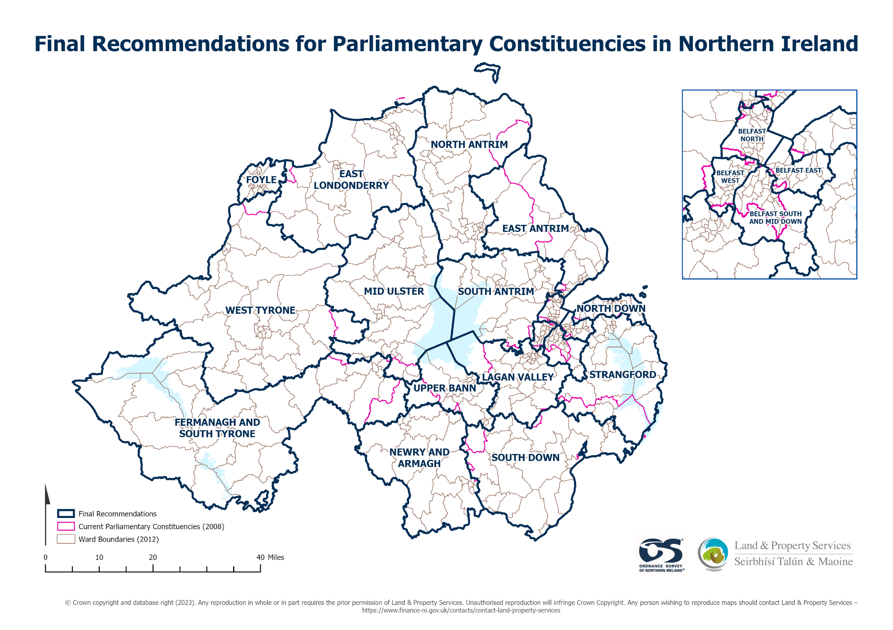

Appendix G

Individual Constituency Maps

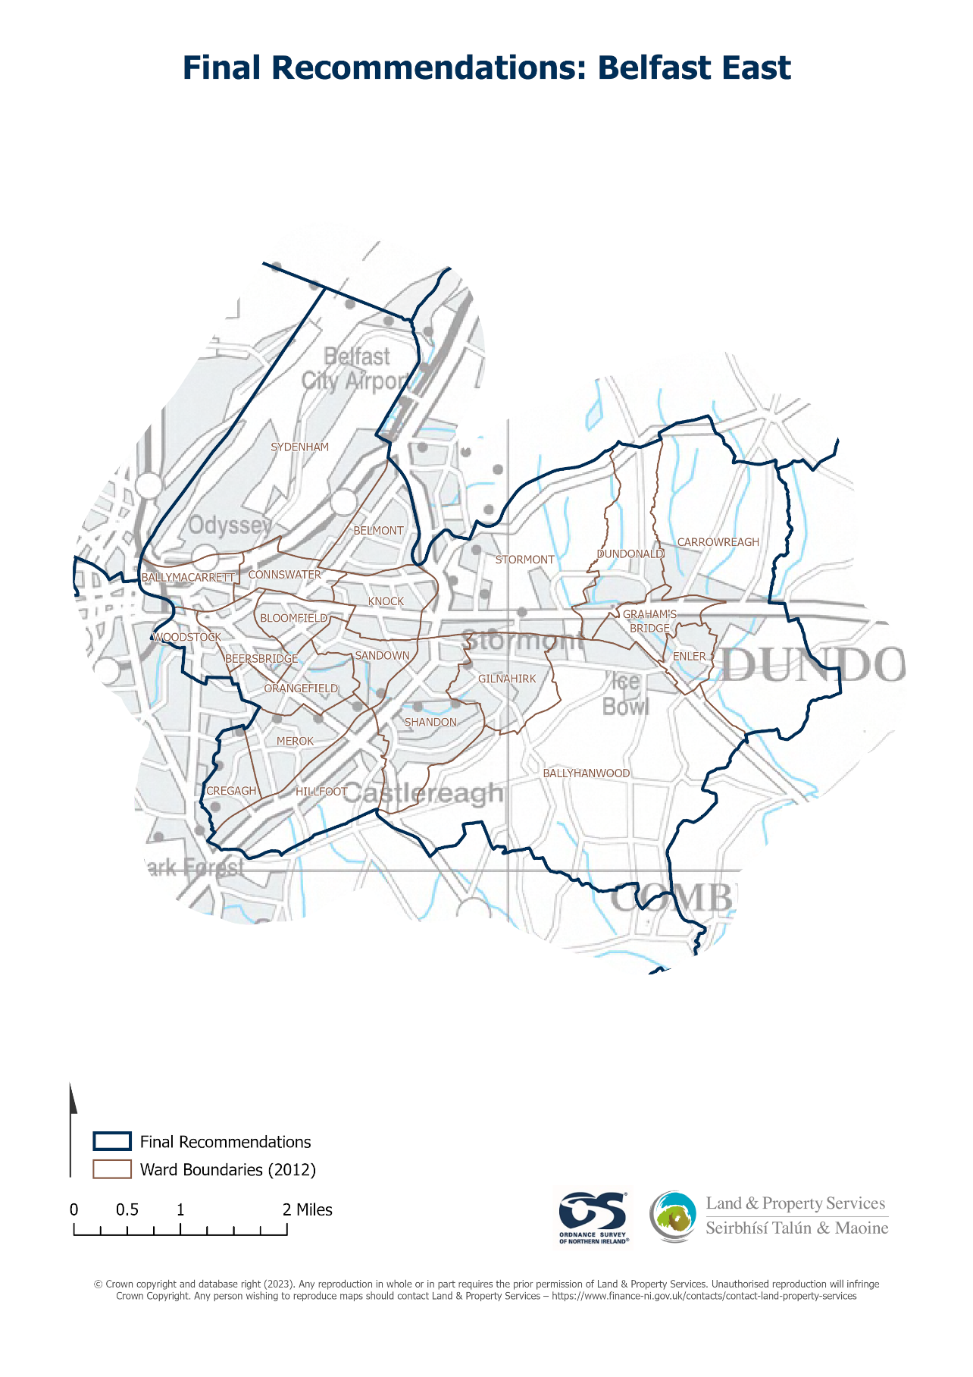

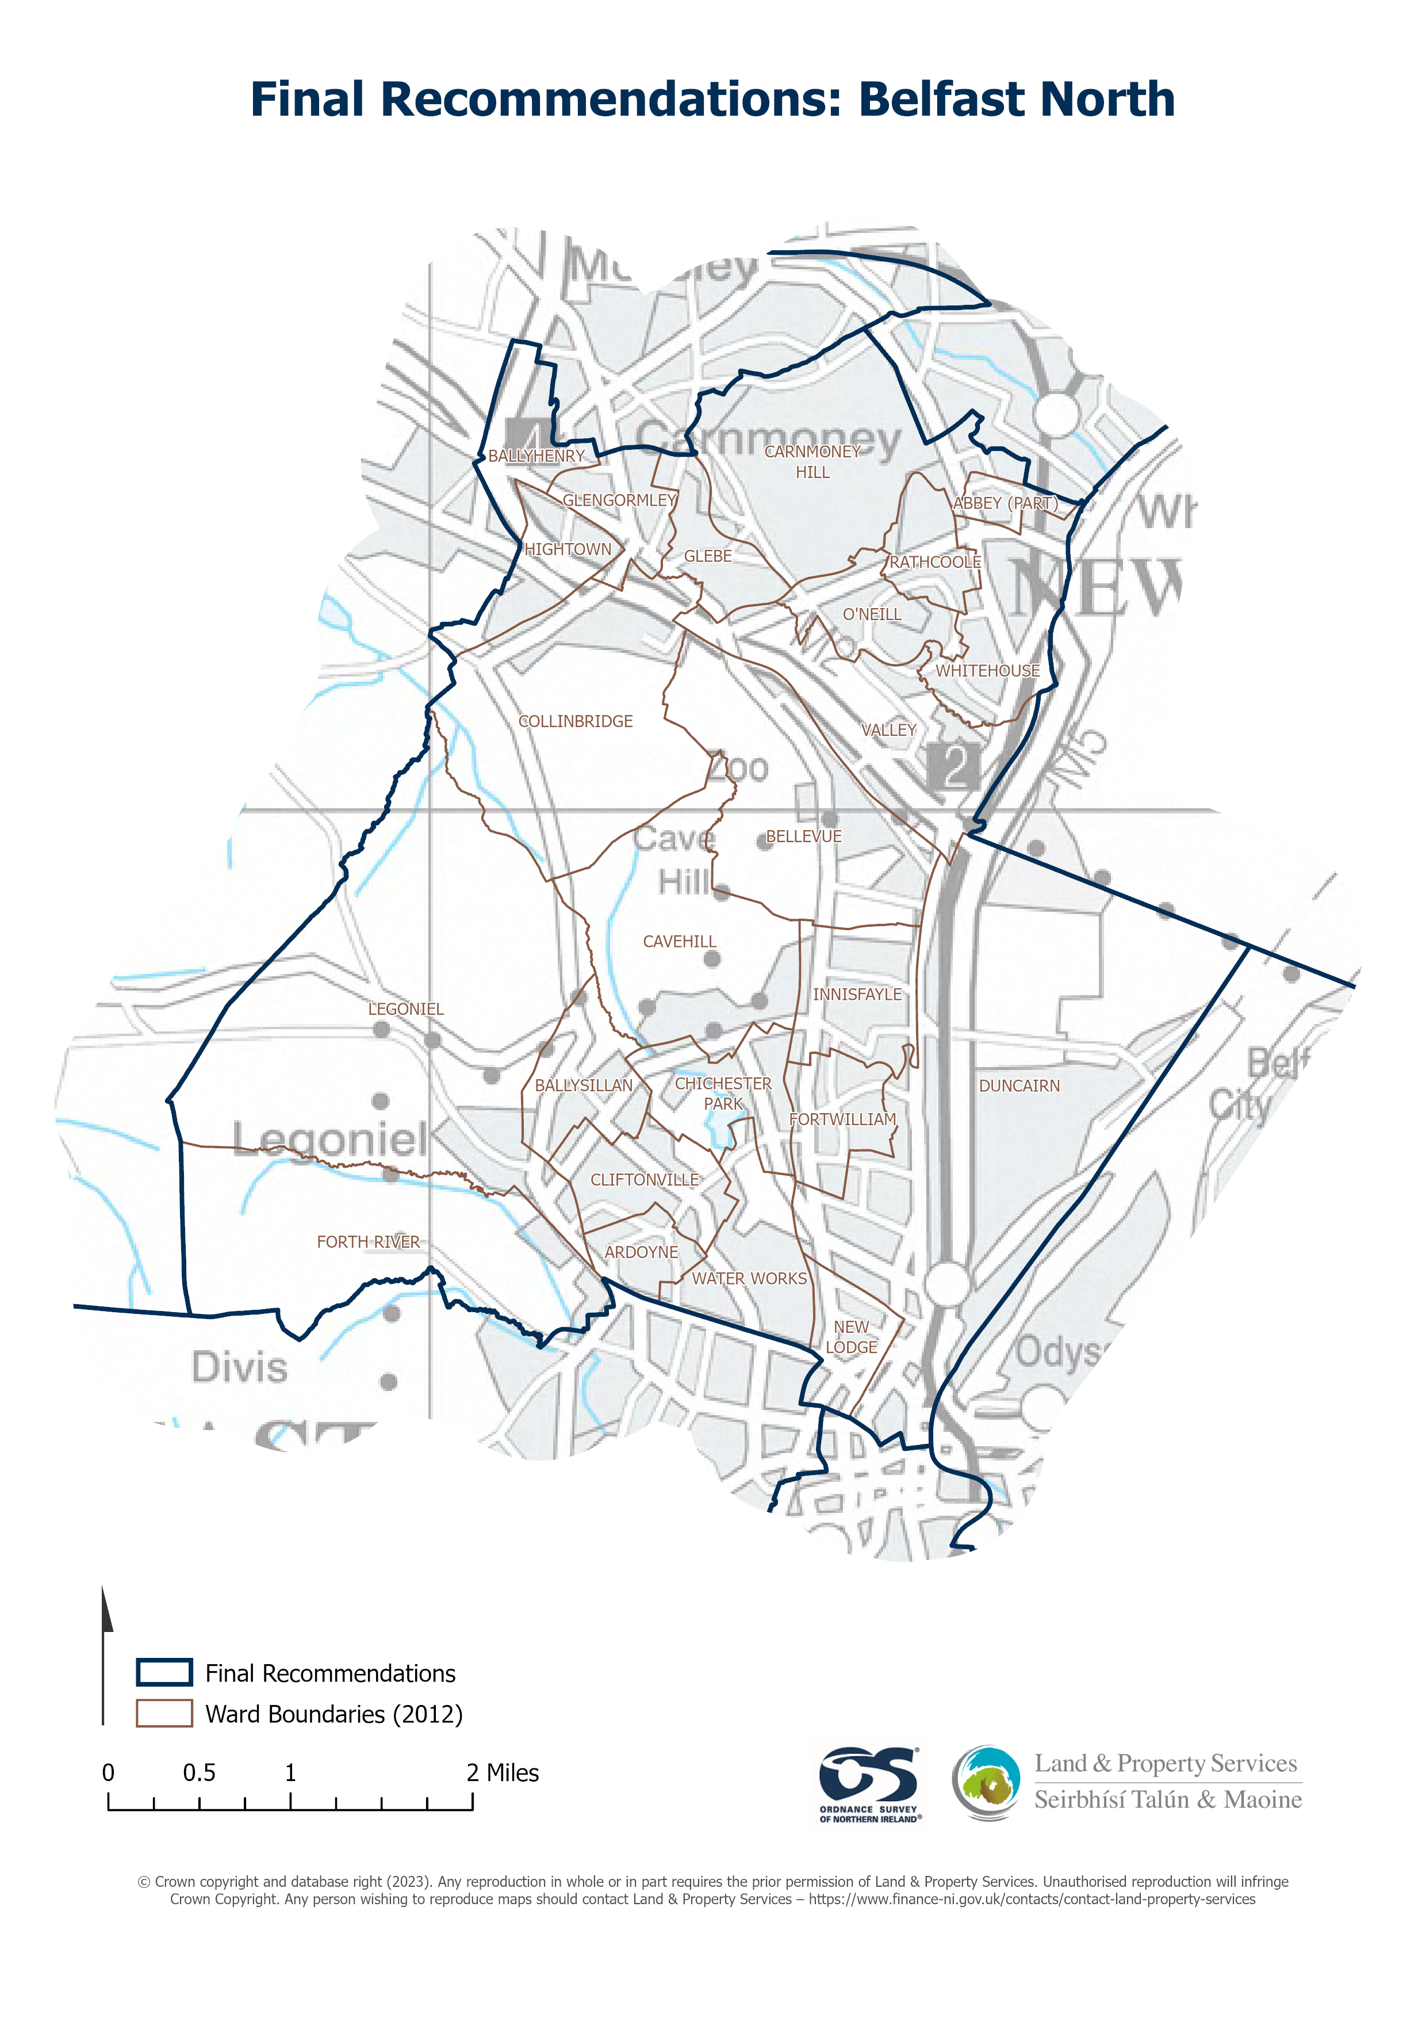

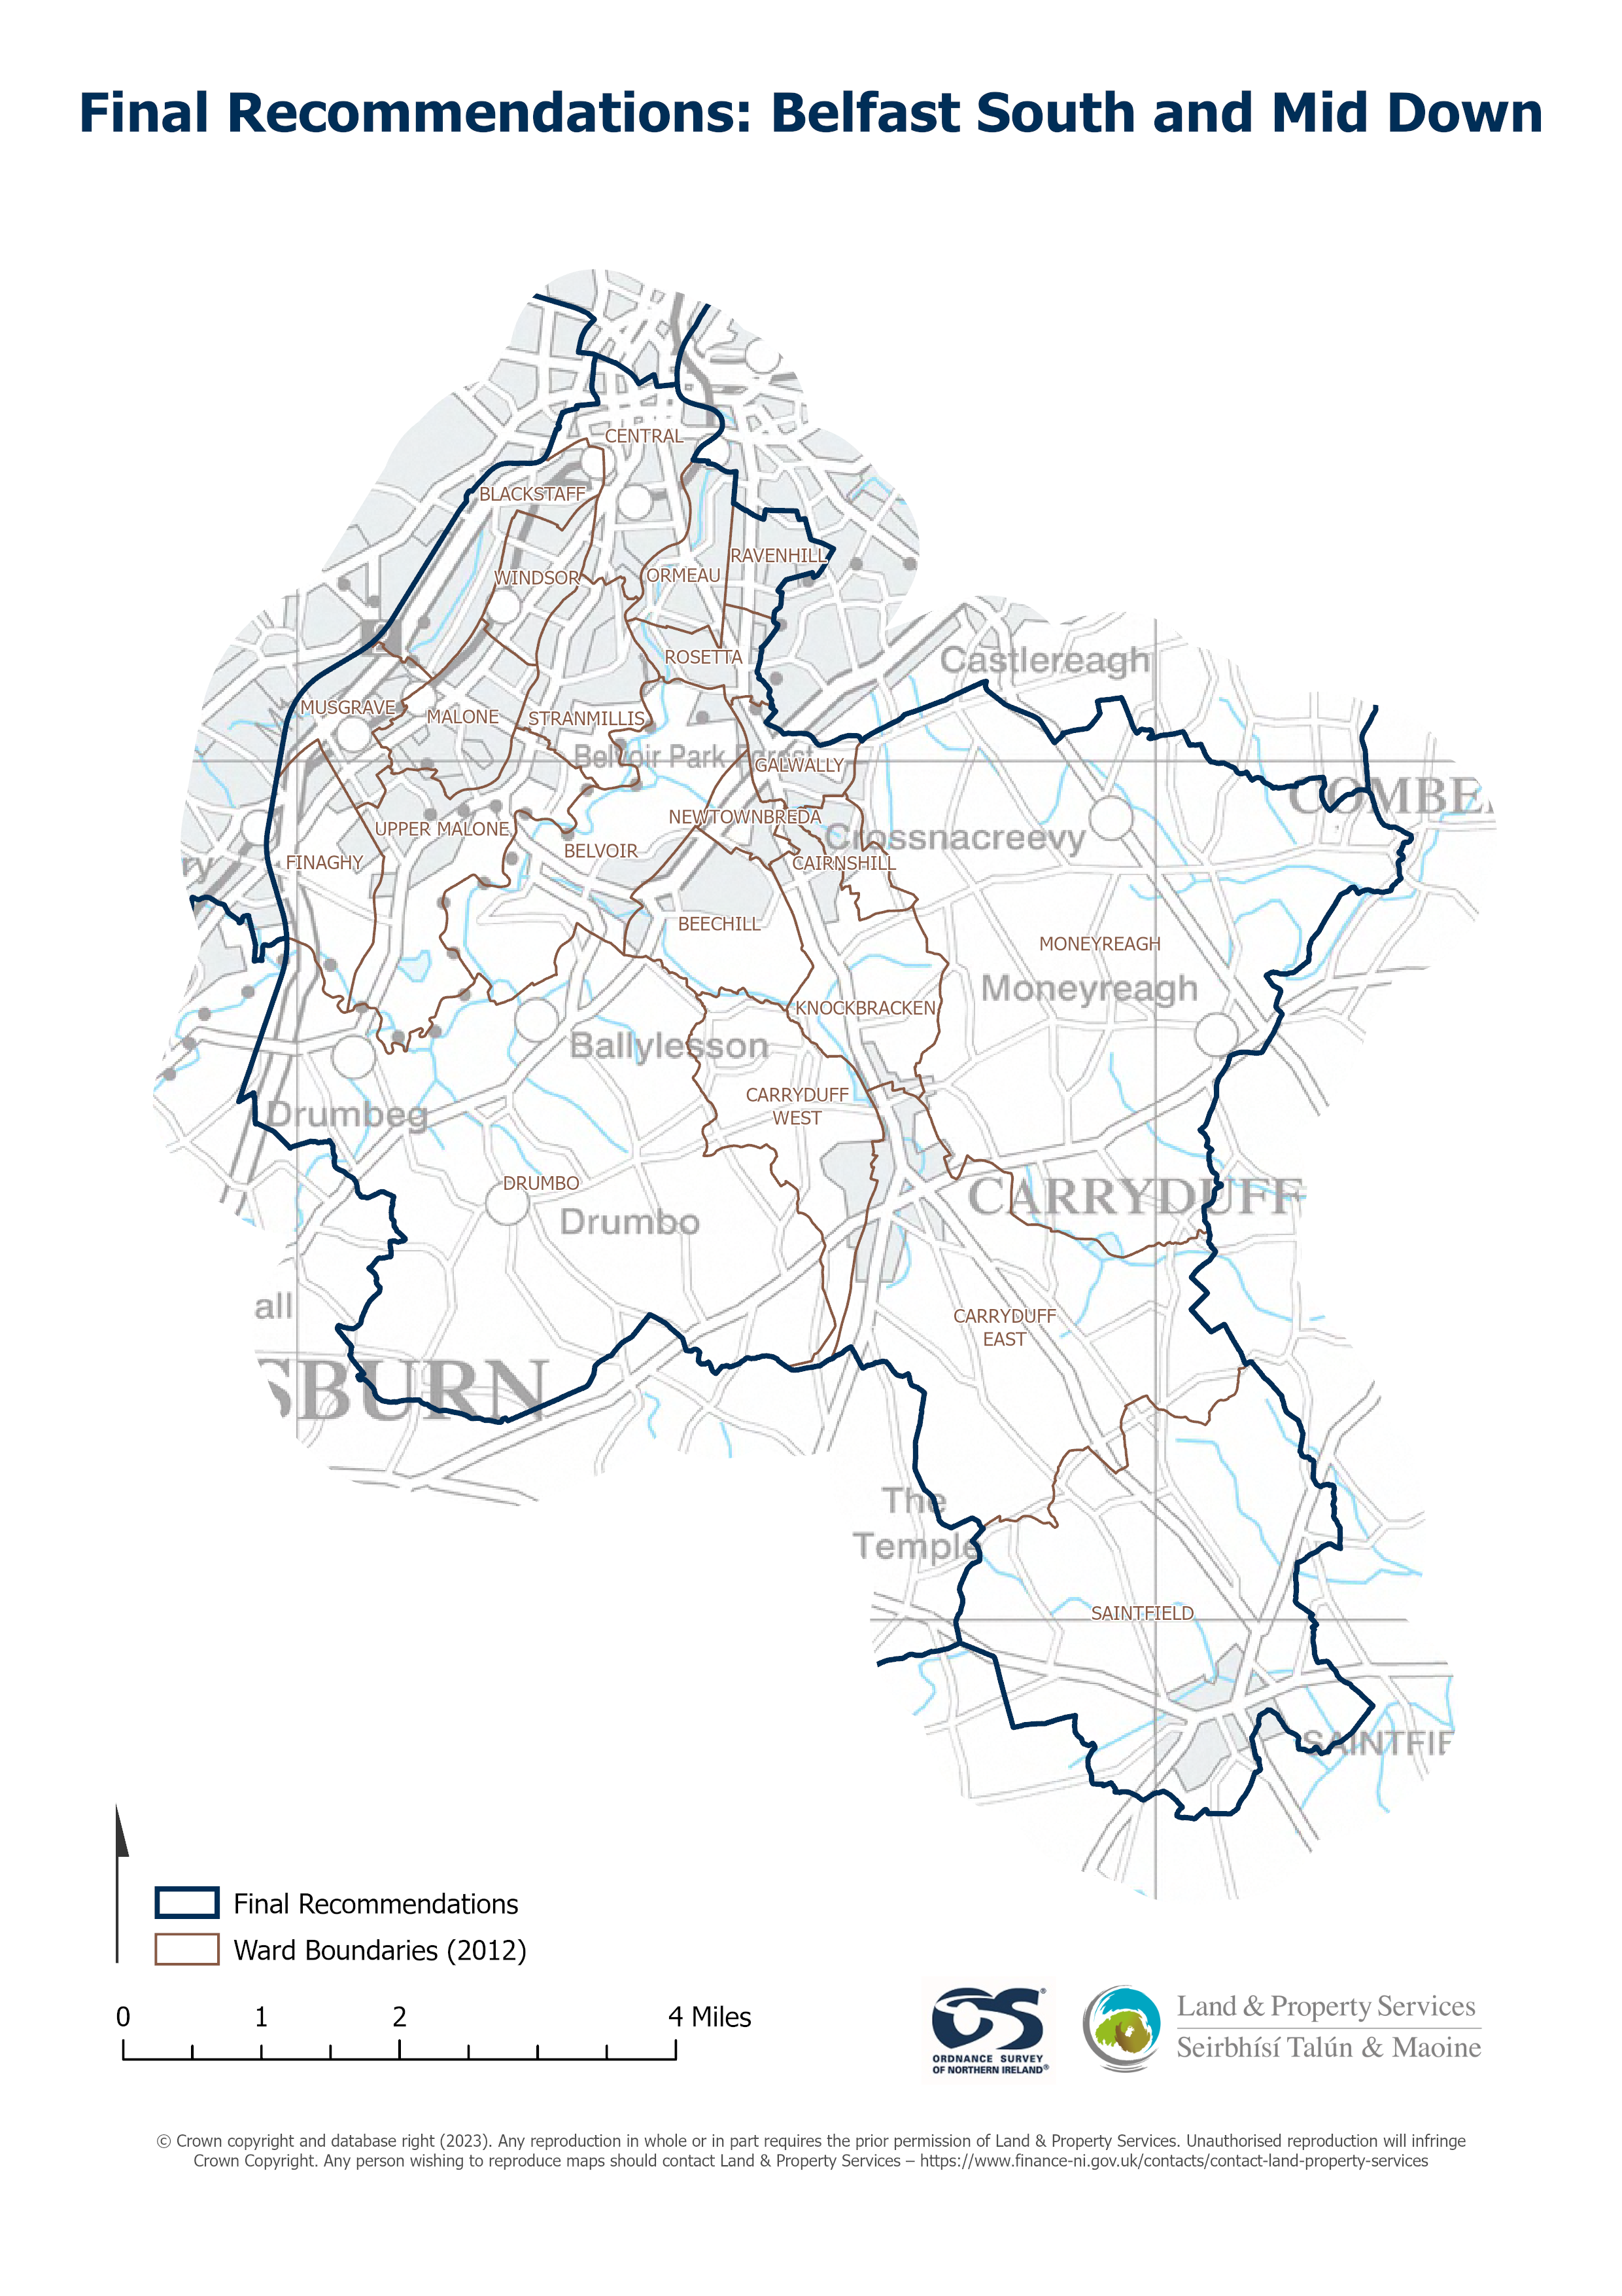

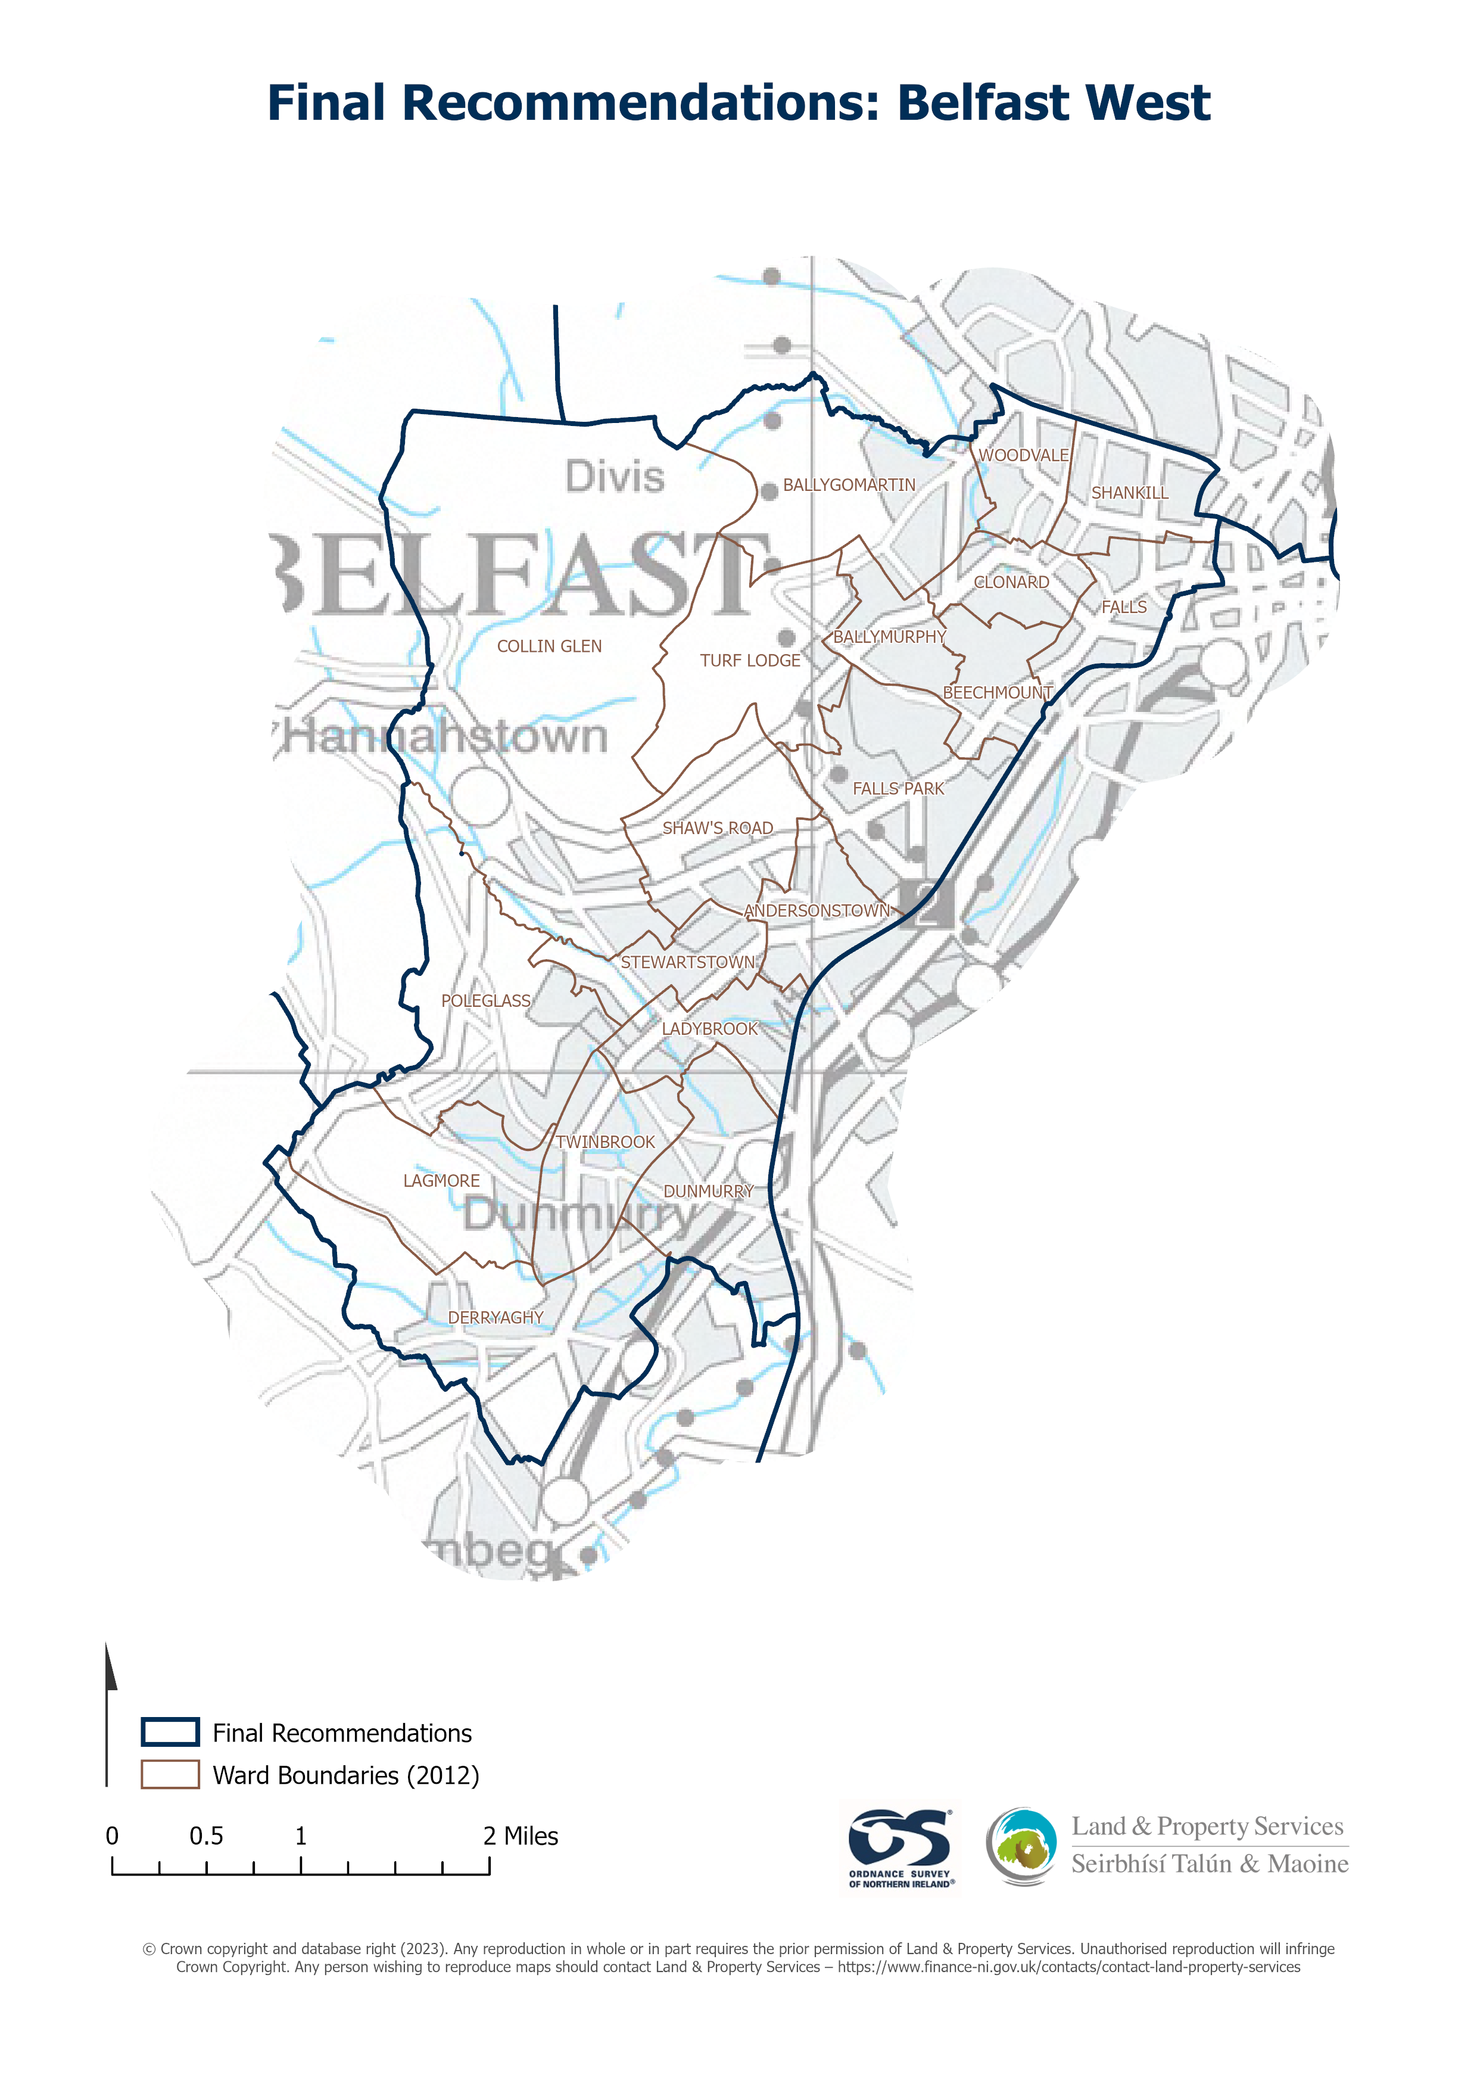

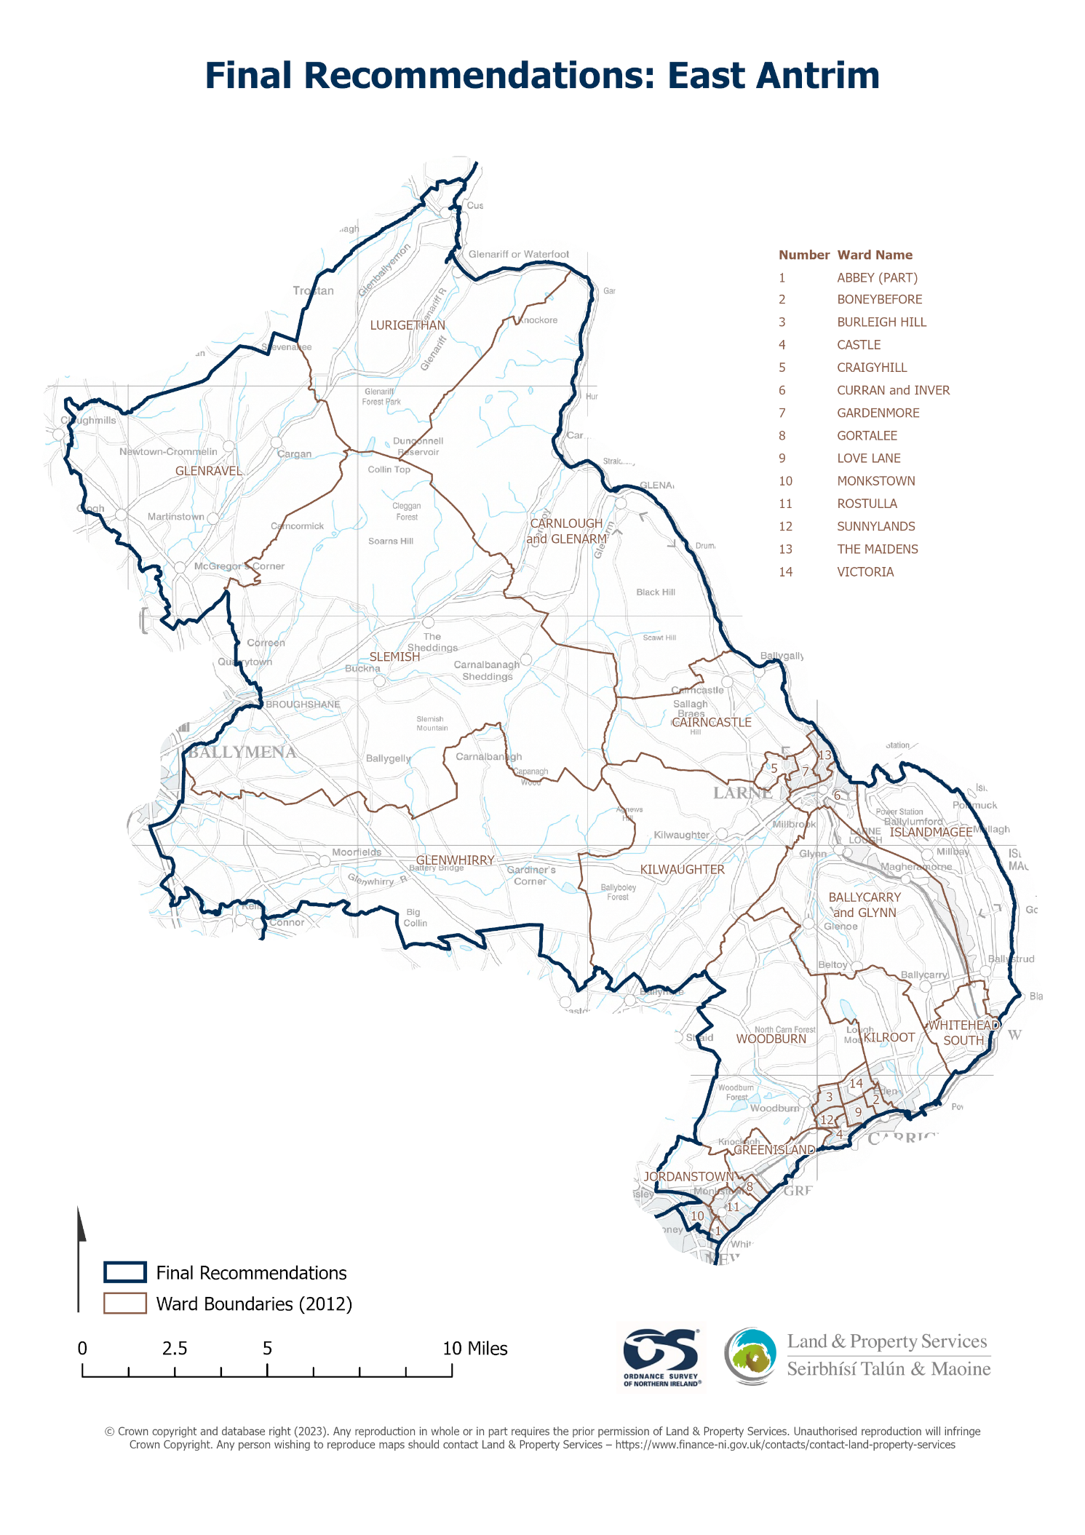

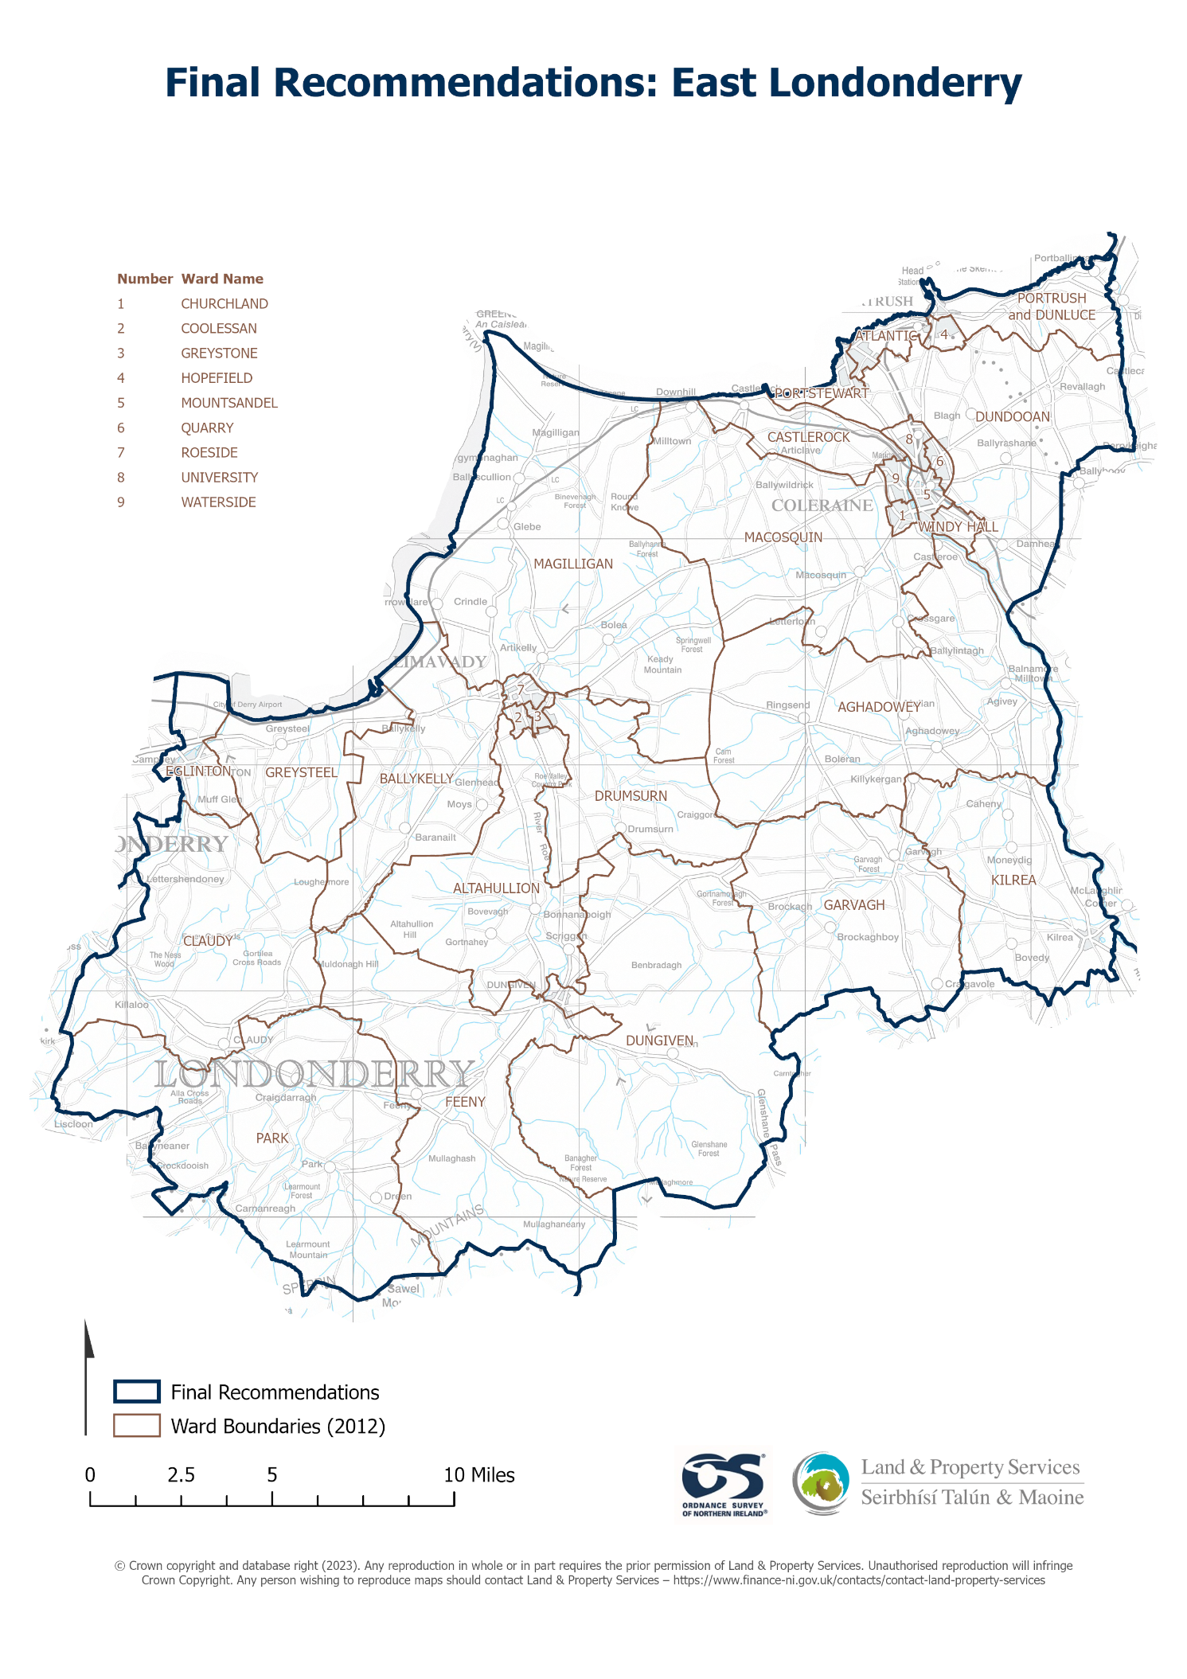

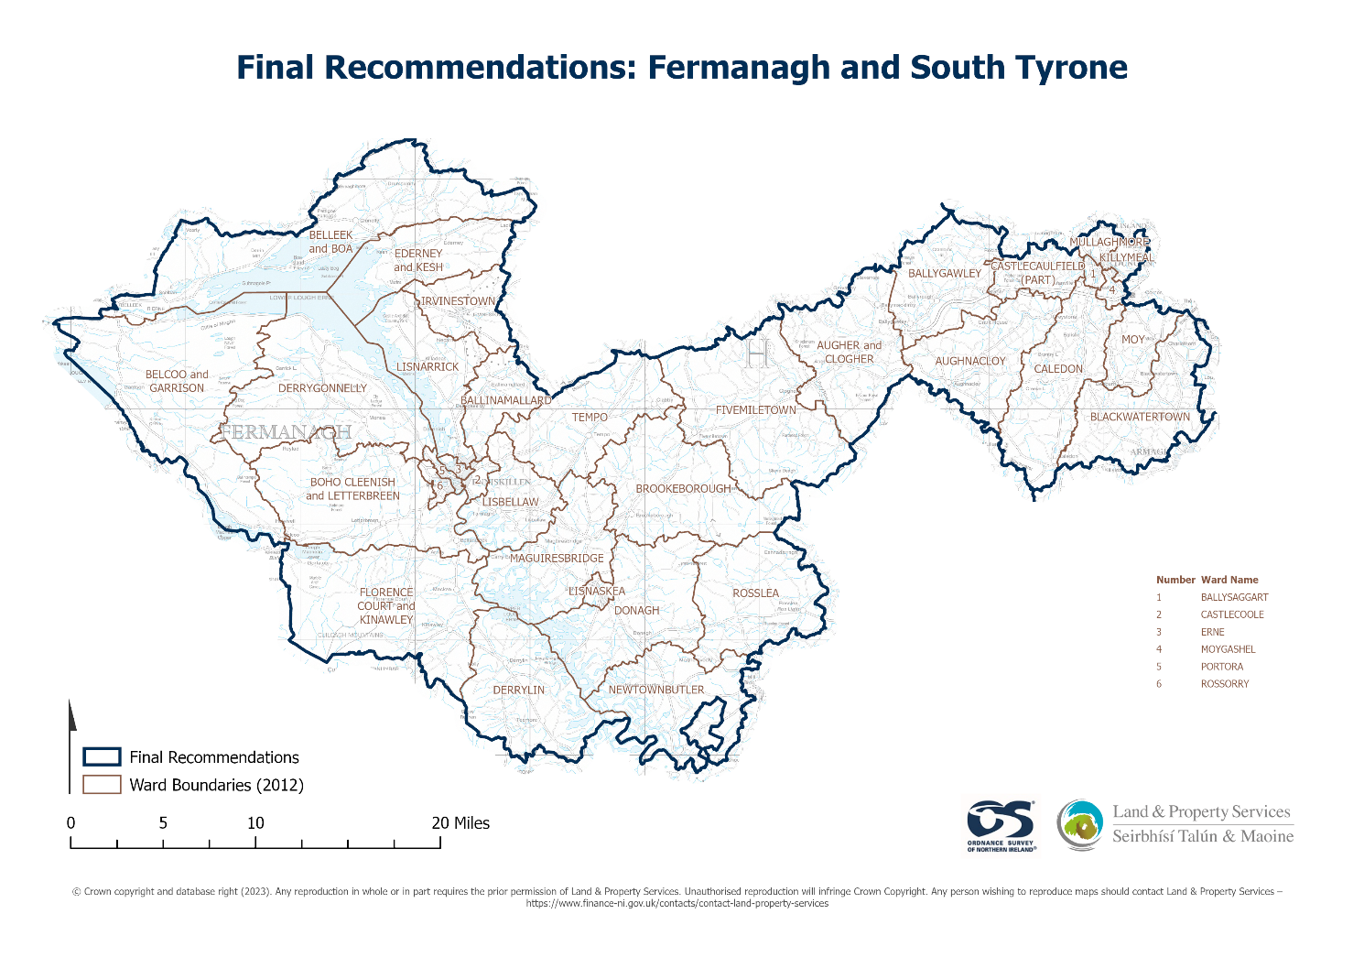

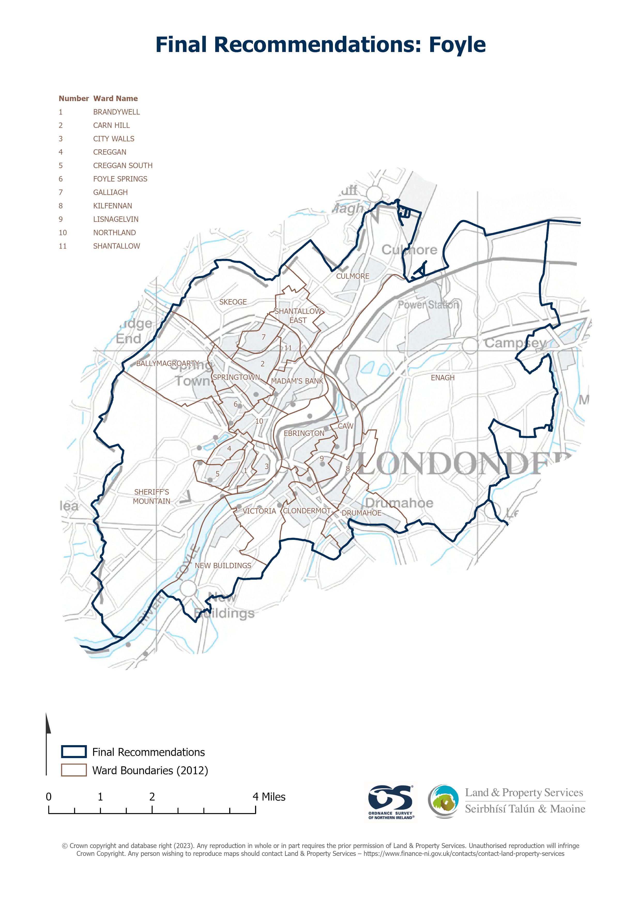

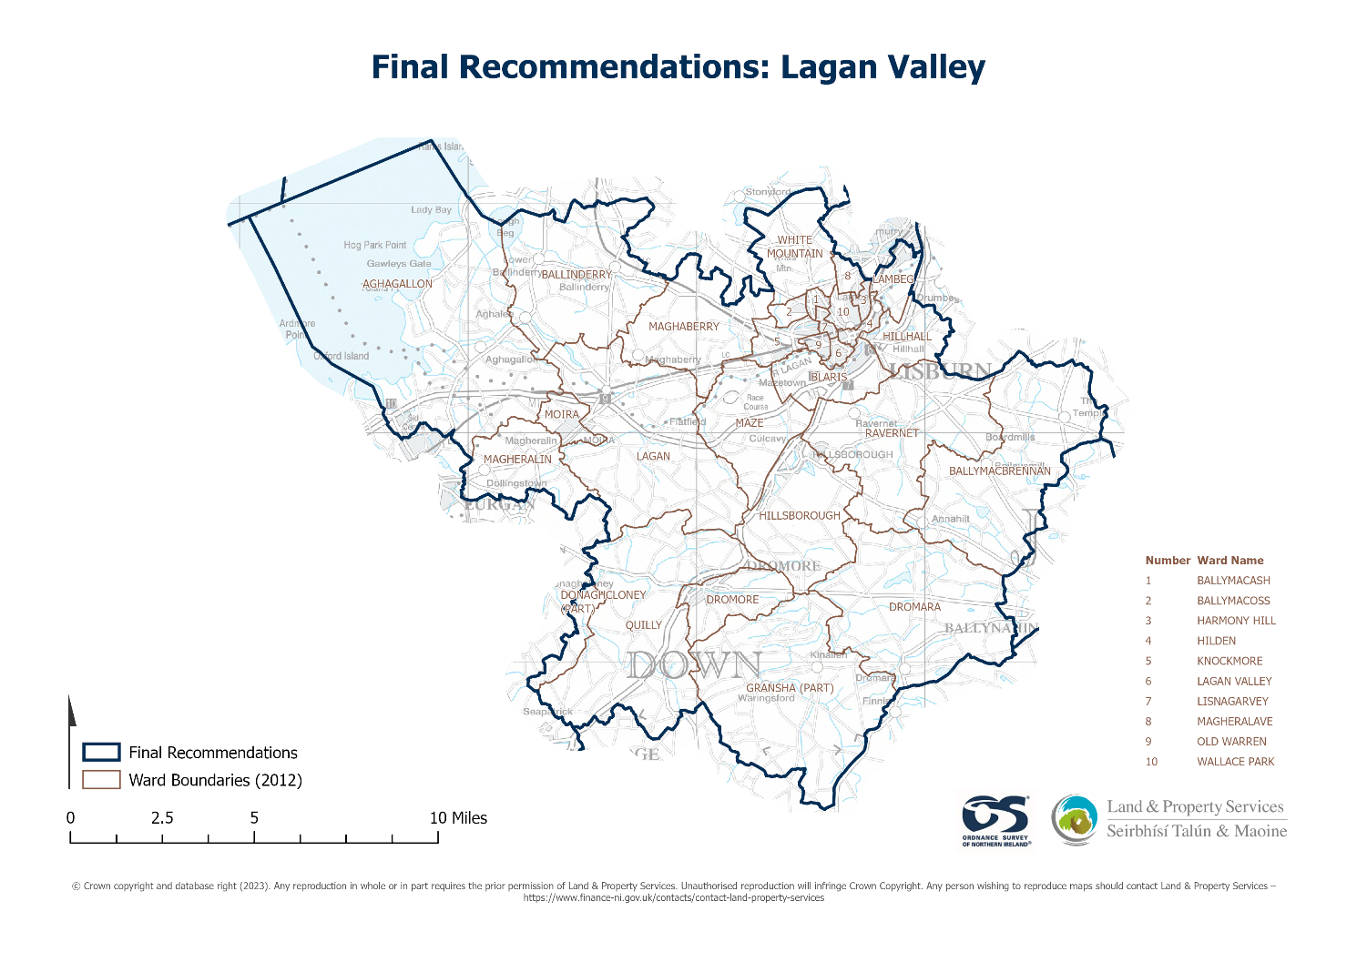

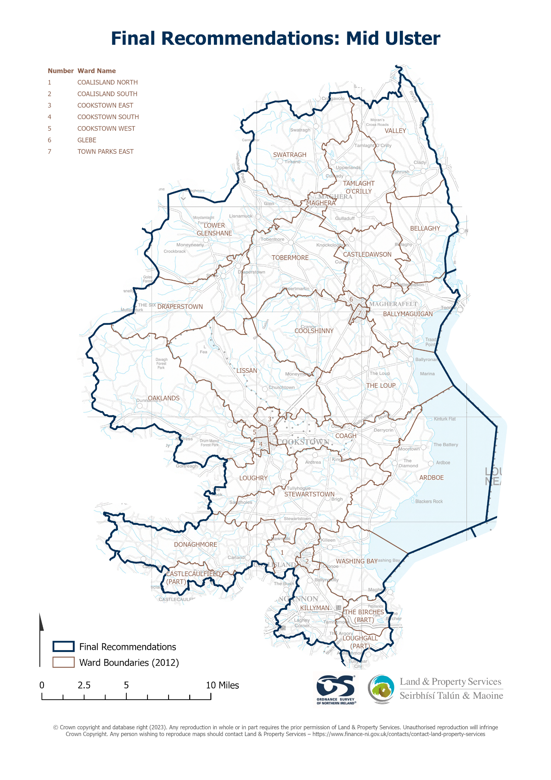

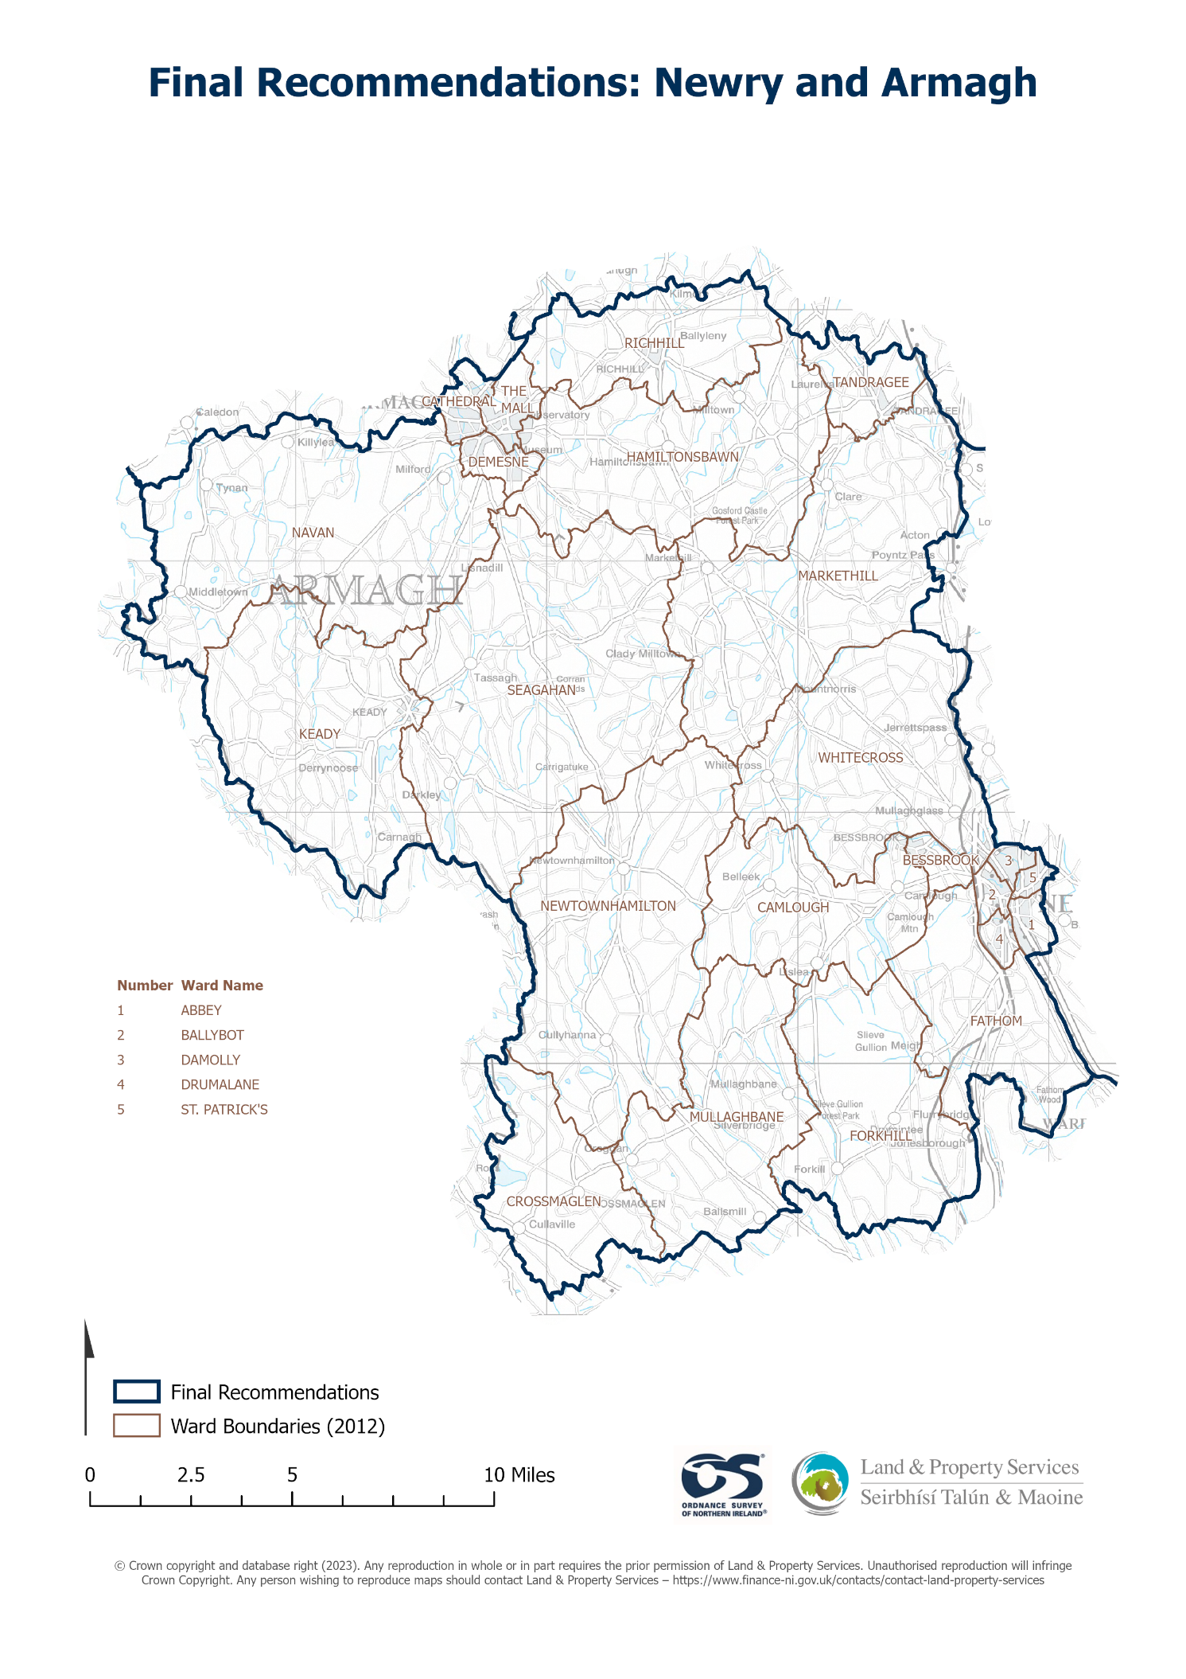

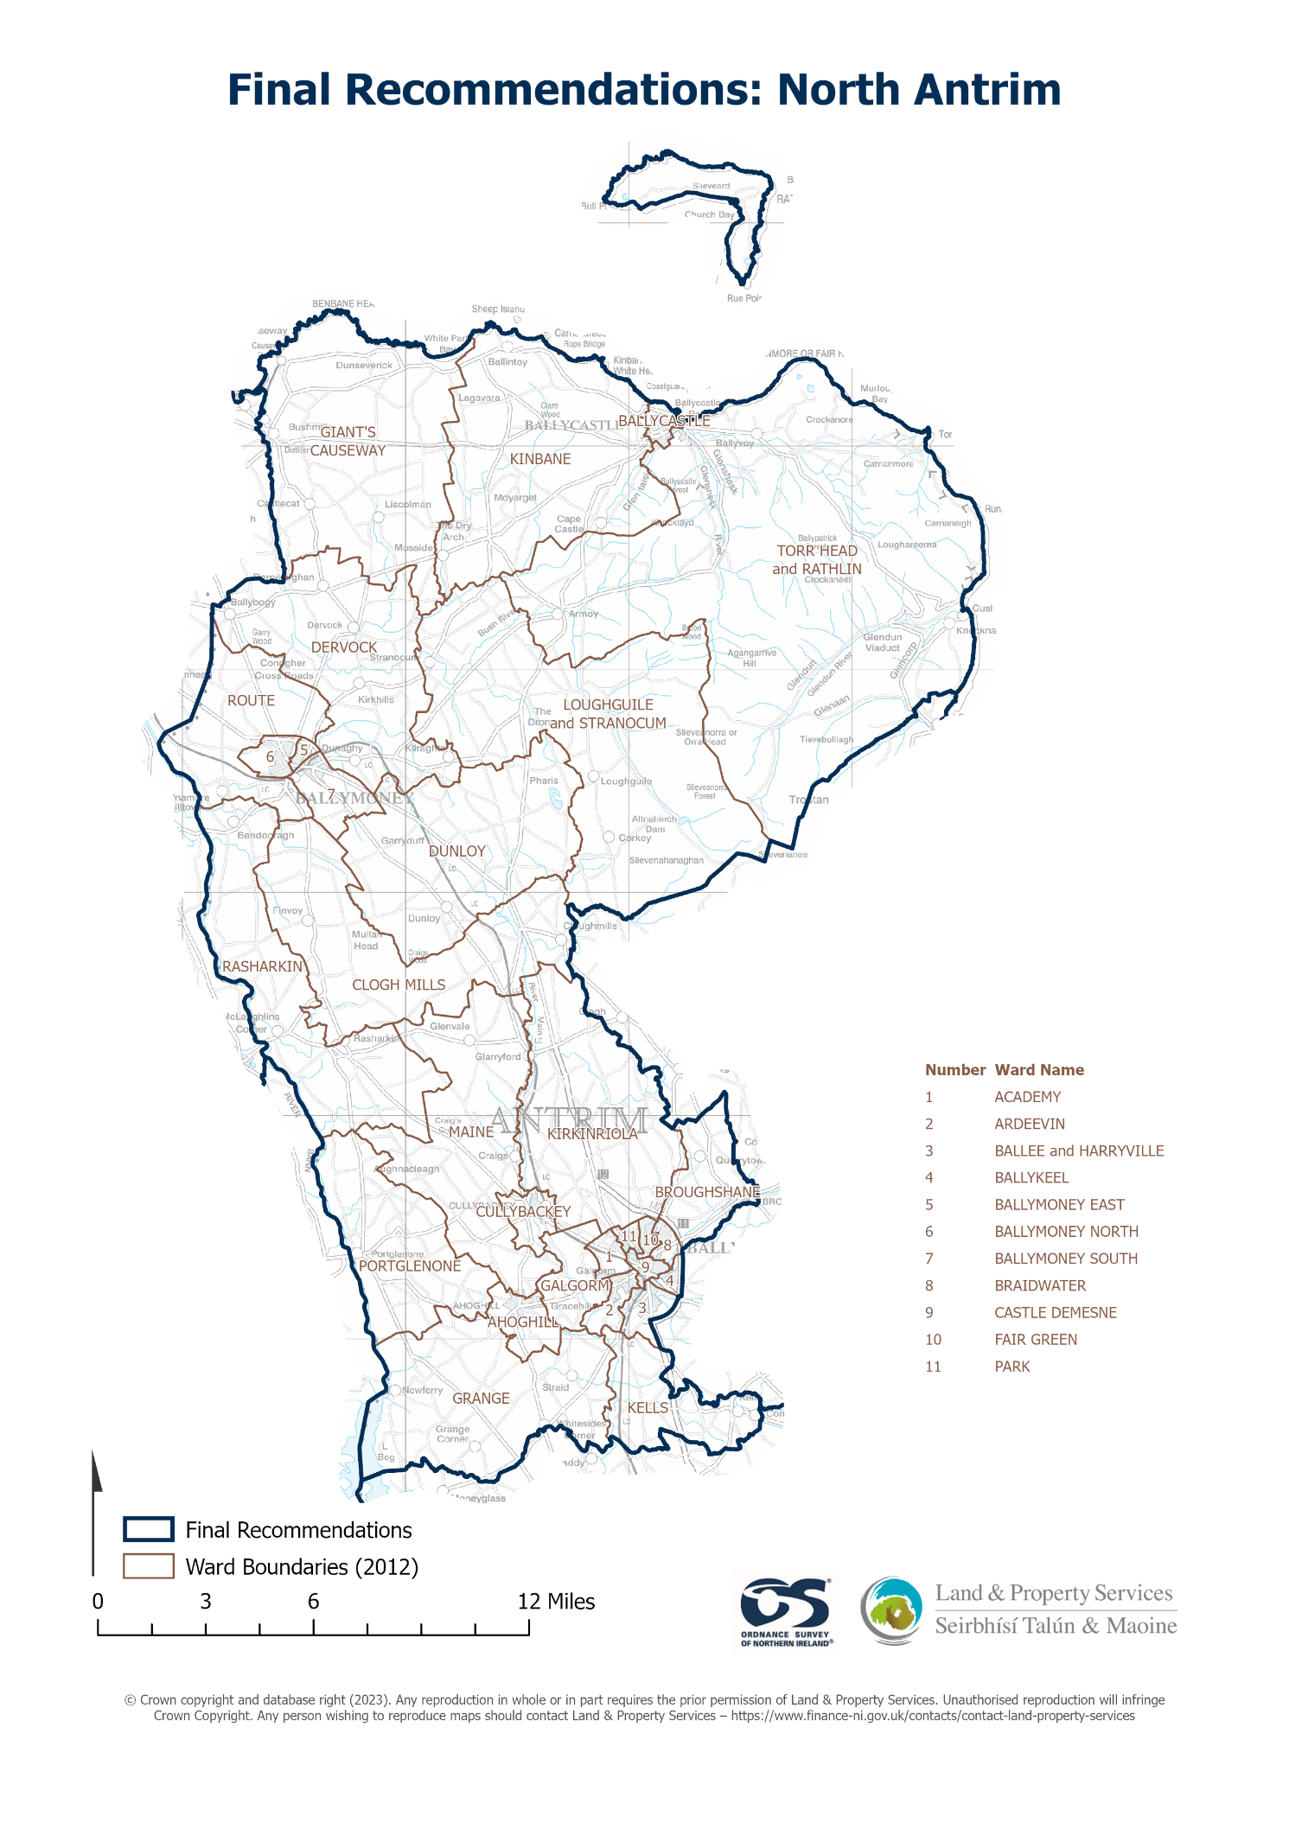

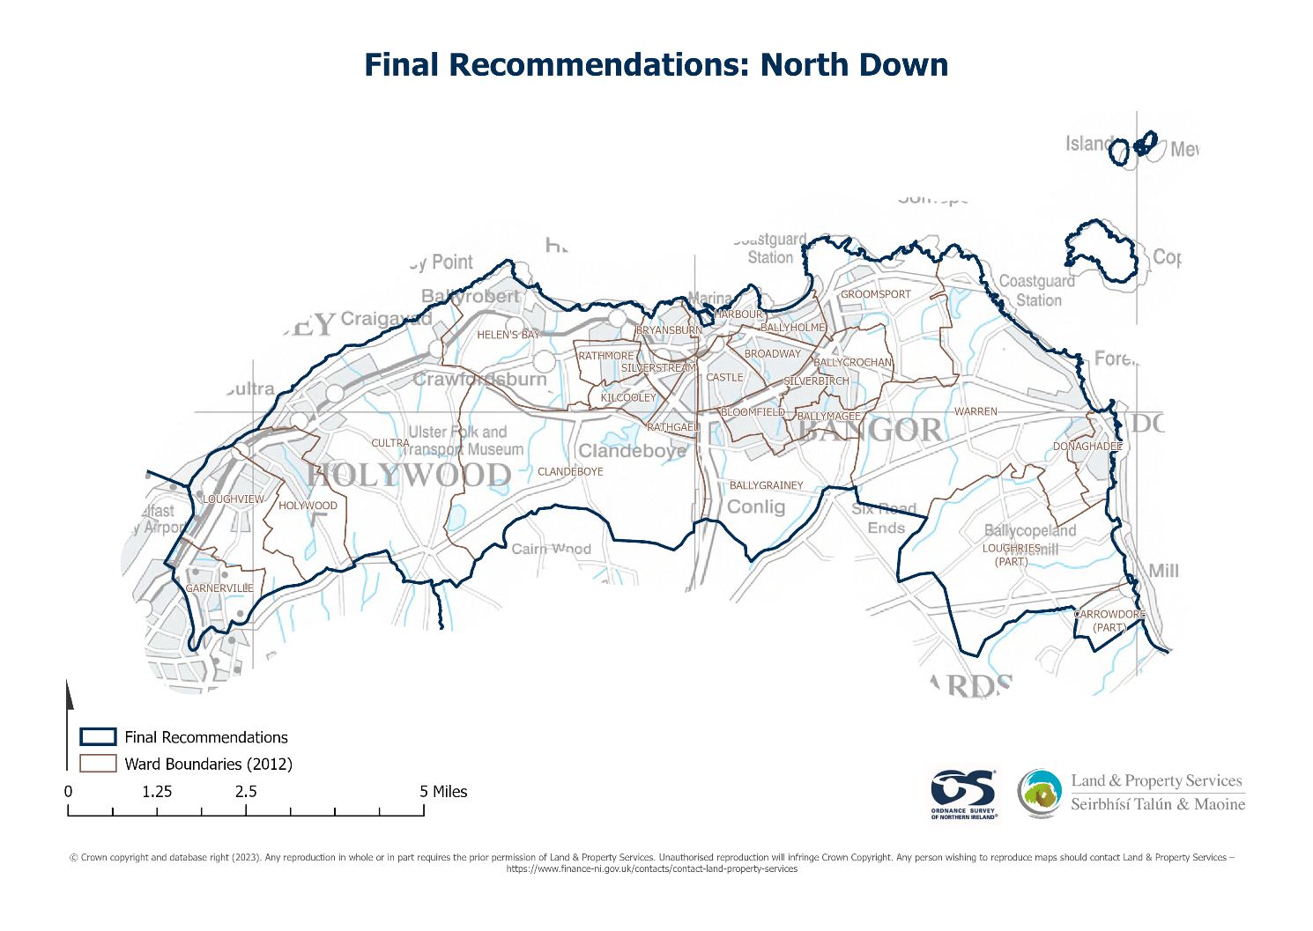

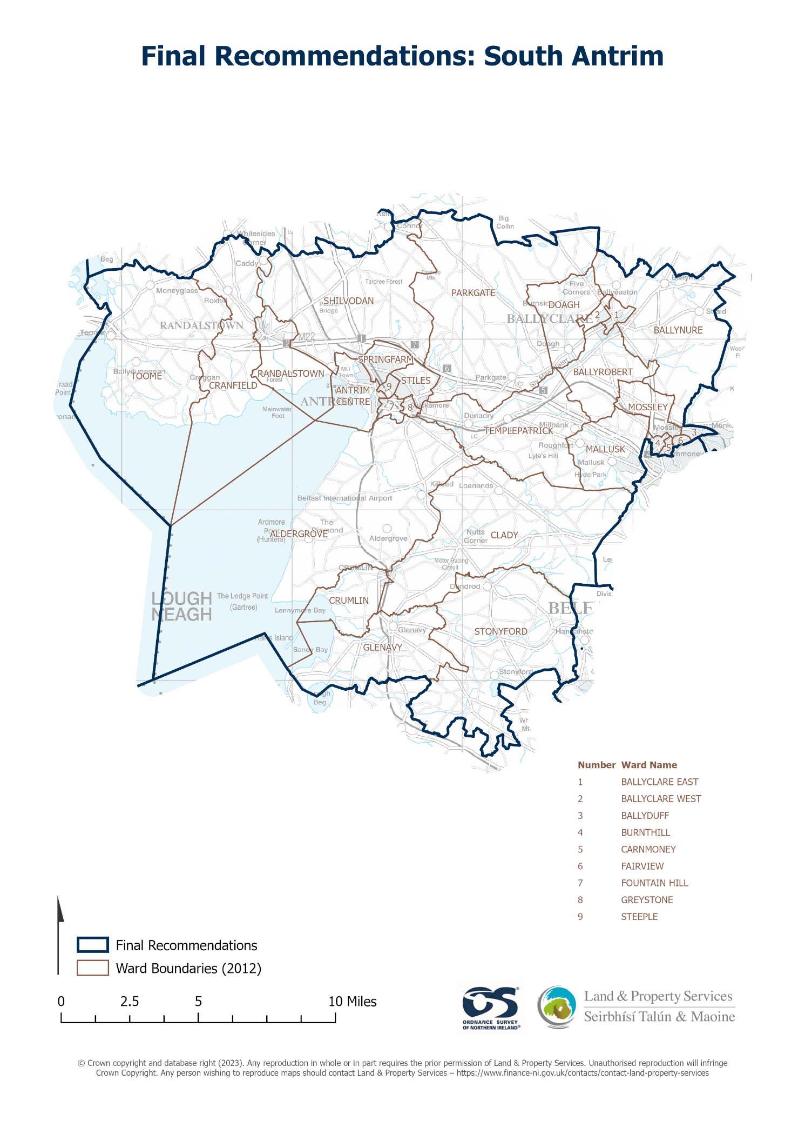

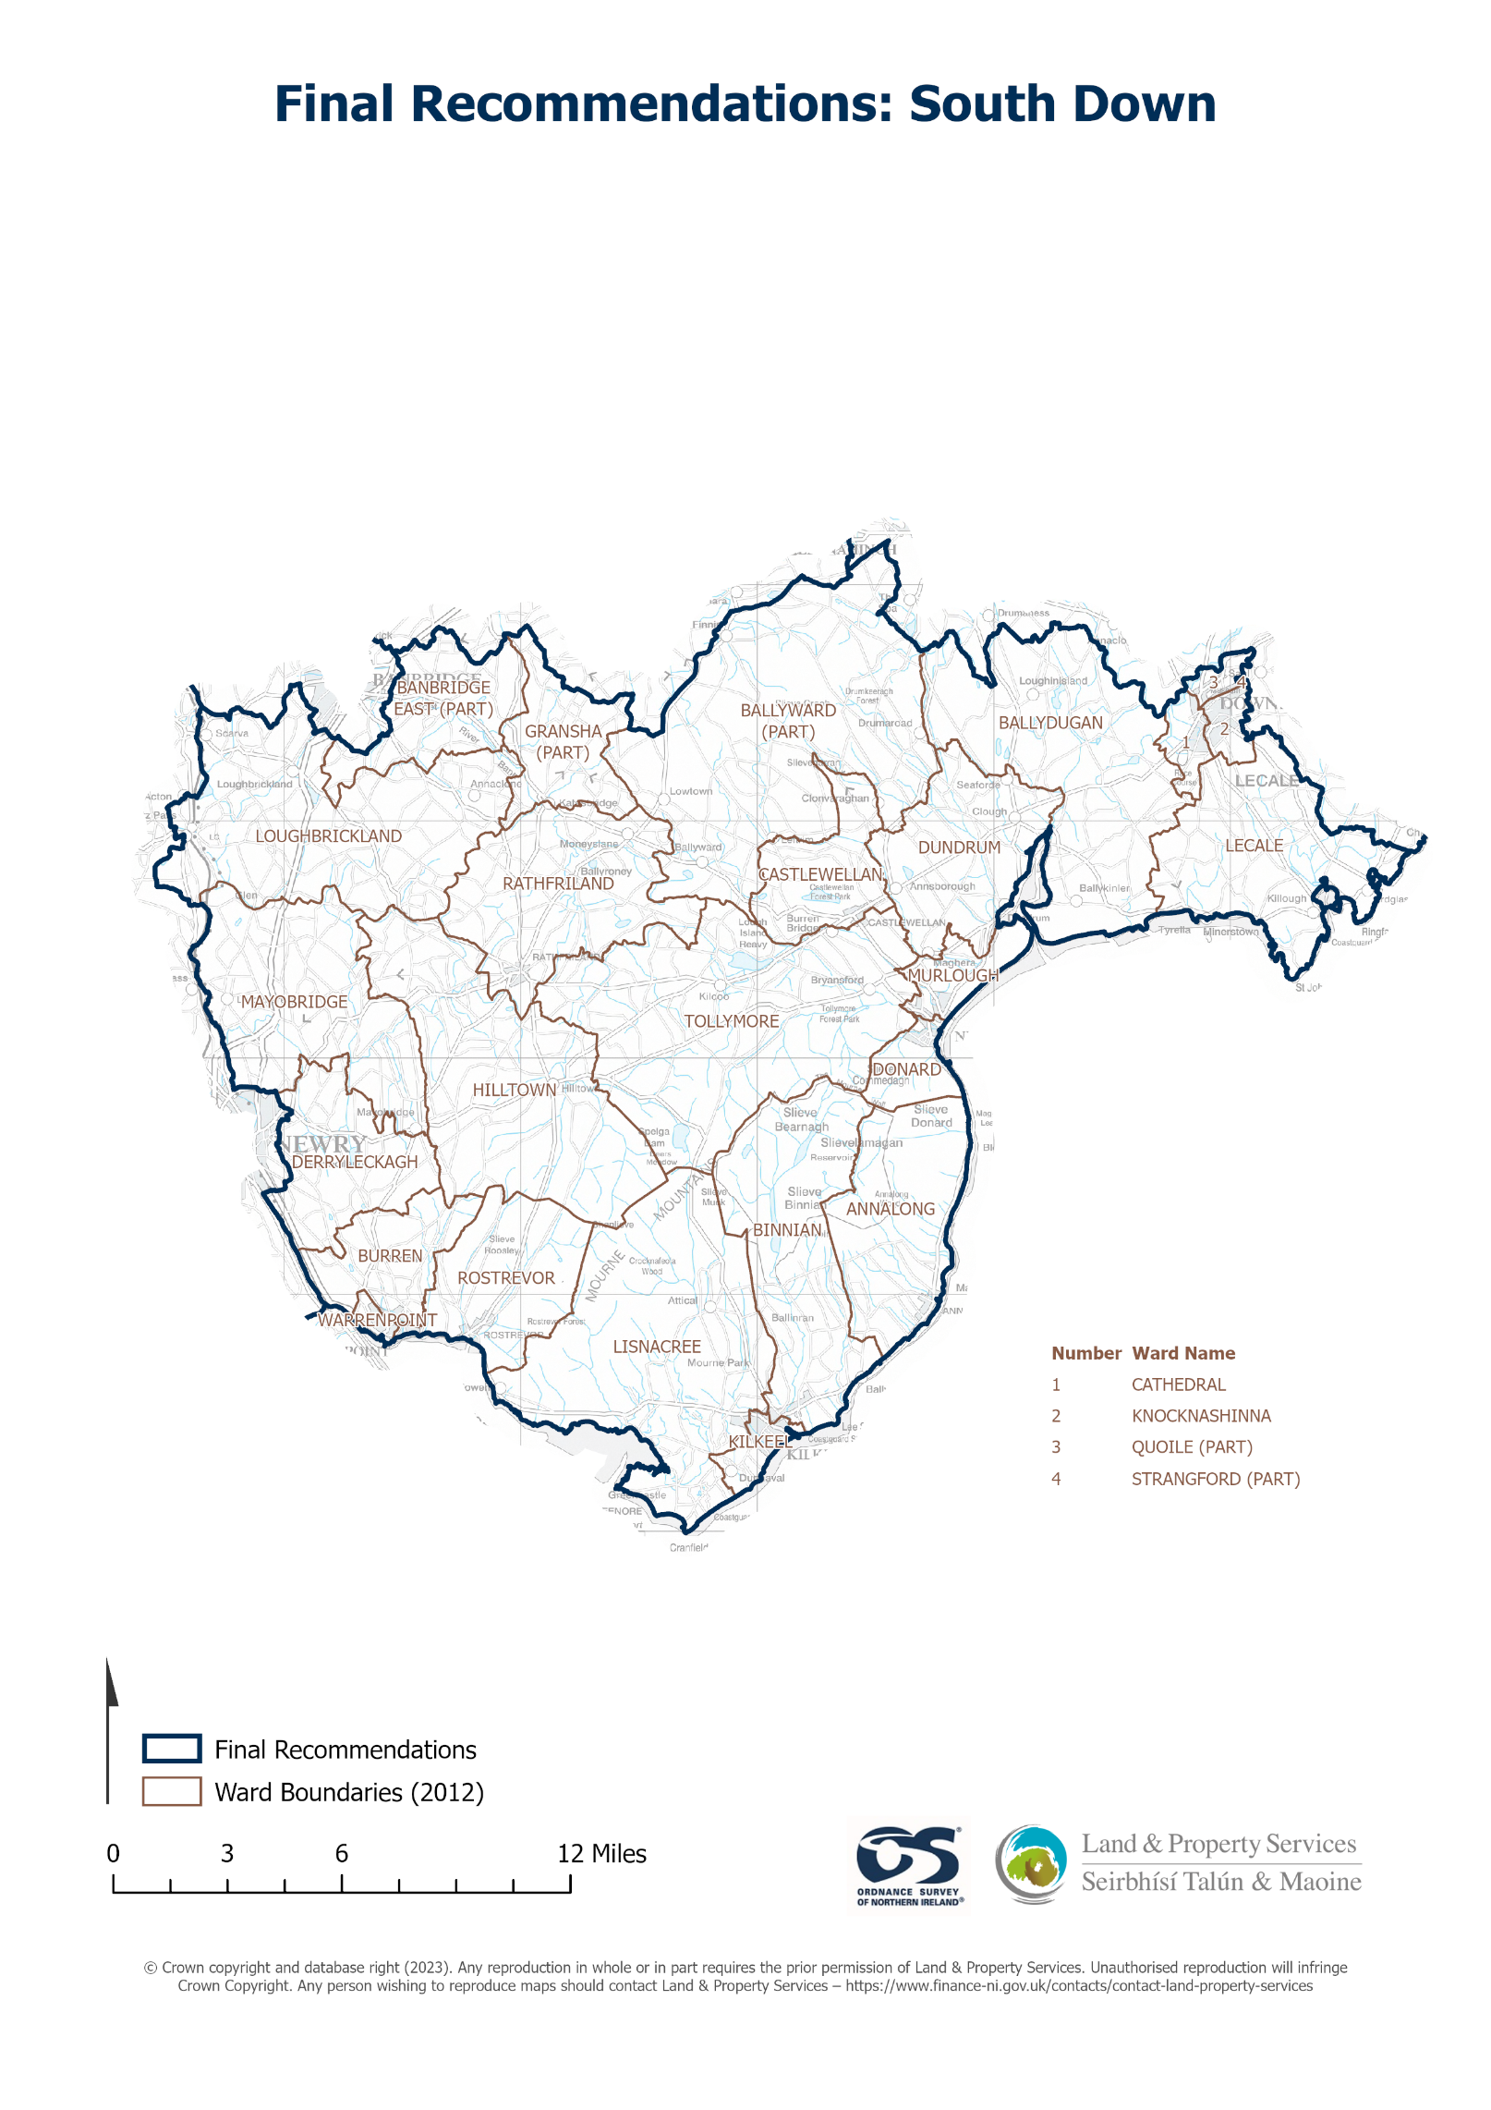

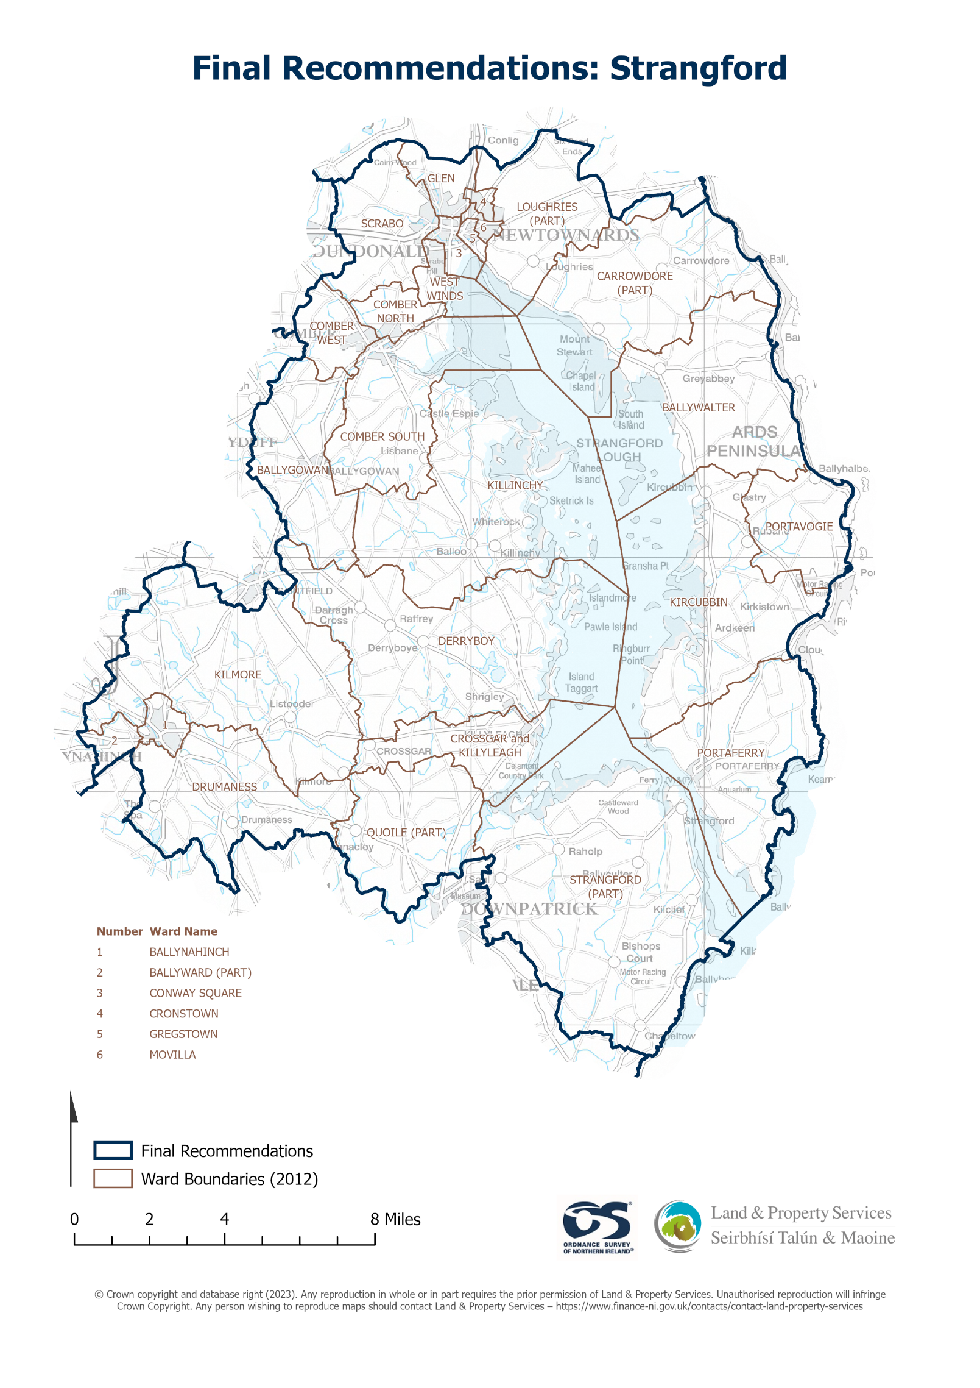

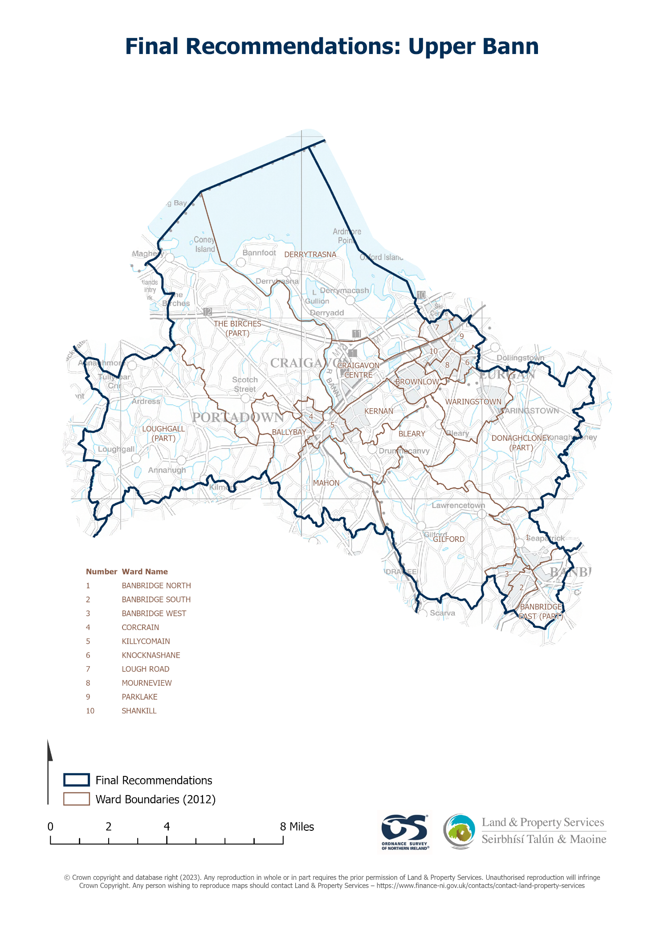

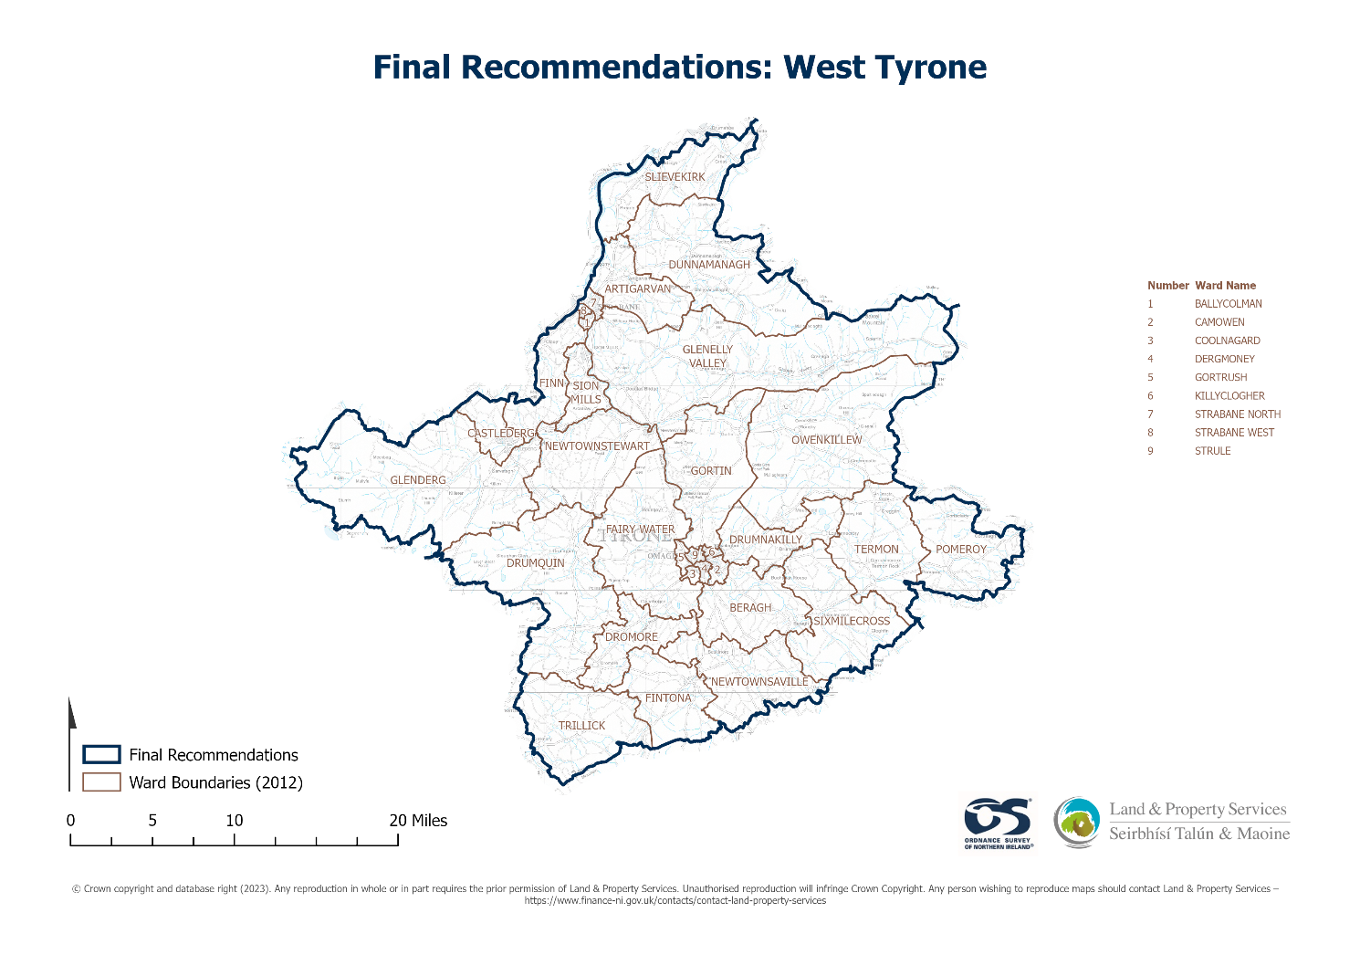

978-1-5286-4069-5
E02901006 06/23

