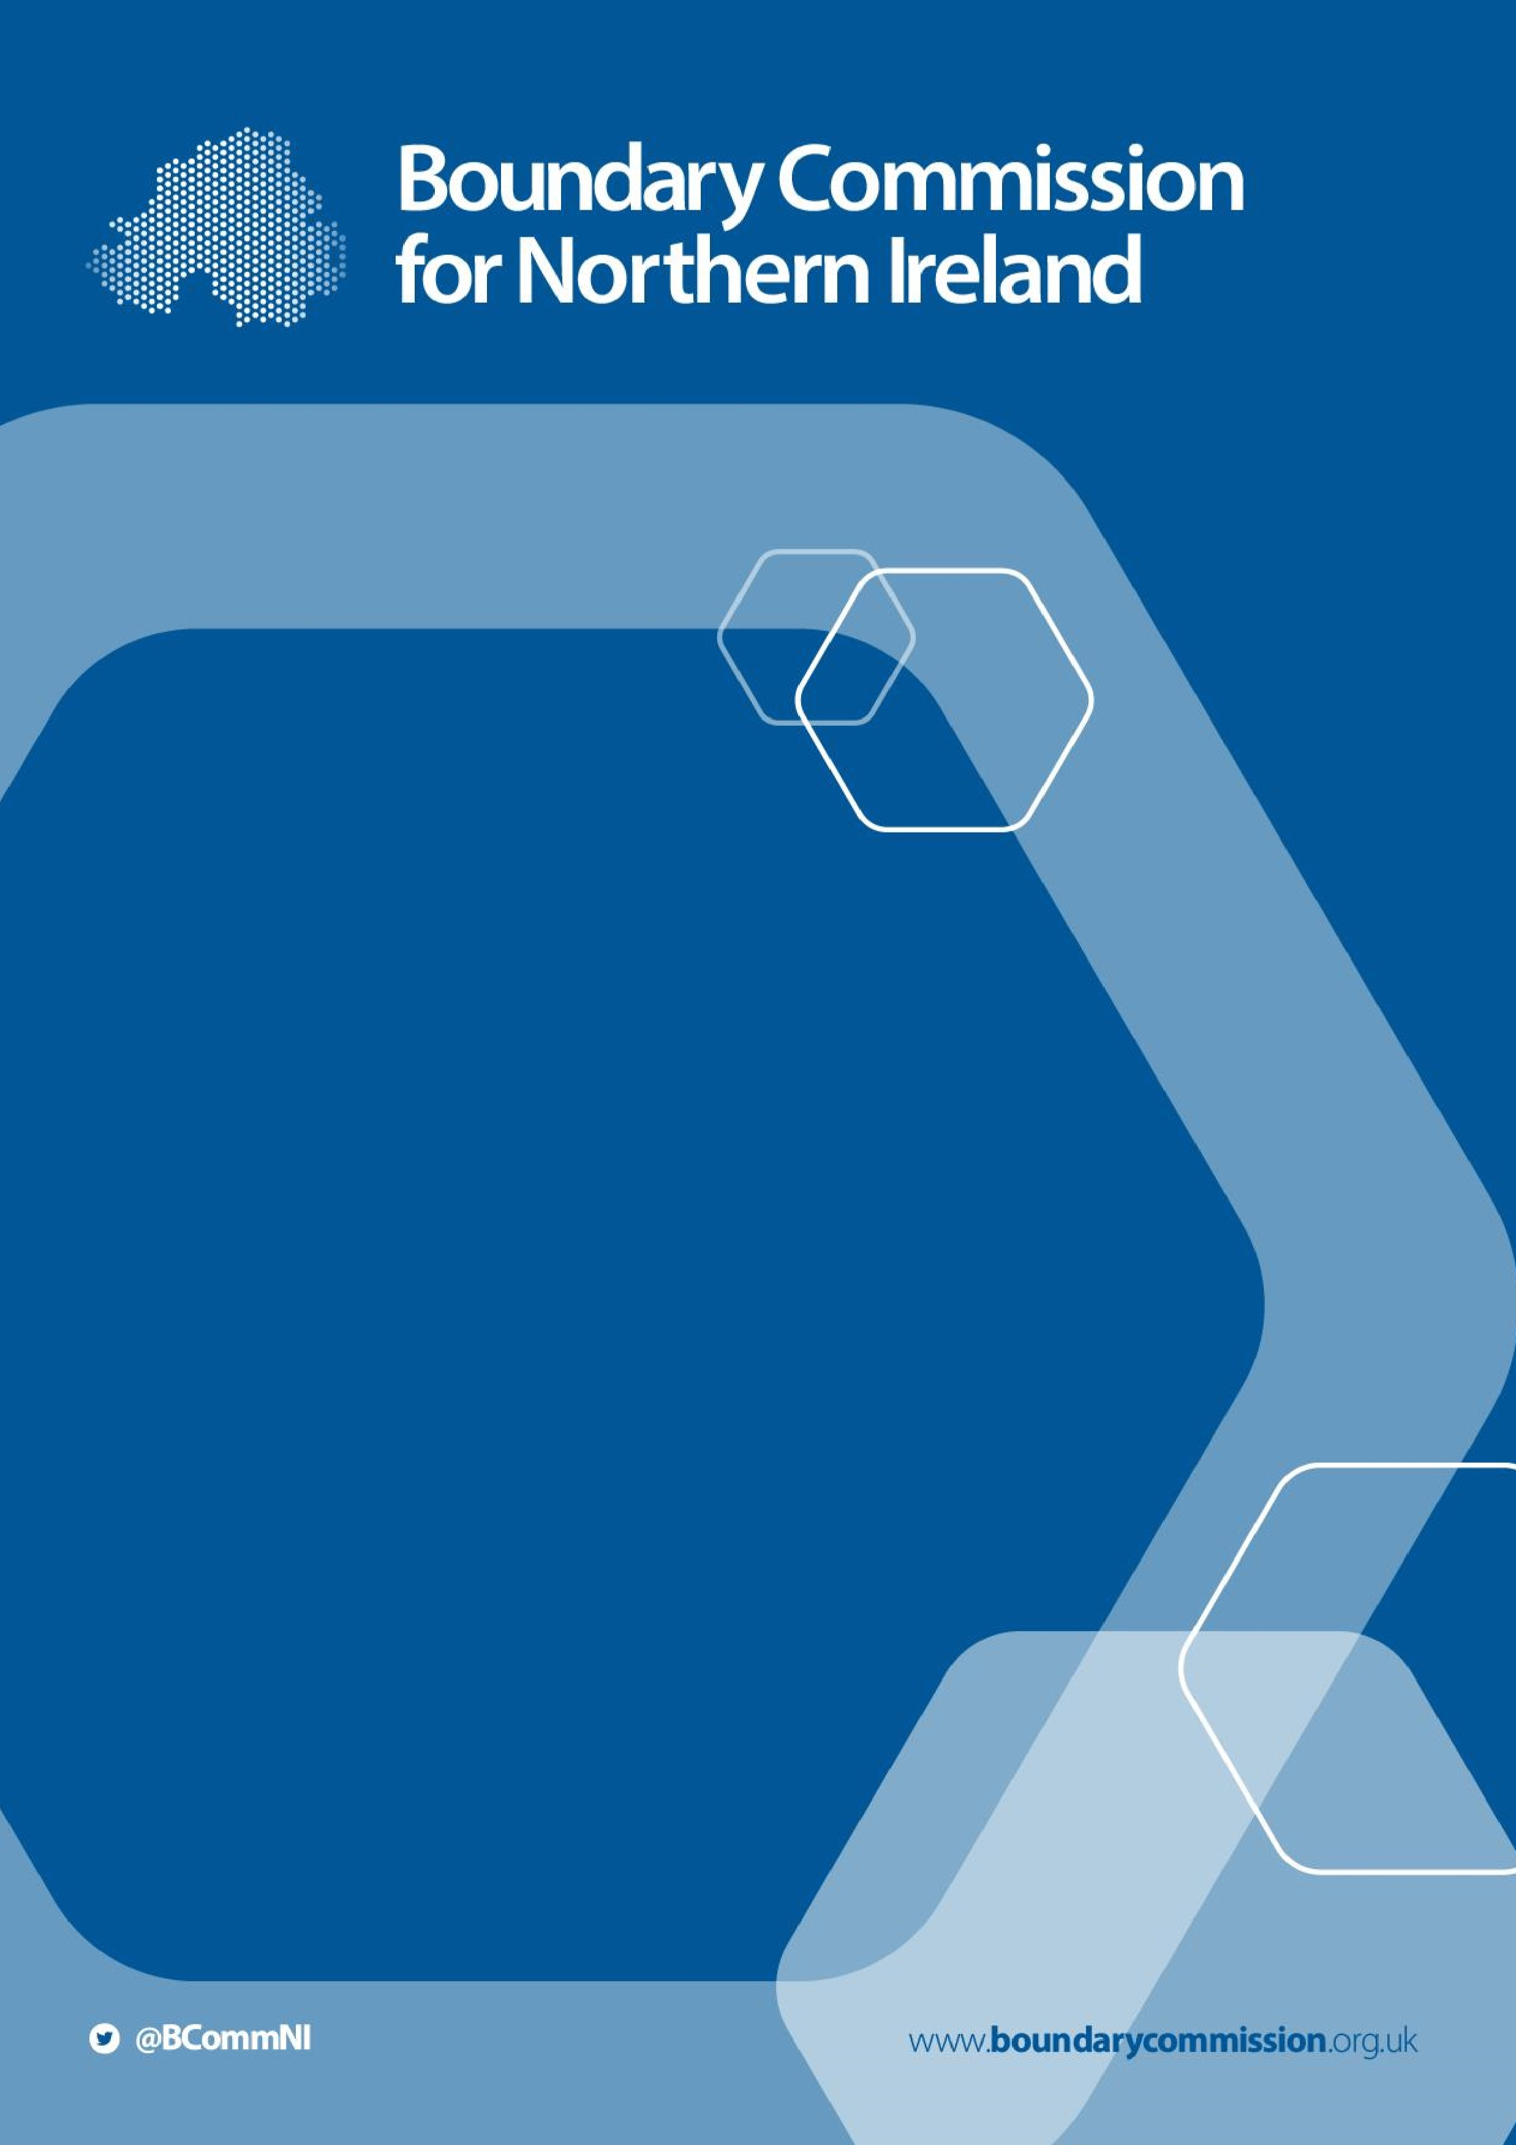

2023
Review of
Parliamentary

Constituencies

Progress Report

2022

January 2023

[Page intentionally blank]

2023 Review of Parliamentary
Constituencies

Progress Report
2022

Presented to Parliament pursuant to Section 3(2C) of the Parliamentary Constituencies Act 1986, as amended by the Parliamentary Voting System and Constituencies Act 2011 and Parliamentary Constituencies Act 2020.

© Crown copyright 2023

This publication is licensed under the terms of the Open Government Licence v3.0 except where otherwise stated. To view this licence, visit
http://www.nationalarchives.gov.uk/doc/open-government-licence/version/3

Where we have identified any third-party copyright information you will need to obtain permission from the copyright holders concerned.

This publication is available at www.boundarycommission.org.uk.

Any enquiries regarding this publication should be sent to us at:

Boundary Commission for Northern Ireland
Level 7
Erskine House
20-32 Chichester Street
Belfast
BT1 4GF
Email: contact@boundarycommission.org.uk

CORRECTION SLIP

Title: Boundary Commission for Northern Ireland: 2023 Review of Parliamentary Constituencies: Progress Report 2022

Session: 2022/2023

ISBN: (if any)

Date of laying: 31st January 2023

Correction:

Text currently reads:
By the close of the third consultation period, 27 written representations had been received.

Text should read:
By the close of the third consultation period, 28 written representations had been received.

Date of correction: 20th March 2023

Rt Hon Sir Lindsay Hoyle MP
Speaker’s Office
House of Commons
London
SW1A 0AA

30th January 2023

Dear Mr Speaker,

- As required by section 3(2B)(a) of the Parliamentary Constituencies Act 1986 (as amended), hereafter referred to as ‘the Act’, each Boundary Commission must submit a report to the Speaker of the House of Commons each January, setting out the progress made with the preparation of the “pending boundary report”. Section 3(2C) of the Act requires the Speaker to lay this report before Parliament.

- In our 2021 Progress Report, we set out the key actions that we had undertaken since the 2023 Boundary Review commenced in January 2021. These included the publication of our Initial Proposals in October 2021, and the initial consultation period which was held between October and December 2021. A total of 31 written representations were received during this consultation period, which were then published on our website.

Secondary consultation period

- Further to the submission of our 2021 Progress Report in January 2022, the secondary consultation period of the 2023 Boundary Review commenced on 9th February 2022 and ended on 23rd March 2022. This provided an opportunity for the submission of further written representations with respect to the representations from the initial consultation period, as well as to give representations at public hearings. In Northern Ireland, three public hearings were held during the secondary consultation period. These took place in Belfast, Cookstown and Derry/Londonderry, with the option to join by video link.

- Five representations were given at the public hearings, and records of these were published on the Commission’s website, in line with the legislation. The three written representations received during the secondary consultation period were also published on our website in May 2022.

Revised proposals

- Having considered the written representations received during the initial and secondary consultation periods, and the records of the public hearings, and having undertaken a number of site visits, the Commission decided on revisions to its initial proposals. Of the 18 constituencies in Northern Ireland, ten remained the same as in the Initial Proposals and eight were revised. A change of name was proposed in one of the revised constituencies.

- In the Revised Proposals, as in the Initial Proposals, the Commission proposed 18 constituencies within the Rule 2 statutory range. The Commission did not consider that its ability to take into account the Rule 5 factors was unreasonably impaired in respect of any constituency, and so the threshold for the use of Rule 7 was not met.

Third consultation period

- The Commission’s Revised Proposals were published on 17th November 2022, marking the start of the third statutory consultation period. This lasted for four weeks (in line with the legislation) and closed on 15th December 2022. As with the initial consultation period, a map showing the Revised Proposals, along with information about how to participate in the consultation, was displayed in public libraries and local council premises across Northern Ireland.

- The Commission provided information and a range of consultation resources via our website, including an interactive map of the Revised Proposals. We also issued a press release, used social media to boost reach, and provided an online consultation portal to facilitate the submission of representations.

- By the close of the third consultation period, 27 written representations had been received. A petition had also been received. These will be published on our website in due course.

- Taking into account representations received throughout the review process, Commissioners will now consider what final recommendations to make for Parliamentary constituencies in Northern Ireland.

Looking ahead

- In line with our statutory duties, the Commission is on course to deliver its Final Recommendations for the 2023 Boundary Review to you before 1st July 2023. Over the next few months, we will liaise with your office, and with the other UK Commissions, with regards to the requirements for the process of submission and laying.

Yours sincerely,

Mr Justice Michael Humphreys
(Deputy Chairman)

Sarah Havlin
(Boundary Commissioner)

Vilma Patterson MBE
(Boundary Commissioner)

