[TC - 001]

General comments on the Commission's revised proposals
My first comment is that given the tight constraints of the boundary commission’s remit these revised proposals are overall a very good attempt to balance both the tight limits, minimise disruption and address local concerns, in particular the numerous submissions regarding the Strangford/South Down boundary.
The revised proposals therefore come across as a solid piece of work that incorporates the sensible feedback as well as possible and that a final recommendation roughly approximating to this revised map will be considered by most to be a successful review.
That said, one thing that came across was the considerable use of partial wards in this revision. I counted around 16 partial wards in use, suggesting the boundary commission has little reservation in using them when necessary. In the initial guidelines I didn’t particularly get the impression that splitting of boundaries was to be encouraged and instead encouraged the use of wards as the most basic building block unit to be used. Therefore with that knowledge I believe that while many of the uses actually seem reasonable I would like to make some suggestions to maximise the drawing of coherent constituencies and minimise disruptions to existing (current) boundaries as per the boundary commission’s initial guideline.

Comments on the Commission's revised proposal for the constituency of Belfast East
I believe Belfast East is a reasonably sound unit that doesn’t require any further changes.

Comments on the Commission's revised proposal for the constituency of Belfast North
I think North Belfast should move one or two more wards around it. The odd splitting of the Shankill area persists despite some improvement in this review. I would add the Forth River into West Belfast alongside other Court wards and compensate that loss with the Carnmoney ward at the northern end of the constituency (or another suitable replacement).

Comments on the Commission's revised proposal for the constituency of Belfast South and Mid Down
Belfast South & Mid Down still feels like an unnecessarily hybrid constituency.
With Belfast West suggested to take an extra ward (Forth river) it allows a more geographically south Belfast ward (in terms of locality and connections) to be added to South Belfast.
This in turn provides sufficient numerical leeway for South Belfast to drop two rural wards, Moneyreagh and Saintfield, and instead keep them in Strangford.
This is described in the general comments later and illustrated in fig. 2.

Comments on the Commission's revised proposal for the constituency of Belfast West
The Belfast West constituency is pretty close to what it finally should be. As mentioned above however I would take Forth River from North Belfast and remove Dunmurry ward to South Belfast.

Comments on the Commission's revised proposal for the constituency of East Antrim
Some expansion of East Antrim is inevitable and these proposals seem as good as any I’ve seen. Perhaps local representations will argue for specific wards to be in one constituency or another.

Comments on the Commission's revised proposal for the constituency of East Londonderry
This seemed like the most logical change of the whole review. Foyle had a couple of spare wards and its neighbours required wards. As a native of neighbouring Enagh ward, it also makes sense on the ground too.
Comments on the Commission's revised proposal for the constituency of Fermanagh & South Tyrone
I think this is one of the better improvements of the revised proposals. It seems that the re-inclusion of Dungannon is sensible. I initially favoured retention of the existing constituency (allowing for ward boundary changes) however if locals have no objection to the inclusion of a part of county Armagh then it is probably fine.

Comments on the Commission's revised proposal for the constituency of Foyle
I initially agreed fully with the new Foyle boundaries shedding their suburban/rural fringes to neighbouring constituencies.

However, having noticed the broad use of split wards throughout the review I would strongly suggest the splitting of New Buildings ward as a convenient means of avoiding some of the unwanted later knock on effects of West Tyrone still requiring at least one additional ward. By splitting New Buildings ( a ward whose 2 Super Output Areas (SOAs) are already split between New Buildings village itself and suburban Prehen ) West Tyrone can conveniently add around 1300 voters to not require any additional wards from Mid Ulster while the remaining Prehen part of the ward would keep Foyle sufficiently above the lower limit. As a native of the constituency, with family connections in the ward, I’d also make this suggestion with some local knowledge of the area; in particular the suburban nature of Prehen and the separate village of New Buildings being a particular justification on the ground and not just for numerical reasons elsewhere. I cannot really offer that such local insight for other constituencies beyond my own opinion. For this reason if the commission only takes one suggestion from my submission to a final recommendation, I’d like it to be this one.

Comments on the Commission's revised proposal for the constituency of Lagan Valley
The boundaries of Lagan Valley will have to undergo some inevitable change and this looks reasonably sound. Although to assist in minimising disruption and numerous split wards there is an argument to be made to include the whole of Donaghcloney in Lagan Valley. I also suggest in fig 2 that Drumbo ward could be effectively swapped with Lambeg ward to facilitate a more explicitly urban South Belfast constituency.
Comments on the Commission's revised proposal for the constituency of Mid Ulster
The revised Mid Ulster seems to be a clear improvement on the initial proposals but the loss of Pomeroy and gain of some split wards seems unnecessarily disruptive. As mentioned elsewhere the splitting of one East L’derry or Foyle ward (Park or preferably New Buildings) would bring West Tyrone above the lower limit and allow Mid Ulster to maintain it. Mid Ulster could even conceivably remain as it is (allowing for ward boundary changes) but likely it needs to take at least Killyman ward to make things easier to organise further to the east.

Comments on the Commission's revised proposal for the constituency of Newry and Armagh
Newry and Armagh proposal continues to be reasonable.

Comments on the Commission's revised proposal for the constituency of North Antrim
North Antrim changes seem reasonable.

Comments on the Commission's revised proposal for the constituency of North Down
North Down changes, including split wards, seem reasonable.

Comments on the Commission's revised proposal for the constituency of South Antrim
The South Antrim constituency by itself seems reasonable. However with the Newtownabbey area typically split between three different constituencies, I would suggest South Antrim transferring one ward to North Belfast to allow North Belfast to transfer the remaining Court DEA ward to West Belfast.

Comments on the Commission's revised proposal for the constituency of South Down
The revised proposals for South Down seem to be among the most sensible proposals possible. The BCNI received numerous responses in the consultation regarding the Strangford / South Down area, in particular requesting some northward shift of wards, but not necessarily moving the town of Downpatrick, and those concerns seem to be largely well reflected in this revised proposal. The changes in the western area of the constituency also seem somewhat inevitable given the concentration of voters in the Newry & Armagh / Upper Bann area so that is also reasonable.

Comments on the Commission's revised proposal for the constituency of Strangford
The main issues mentioned in the consultation regarding Strangford (and South Down) are reflected in the changes and mentioned in the South Down comments above.
The commission specifies an electorate of 70,100 in the revised proposal for Strangford. I would therefore suggest the addition of Saintfield and Moneyreagh (already in current constituency) to have a new constituency of 75,423. That would allow the retention of a nominal Belfast South constituency (with or without the inclusion of Drumbo) and remove the need for a new hybrid Belfast South and Mid Down constituency.

Comments on the Commission's revised proposal for the constituency of Upper Bann
The boundary changes make sense on the whole but I believe there was a less disruptive option open to the BCNI that didn’t require splitting wards, namely transferring all of Donaghcloney to Lagan Valley. See fig. 2.

Comments on the Commission's revised proposal for the constituency of West Tyrone
The split ward of Slievekirk aligning with West Tyrone makes sense numerically and on the ground.
The Donaghmore ward transfer however doesn’t make as much sense on the ground and is largely chosen to allow for numeric constraints. I initially preferred the transfer of Park from East L’derry, however seeing the freedom demonstrated in the splitting of wards, the most obvious change (subsequently preventing other awkward wards and need for other split wards) would be the splitting of the New Buildings ward. As mentioned in the Foyle response, on the ground there is a clear demarcation within the ward between a suburban residential part of Foyle (Prehen/Dunhugh) and the village of New Buildings (clearly reflected locally in the two super output areas of the ward attached below). This would facilitate fewer radical changes elsewhere as per the remit to minimise changes from current constituencies.

Fig. 1 New Buildings 1 Super Output Area (Left) incorporating New Buildings village proper and New Buildings 2 Super Output Area (Right) incorporating Prehen and Dunhugh areas.
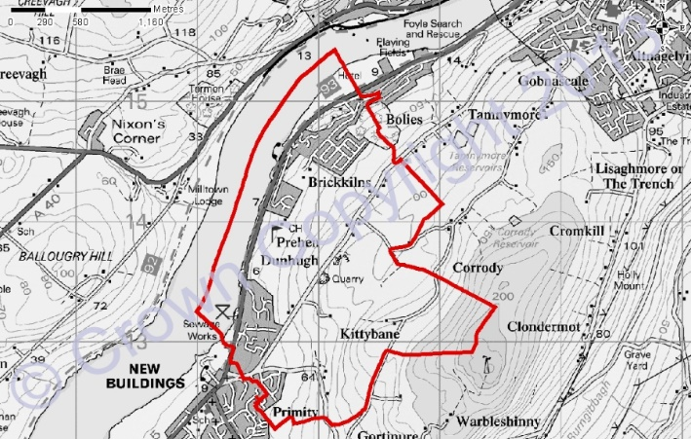
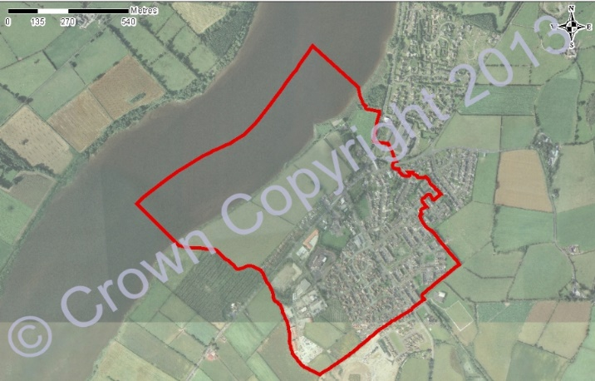

Summary

My comments on the revised proposals above along with my suggestions can be best visualised below in this (approximate) map. Some of the comments would make little sense as standalone comments without wider context. In some cases I think there are perfectly reasonable proposals from the BCNI, but changes are suggested that can sometimes be somewhat meaningless without an acknowledgment of some possible knock-on changes. Therefore the map below attempts to illustrate some of those suggestions.

- I would likely split one ward (blue area) of New Buildings to bring West Tyrone above the lower limit.
- With this change, Pomeroy can be returned to Mid Ulster which needs to only take Killyman ward (if anything).
- No split wards are required in Upper Bann now if all of Donaghcloney is removed.
- Keeping all the split wards suggested in the revised proposals for Strangford (not illustrated here) and the retention of Saintfield and Moneyreagh from Belfast South becomes numerically viable.
- North Down and East Belfast remain exactly as the boundary commission proposed and South Belfast compensates by gaining the geographically South Belfast ward of Dunmurry from Belfast West and Lambeg from Lagan Valley, effectively swapping it with Drumbo ward and keeping a largely rural ward in a rural constituency and incorporating another urban ward into an urban constituency.
- Belfast West tin turn compensates for Dunmurry by taking the Forth River ward and neatly maintaining the Shankill as one local area in one constituency.
- Belfast North takes one additional ward around the northern end of the Newtownabbey area (Carnmoney ward) to compensate for loss of Forth River.

Fig. 2 Suggested approximate ward map of NI (left) and of the greater Belfast area (right)

